How many military bases do we have overseas, and where are they?
No doubt, you and I have read in a variety of articles, that America has many military overseas bases. The cost to maintain our overseas bases is a big number (a trillion?) so maybe it’s time to cut unnecessary costs by only supporting those bases that really contribute to our national security.
We should let our national legislators know that because of the big expense, let’s check out which bases are essential to our national security, and among the 80 foreign countries, which one are really important to protect America?
Using logic and determining where we really need a military presence, will save us valuable dollars needed to fund important domestic issues.
=======================================
America’s Overseas Military Bases
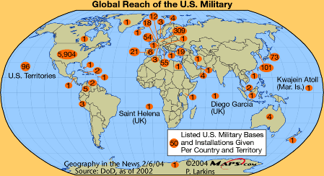 Here are America's oldest international military bases.
Story by 24/7 Wall St. Staff • February 10, 2024
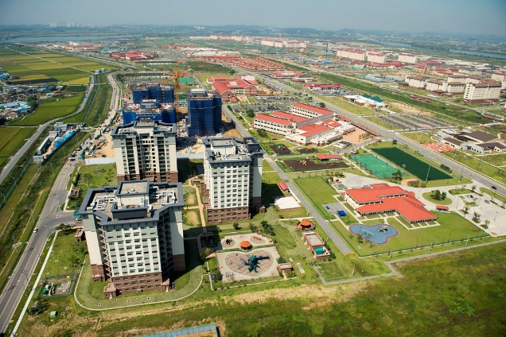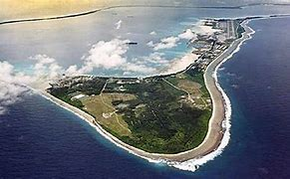
Camp Humphreys, South Korea Diego Garcia, an island of the British Indian Ocean Territory
Out of 195 countries throughout the world, the United States is the country that maintains the most overseas military bases. With over 750 bases across 80 countries globally, no other nation in history has commanded the presence that America has globally. The vast majority of these bases can be found within the contiguous United States, with Europe hosting the next most, followed by Southeast Asia, which is home to Camp Humphreys in South Korea. Camp Humphrey may be the largest American military base abroad, but it is far from the oldest, having opened in 1950.
24/7 Wall St. reviewed the study, U.S. Military Bases Abroad, 1776-2021 by David Vine, professor at the Department of Anthropology at American University to determine America's oldest overseas military bases. We ranked the bases according to the year they opened, listing the 23 bases founded by 1943 at the latest. Data on the number of active-duty personnel and bases within each country as well as estimated land acreage of each base came from the Quincy Institute for Responsible Statecraft, a military think-tank.
This list is comprised of 23 bases of which 13 are located in Puerto Rico, operated by the Army, Navy, and Air Force. Not surprising given the important strategic position Puerto Rico holds between the Caribbean Sea and the Atlantic Ocean. The first of these was constructed in 1902. (Also see, the six European bases where the U.S. is storing nuclear bombs.)
In the wake of the United States' victory over Spain in the Spanish-American War in 1898, Puerto Rico was one of the territories it received. Following that war, Cuba gained independence from Spain and agreed to lease Guantánamo Bay to the U.S. Navy on its southeastern shore in 1903. Other possessions the U.S. secured from Spain in the Pacific – Guam and Wake Island – have military bases.
Four of America's oldest overseas bases are in the United Kingdom, established there just after America entered the war in 1941. That same year, the U.S. began leasing from Denmark the Thule Air Base in Greenland, which at more than 233,000 acres, is by far the largest overseas military base by physical size. (This is the largest military base in each state.)

