Who would’ve thought that due to critical shortages in manpower, the Air Force has initiated a Voluntary Retired Return to Active Duty Program?

Our Air Force, and our overall military is having problem getting new recruits, with ongoing retirements, has initiated a Voluntary Retired Return to Active Duty program. Initially, the Air Force wants to attract 1000 retirees in important positions like retired pilots to “unretire.”

The Air Force was short 2,000 recruits in the past year, and he Navy missed its mark by several thousand for the active-duty force, while the Army fell short of its annual goal by about 10,000 new recruits.

Ironically, getting young people to join the military is a problem in China and Taiwan.
This is a recent problem in China, but has been a problem in Taiwan for many years.

===============================================

SOURCE:

The US Air Force is again letting retirees come back amid worries about recruiting and retention

Story by insider@insider.com (Ella Sherman), February 8, 2024

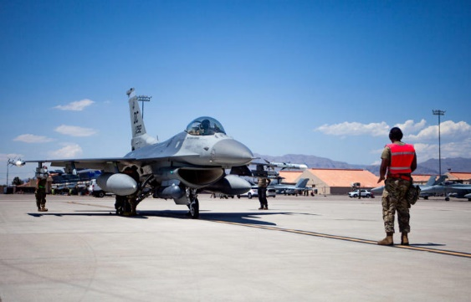

U.S. Air Force Tech. Sgt. Damian Dorsey, aircraft armament systems technician, from the 113th Aircraft Maintenance Squadron out of Washington D.C., conducts pre-flight procedures for an F-16 Fighting Falcon during Red Flag 23-3, at Nellis Air Force Base, Nevada, July 19, 2023. U.S. Air Force photo by Senior Airman Jakob Ivanick© U.S. Air Force photo by Senior Airman Jakob Ivanick
- The US Air Force is opening back up its Voluntary Retired Return to Active Duty Program.
- The program will be used to address certain manpower shortages.
- The Air Force has faced challenges with recruitment and retention, which can affect readiness.
The US Air Force said Wednesday it is bringing back the Voluntary Retired Return to Active Duty Program in hopes of reactivating retired service members to address "critical manning shortages" amid concerns about recruitment and retention.
"The VRRAD program is a strategic enabler to embrace experienced talent, tapping into a valuable resource of retired members to fill critical roles to close the gap against our peer competitors," Deputy Chief of Staff for Manpower, Personnel and Services Lt. Gen. Caroline Miller said in a statement.
The trend in recruiting for the Air Force and some of the other services hasn't been great. In 2022, the Air Force almost fell short of its recruiting goal, and in 2023, the branch missed its active-duty recruiting goal by more than 2,000 soldiers.
The US military had anticipated that new taglines, relaxed regulations, and financial benefits would persuade individuals to join the ranks in 2023, but services fell short. The Navy missed its mark by several thousand for the active-duty force, and the Army fell short of its annual goal by about 10,000 new recruits.
Retaining pilots is another one of the Air Force's big problems, as many pilots have been drawn to commercial aviation.
On top of low recruitment and problems with retention, a majority of young adults in the US also recently expressed that they hold negative views of the country's military in a Pew Research Center poll that found only 43 percent of adults in the US ages 18 to 29 have positive views of the military. Such perceptions could exacerbate problems.
The VRRAD program, which opens the door to as many as 1,000 retired service members, has the potential to help fill some of the Air Force's gaps in manpower if it gets sufficient interest.
Some critics have taken to social media, where some additional details of the revived program were revealed, to say the program has "zero incentives" and that "nothing in this sounds appealing or rewarding for a retiree to return to active duty." Others may hold different views. It's unclear how pervasive these views may be among potential applicants.
The VRRAD program originally began in 2017 as a way for previously experienced pilots to take up positions so that active-duty pilots could make time for missions and training.
Only 120 pilots were hired until the program stopped taking applications in 2020, reported Military.com. This time around, the program expects to accept applications from Feb. 8 of this year to Jan. 31, 2026.

