Some great uses for anyone with a can of WD-40
I have a can of WD-40 in my garage and only use it to free locks that are frozen or stuck. But there are dozens of other uses for WD-40 that can be useful to anyone. So click on the following link and find out more than thirty (30) different uses for that can of WD-40 we have all stored in the garage, basement, or wherever you store your maintenance tools.
https://www.familyhandyman.com/list/brilliant-ways-to-use-wd-40/
===============================================================
SOURCE:
WD-40 is well known as a lubricant, but it has a ton of other game-changing applications around the house. Here are 34 unique ways to use WD-40
Rachel Brougham, Dec. 02, 2022
.

DILOMSKI/SHUTTERSTOCK
- Keep Dead Bugs Off Your Car Grille
It’s bad enough that your grille and hood get splattered with bugs every time you drive down the interstate, and it’s not easy to clean bugs and tar off your car. Just spray some WD-40 on the grille and hood before going for a drive and most of the critters will slide right off. The few bugs left will be easy to wipe off later without damaging your car’s finish.
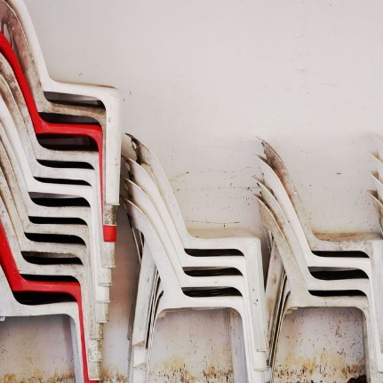
ISARAVUT/SHUTTERSTOCK
- Renew Faded Plastic Furniture
Bring color and shine back to faded plastic patio furniture. Simply spray WD-40 directly on the surface and wipe with a clean, dry cloth. You’ll be surprised at the results.
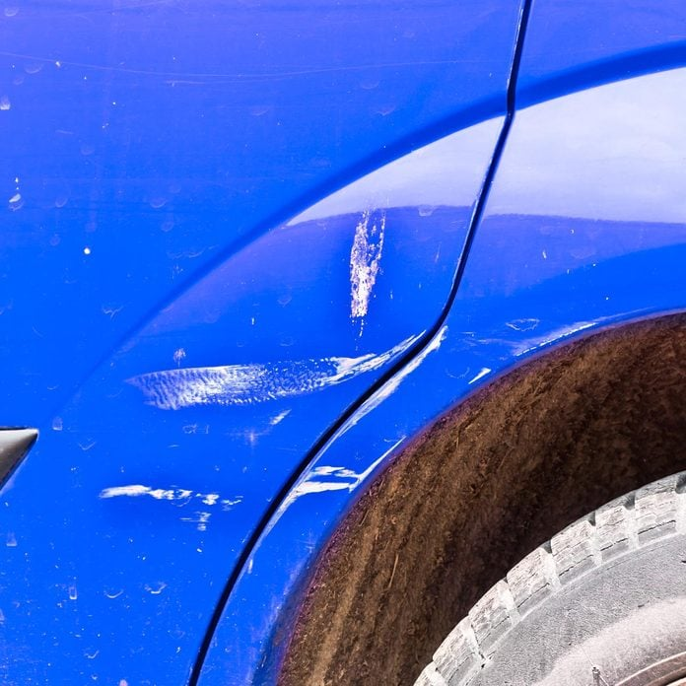
SRDJAN RANDJELOVIC/SHUTTERSTOCK
- Remove ‘Paint Rub’ From Another Car
Picture this: you return to your parked car to find that while you were gone, another vehicle got a bit too close for comfort. Luckily there’s no dent, but now your car has a blotch of “paint rub” from the other car on it. To remove paint-rub stains on your car and restore its original finish, spray the affected area with WD-40, wait a few seconds, then wipe with a clean rag.
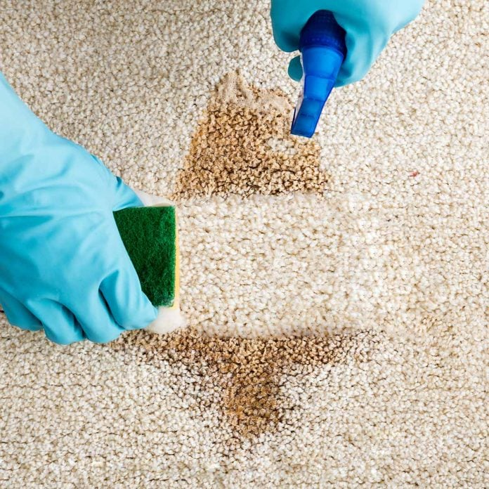
ANDREY_POPOV/SHUTTERSTOCK
- Clean Carpet Stains
Don’t let ink or other stains ruin your fine carpet. Spray the stain with WD-40, wait a minute or two, and then use your regular carpet cleaner or gently cleanse with a sponge and warm, soapy water. Continue until the stain is completely gone.
4 / 33
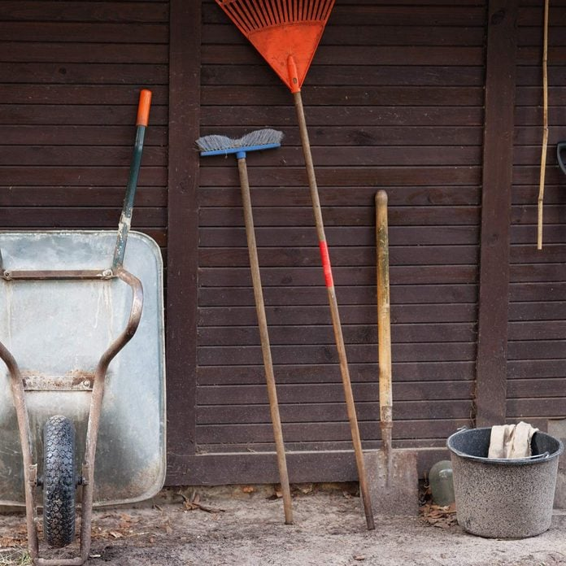
DENISS GRIGORJEVS/SHUTTERSTOCK
- Keep Wooden Tool Handles Splinter Free
No tools can last forever, but you can prolong the life of your wood-handled tools if you keep them from splintering. Just rub a generous amount of WD-40 into the wood. It shields the wood from moisture and other corrosive elements and keeps it smooth and splinter-free for the life of the tool.
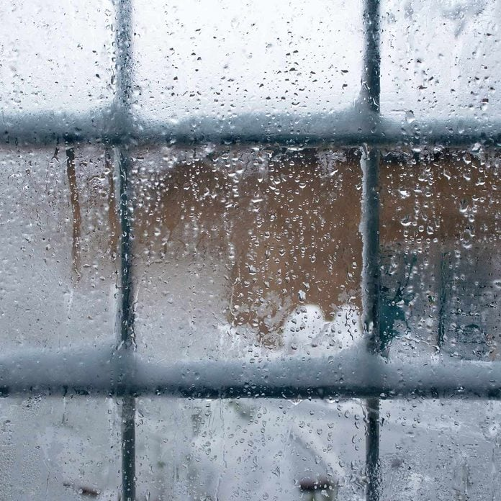
IGORSTEVANOVIC/SHUTTERSTOCK
- Prevent Snow Buildup on Windows
Does the weather forecast predict a big winter snowstorm? You can’t stop the snow from falling, but you can prevent it from building up on your house’s windows with a little bit of WD-40. Just spray WD-40 over the outside of your windows before the snow starts and the snow won’t stick.
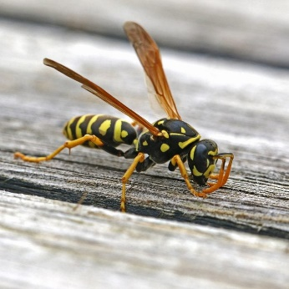
RUTH SWAN/SHUTTERSTOCK
- Keep Wasps from Building Nests.

Don’t let yellow jackets and wasps ruin your spring and summer fun. Their favorite place to build nests is under eaves, so next spring mist some WD-40 under all the eaves of your house. It will block the wasps from building their nests there.
7 / 33
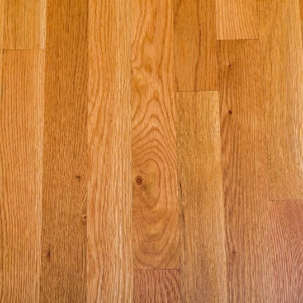
DARRYL BROOKS/SHUTTERSTOCK
- Tone Down Polyurethane Shine
A new coat of polyurethane can sometimes make a wood floor look a little too shiny. To tone down the shine and cut the glare, spray some WD-40 onto a soft cloth and wipe up the floor with it.
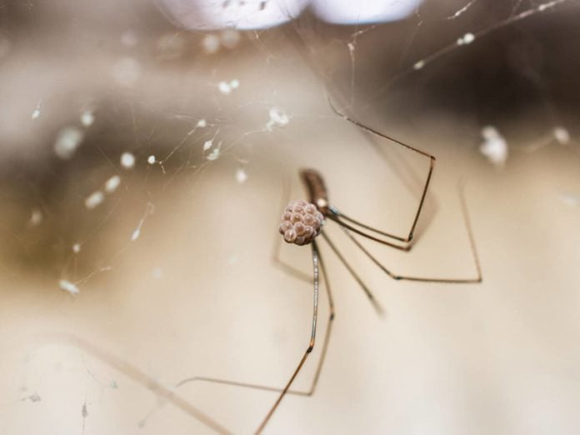
PANYAWAT BOOTANOM/SHUTTERSTOCK
- Keep Spiders Away
So what’s the WD in WD-40 stand for? Water displacing. WD-40 is mainly used as a solvent. It has lubricant-like properties that do not come from the substance itself, but rather from dissolving components.
Have a fear of spiders? Just spray some WD-40 on places where spiders, ants and other insects can get in, such as windowsills and door frames. It will keep the spiders and other bugs out.
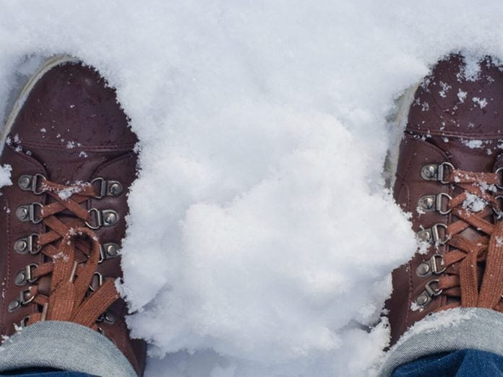
ZAXKY EX/SHUTTERSTOCK
- Waterproof Shoes and Boots
If it’s wet outside, give the tops and sides of your shoes or boots a coat of WD-40 before you head out the door. WD-40 acts as a barrier so moisture can’t seep into your shoes and get your socks wet.
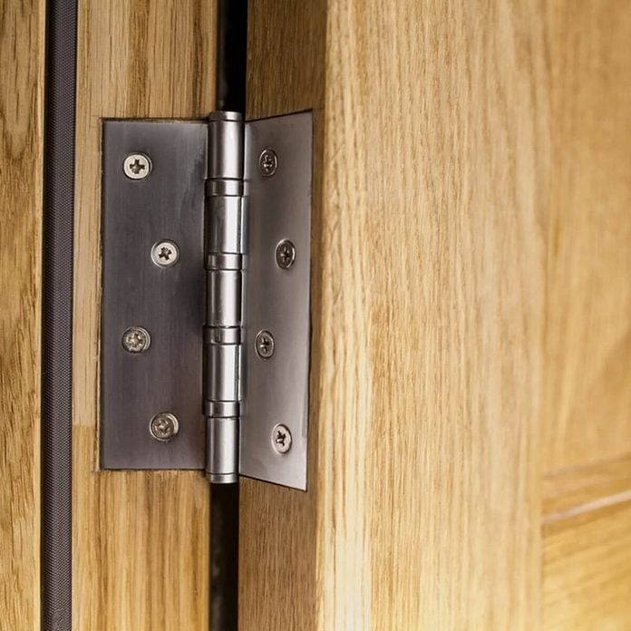
ARTSIOM KUCHYNSKI/SHUTTERSTOCK
- Fix Squeaky Hinges
Nothing can be more irritating than a squeaky hinge on a door. Apply some WD-40, rotate it back and forth, and the squeak should vanish.
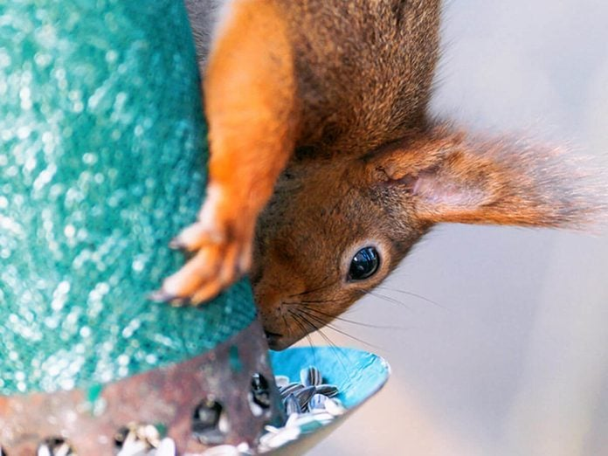
STEFAN HOLM/SHUTTERSTOCK
- Keep Squirrels Away from Bird Feeders
It happens all the time: Just as you fill your bird feeder with seed, the squirrels get into it and eat it all before the birds have a chance. Next time you fill up the feeder, just spray a good coat of WD-40 on top of the feeder and those rodents will slip right off.
Advertisement
Advertisement
12 / 33
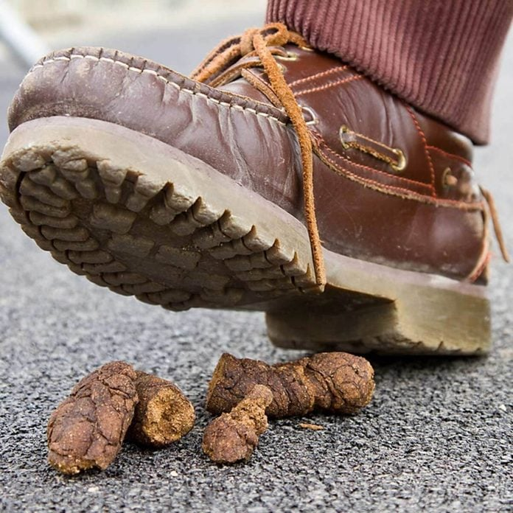
NATURSPORTS/SHUTTERSTOCK
- Get Poop Off Your Shoe
You return home and discover you stepped in dog do-do while on your evening walk. No problem! Just spray some WD-40 on the sole of your shoe and use an old toothbrush to clean the poop out of the crevices. Rinse with cold water and your shoes will be as good as new.
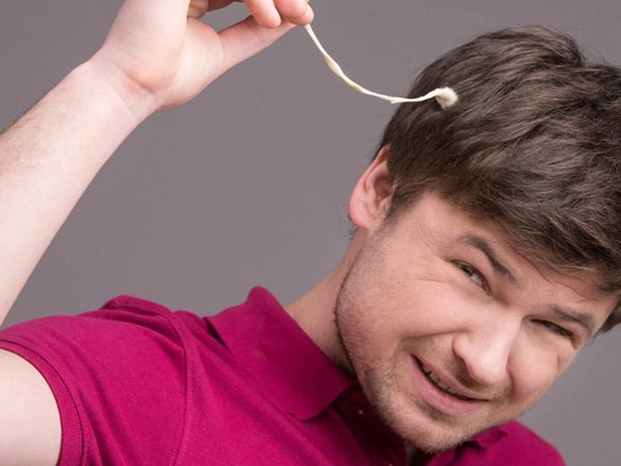
BLUESKYIMAGE/SHUTTERSTOCK
- Remove Chewing Gum
Forget peanut butter. Next time your child gets bubble gum stuck in their hair, spray it with some WD-40, then comb it out and rinse thoroughly.
14 / 33
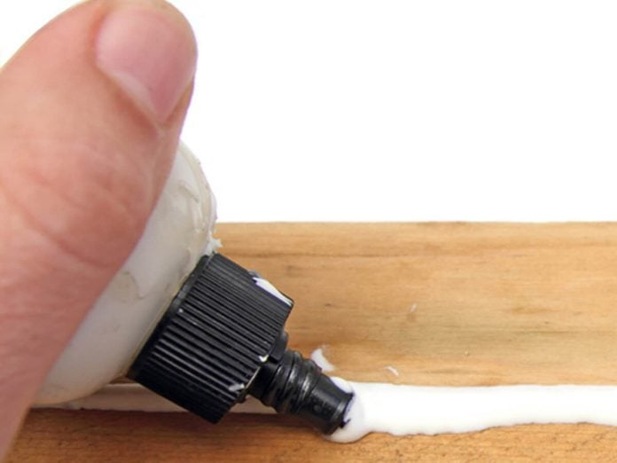
GDVCOM/SHUTTERSTOCK
- Get Rid of Sticky Fingers
Next time you’re working on a project and accidentally get some super glue stuck to your fingers, just spray the area with WD-40. The sticky glue will come off when you rub your hands together.
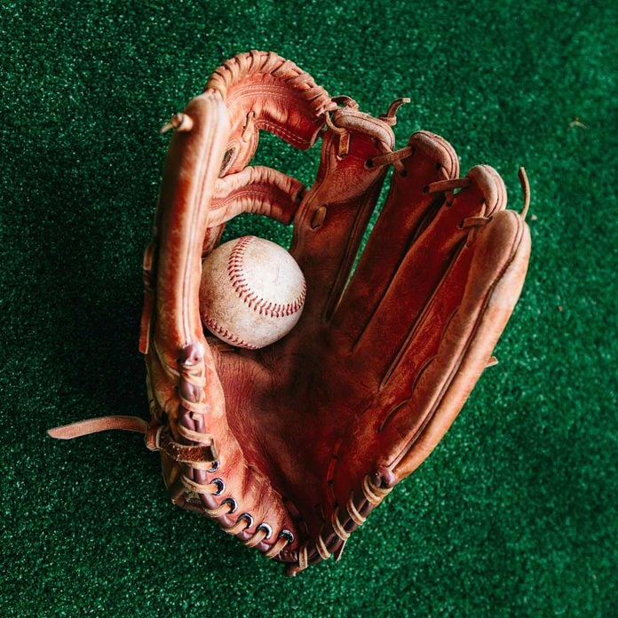
SCHARFSINN/SHUTTERSTOCK
- Break in a New Baseball Glove
Another one of the great WD-40 uses you haven’t thought of yet? Use WD-40 instead of neat’s-foot oil to break in a new baseball or softball glove. Spray the glove with WD-40, put a baseball in the palm, and fold it sideways. Take a rubber band or belt and tie it around the folded glove. The WD-40 will help soften the leather and form around the baseball, creating a pocket. Keep the glove tied up overnight, then wear it for a while so it will fit the shape of your hand.
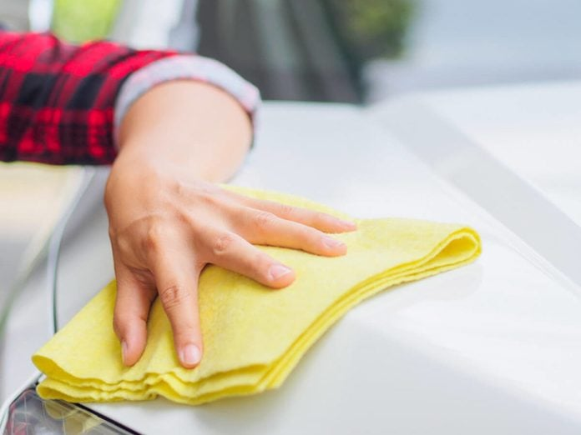
SIAM.PUKKATO/SHUTTERSTOCK
- Remove a Paint Smudge
When you find a paint smudge on your car — say from a rogue shopping cart in the parking lot — spray the area with WD-40 and wipe with a clean rag. It will remove the smudge.
17 / 33
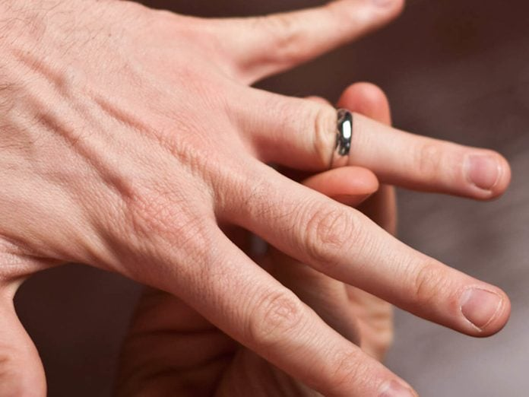
MCARPER/SHUTTERSTOCK
- Remove Tight Jewelry
Ring too tight? A quick spray of WD-40 will help you slide it right off your finger.
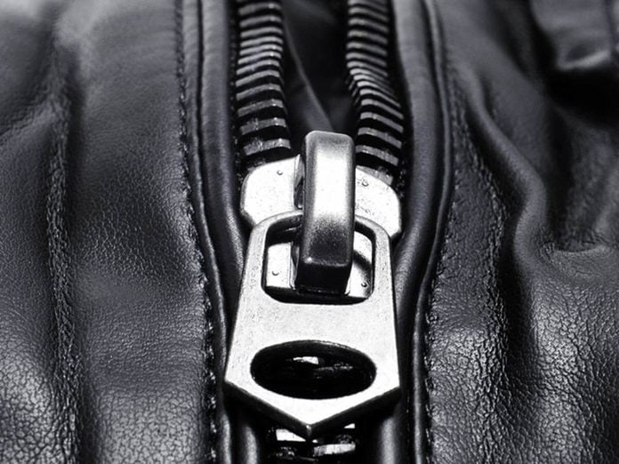
NITO/SHUTTERSTOCK
- Loosen a Zipper
That stubborn jacket zipper doesn’t stand a chance against WD-40. Just spray some directly on the zipper and move the pull up and down the teeth a few times. For other issues, check out these different ways to repair the zipper on your jacket.
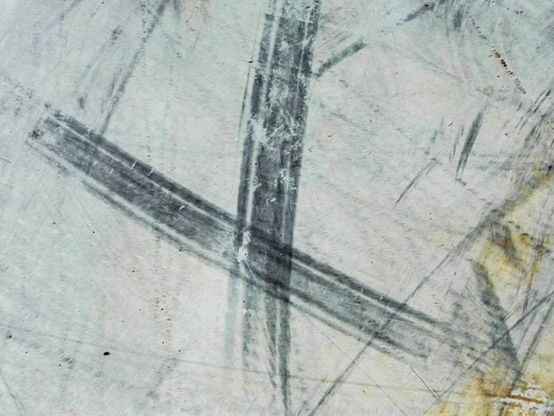
ANDREI KHOLMOV/SHUTTERSTOCK
- Remove Floor Scuff Marks
If mopping doesn’t remove scuff marks from the floor, try spraying some WD-40 on the marks and then wipe them away. The lubricant shouldn’t harm the floor, but test in an inconspicuous place if you’re concerned.
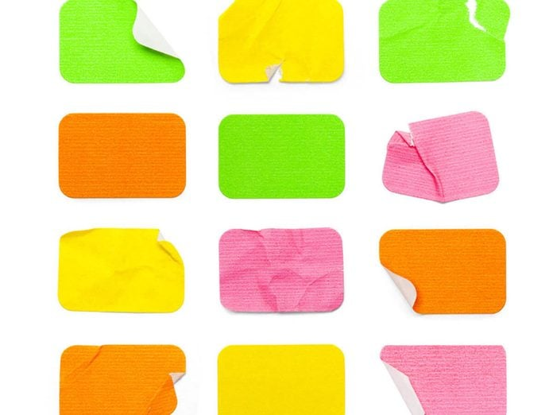
MEGA PIXEL/SHUTTERSTOCK
- Get Rid of Sticky Residue
Remove the residue left behind by stickers, tape and labels. Just spray with WD-40, wait about a minute then wipe the residue away with a cloth.
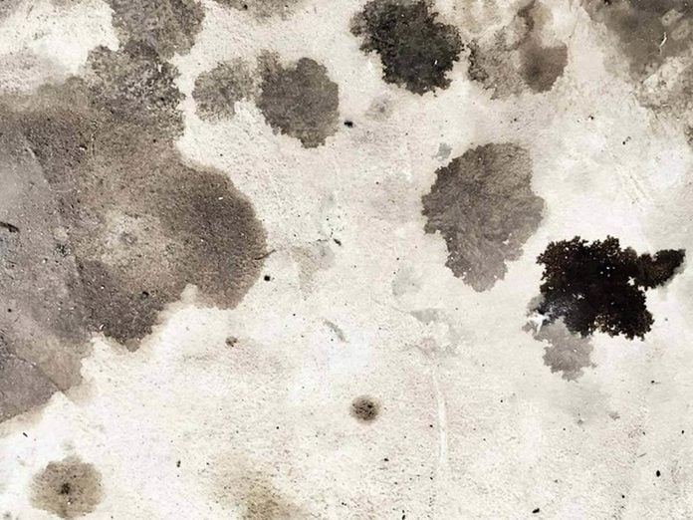
SPEEDPHOTO/SHUTTERSTOCK
- Oil Spots
If there’s an ugly oil spot on your garage floor or the driveway, give the spot a good coat with WD-40 then hose it down. The spot should disappear once the water dries.
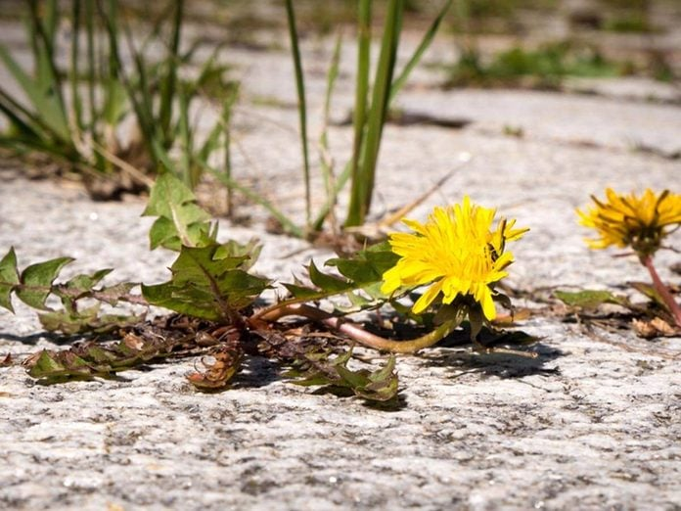
FLOKI/SHUTTERSTOCK
- Kill Weeds
Some gardeners will tell you WD-40 works great as a weed killer. Try using it on thistle. It should wither and die, allowing you to then pull it out, root and all, so it doesn’t return to your yard.
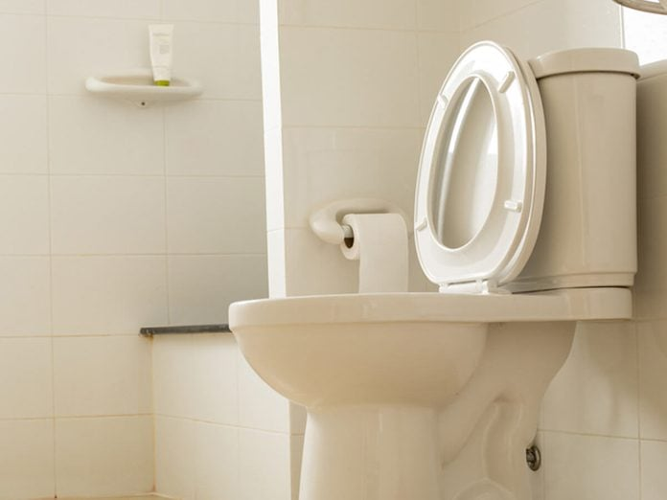
SHUTTEROK/SHUTTERSTOCK
- Clean the Toilet
Remove lime stains from the toilet bowl by spraying in some WD-40. Then just scrub with a toilet brush and flush.
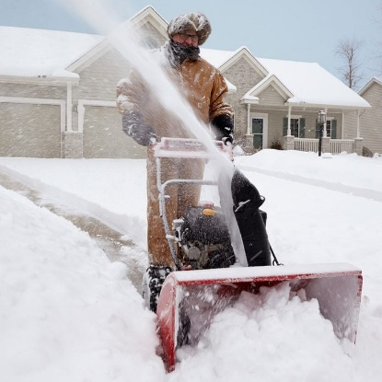
FAMILY HANDYMAN
- Keep Shovel or Chute Snow Free
Here is a simple tip to make shoveling snow quicker and less strenuous by keeping the snow from sticking to your shovel and weighing it down. Spray a thin layer of WD-40 on the shovel blade, and the snow will slide right off. If you have a snow thrower, spray WD-40 on the inside of the chute so snow won’t stick and clog the chute.
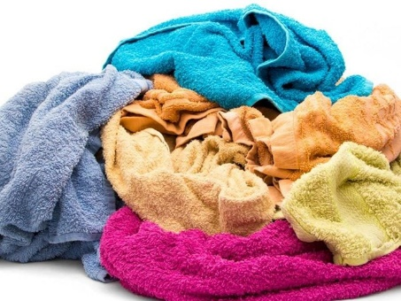
MIHASTOCK/SHUTTERSTOCK
- Remove Hair Dye Stains
If you color your hair at home and some of the dye stains your towel, spray some WD-40 on the stain and rub it in. Then toss the towel in the washer and run on a hot cycle.
26 / 33
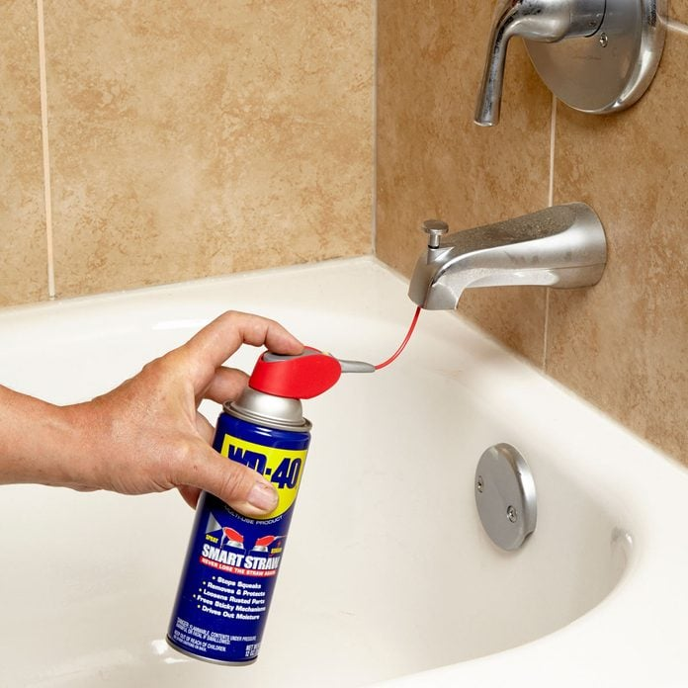
FAMILY HANDYMAN
- Quick Diverter Lube
Over time, the hard water in our area leaves deposits in the moving parts of the plumbing. When the tub spout diverter clogs, use WD-40 with its spray nozzle curved up the spout to the diverter valve. A couple of sprays loosens things up.
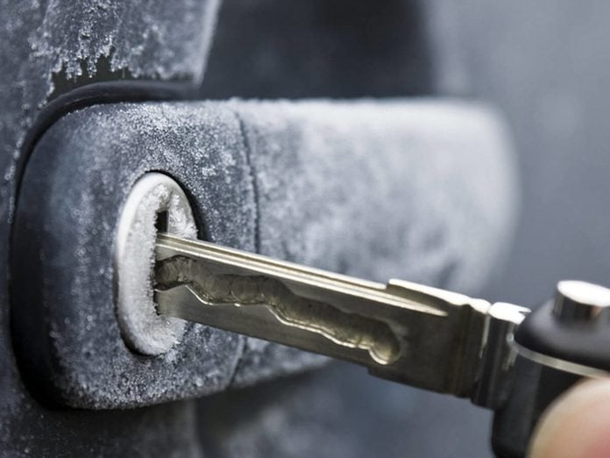
BRIAN A JACKSON/SHUTTERSTOCK
- Keep Car Locks from Freezing
If an ice storm is in the forecast, spray WD-40 in the locks of your car. It will prevent water from seeping in and freezing the lock.
TWIN DESIGN/SHUTTERSTOCK
- Free Stuck LEGOs
Next time your child asks you to pull apart those stubborn, tiny little LEGO pieces, give them a quick squirt of WD-40. They’ll come apart much easier.
KAYAME/SHUTTERSTOCK
- Remove Crayon and Marker from Walls
Oops, your kids colored the wall. No problem! Spray some WD-40 on the wall, then wipe off the crayon or marker with a clean rag. If you have wallpaper, do a quick test first.
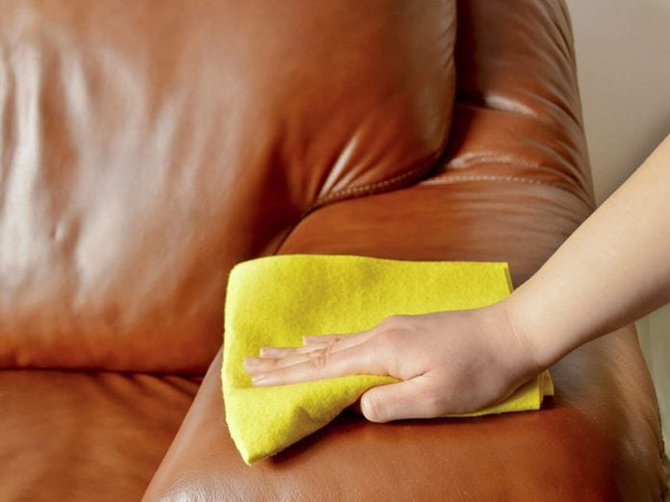
CUNAPLUS/SHUTTERSTOCK
- Remove Paint from Leather
If you’re painting a drop or two of paint lands on your leather couch, spray the spot with WD-40 and wipe with a clean rag. The paint will come right off.
31 / 33
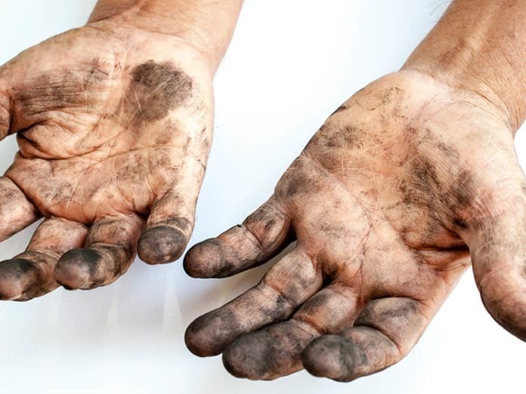
AMAWASRI PAKDARA/SHUTTERSTOCK
- Remove Grease
Instead of leaving grease all over the bathroom sink, spray your hands with WD-40 as soon as you’re finished working on your car. Rub them together, then wipe with a paper towel and follow with some soap and water.
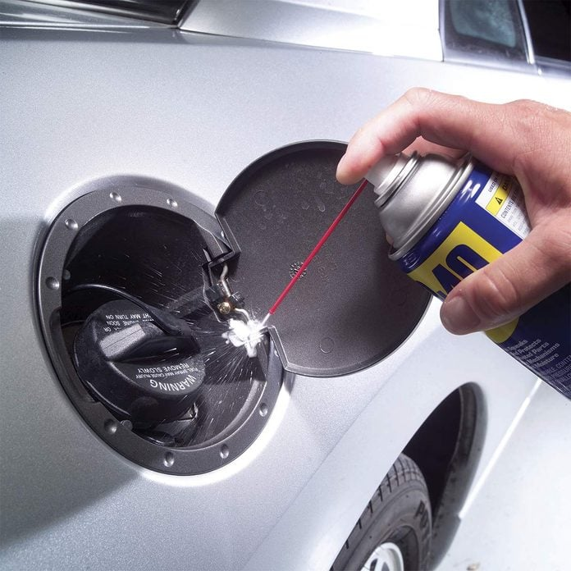
FAMILY HANDYMAN
- Lubricate the Gas Tank Lid
The gas tank lid really takes abuse, especially in salty environments. A squirt of WD-40 a few times a year prevents rusting. Wipe away any excess to keep it from dripping onto (and damaging) your car’s finish.
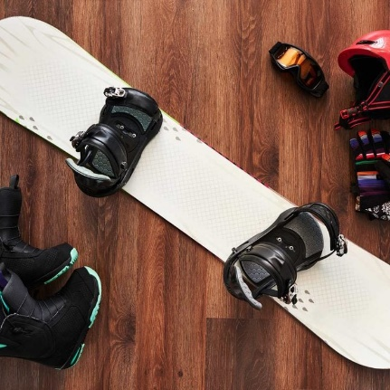
DMYTRO VIETROV/SHUTTERSTOCK
- Remove Old Wax From Skis and Snowboards
To remove old wax and dirt from skis and snowboards, spray the base sparingly with WD-40 before scraping with an acrylic scraper. Use a brass brush to further clean the base and remove any oxidized base material.

