Corruption Cripples the PLA.

Right after New Years of 2024, (January 5, 2024) CNN reported that nine (9) PLA generals had been fired for corruption. Mr. James Char, a China watcher in Singapore noted that since 2016 the “Chinese high command and the Rocket Force leadership has been compromised.”

First, their Defense Minister, Li Shangfu was removed, then nine more generals fired, including five (5) from their Rocket Force high command. General Li Yuchao, the PLA Commander and his political commissar were dismissed along with a senior officers responsible for procurement. Several other senior officers removed who were also involved with arms procurement.

Another very senior officer fired was the PLA Air Force commander.

Simultaneously, three senior executives of defense contractors were also fired.

Mr. Char opined that the huge amount of funds (in billion$) allocated to their strategic Rocket Force (previously the 2nd Artillery corps) was extremely vulnerable to corruption.

In recent years, open sources have noted that the Chinese were adding dozens of ICBM launching sites in the Gogi desert and locations away from major population locations. Noting that public sources have disclosed that the U.S. has around 4000 nuclear weapons, it would be a wise tactic to direct our nuclear weapons into areas of least value to China.

I have assumed that most of these sites were dummy sites which is a practical solution to protect their population and key locations. Another recent report noted that instead of fuel used to load their long range missiles, water is being used. Today, we have sensors that can detect the presence of radiation, so fake nuclear missile sites will be detected and not targeted.

If these stories about corruption in the most senior levels of the PLA, especially her rocket forces, this can set back Chinese nuclear capabilities for 5-10 years.

==============================================

SOURCES:

Xi’s latest purge targets the military. Why did powerful generals fall out of favor?
Analysis by Nectar Gan, CNN, January 5, 2024

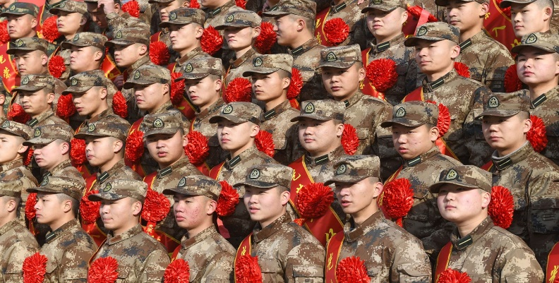
New recruits for the People's Liberation Army (PLA) Rocket Force participate in a send-off ceremony at the Fuyang Institute of Technology on December 26, 2021 in Fuyang, Anhui Province of China. Wang Biao/VCG/Getty Images/File

For much of 2023, a storm has been quietly engulfing the world’s largest military – the People’s Liberation Army (PLA) of China.
Behind the walled government and military compounds of the Chinese capital, powerful generals have disappeared from public view one after another. Some were subsequently removed from their positions without explanation, even for roles as high-profile as the defense minister.
After months of intense public speculation and evasive non-answers from government spokespersons, the clearest sign of a sweeping purge inside China’s military came last Friday, when nine high-ranking PLA officers were ousted from the country’s top legislature.
While the National People’s Congress (NPC) itself is just a rubber-stamp parliament, its members enjoy a degree of immunity from arrest and criminal prosecution granted by the constitution. Previously, such sudden expulsions often served as a prelude to further disciplinary or legal action.
In keeping with the opacity that shrouds Chinese elite politics, no reason was given for the generals’ sudden ouster from the legislature.
But experts who have long studied China’s military point to a corruption purge as the likely cause – possibly over the procurement and development of advanced equipment that has been a key element in leader Xi Jinping’s efforts to “modernize” the PLA and transform it into a “world class” fighting force.
To some, the scale and depth of the latest purges recalls the graft probes in the early years of Xi’s tenure, which led to the downfall of multiple senior generals and their underlings.
Xi has made rooting out corruption and disloyalty a hallmark of his rule since coming to power in 2012, and the latest shake-ups suggest that campaign is far from over within the military.
At the center of the latest purge is the PLA’s Rocket Force, an elite branch Xi has built up to oversee China’s fast-expanding arsenal of nuclear and ballistic missiles.

The Chinese leader has described the force as a “core of strategic deterrence, a strategic buttress to the country’s position as a major power, and a cornerstone on which to build national security.”
“Right now, it’s obvious to Xi Jinping and the Chinese high command that the Rocket Force leadership has been compromised,” said James Char, a longtime PLA-watcher and research fellow at the S. Rajaratnam School of International Studies in Singapore.
“If this were allowed to fester over the longer term it would definitely have repercussions on the PLA’s overall combat capabilities,” Char said.
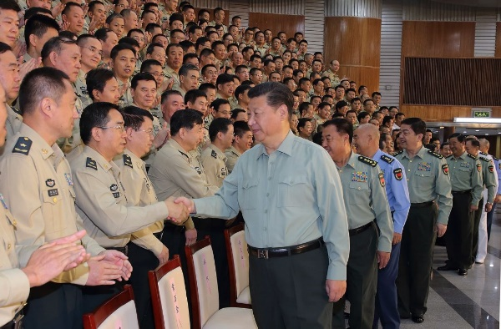
Chinese leader Xi Jinping shakes hands with officers during his inspection of the PLA's Rocket Force in Beijing on September 26, 2016.
Li Gang/XinhuaGetty Images

Hotbed for corruption

Among the nine PLA officials expelled from the legislature, five are linked to the Rocket Force.
The most notable was Gen. Li Yuchao, who was abruptly replaced as commander in July along with his political commissar. Li’s predecessor and two former deputy commanders were also on the list, as well as an official in charge of the force’s equipment procurement.
Three more of the ousted were also involved in arms procurement – two hailed from the PLA’s Equipment Development Department, while the other oversaw equipment for the PLA Navy’s South Sea Fleet before becoming its commander.
The remaining general dismissed from the legislature was a former commander of the PLA Air Force.
“By the affiliation of these nine personnel … we can more or less presume that corruption is the main cause behind the investigations into their wrongdoing,” Char said.
The ouster of the nine came just two days after three aerospace executives from China’s military-industrial complex were stripped of their roles in the country’s top political advisory body.
The move against the three executives, who hailed from state-owned defense contractors that manufacture arms and missiles, is seen by some analysts as further indication of a corruption probe into military procurement for the Rocket Force – a highly secretive and lucrative field flushed with billions of dollars of funding that makes a fertile ground for graft.
“The PLA Rocket Force has been invested with a lot of expensive equipment since 2016,” Char said, referring to the time of Xi’s wide-ranging reforms of the military.
As part of that ambitious overhaul, the Rocket Force was upgraded into a full armed service from the former Second Artillery Corps. Since then, it has rolled out an unprecedented expansion, adding powerful new intercontinental and intermediate-range ballistic missiles to its arsenal and boosting the number of missile brigades from 29 to 40.
“Clearly, with this increase in the size of the PLA Rocket Force, the amount of equipment and investment that the PLA has poured into the service is immense,” Char said.
In the past few years, satellite photos have shown the construction of what appears to be hundreds of silos for intercontinental ballistic missiles in Chinese deserts, and the US Defense Department predicts China could have some 1,500 nuclear warheads by 2035 if it continues to expand the stockpile at its current exponential pace.
In September, CNN also revealed how China, alongside Russia and the United States, have all built new facilities and dug new tunnels at their nuclear test sites in recent years.
“Xi has placed great importance on those developments and that attention may have exposed the level of corruption that generated a clean-up effort that had the added benefit of undermining patronage networks that may infringe on Xi’s plans and power,” said Carl Schuster, a former director of operations at the US Pacific Command’s Joint Intelligence Center.
“Xi wants qualified people whose loyalty and judgement he trusts.”
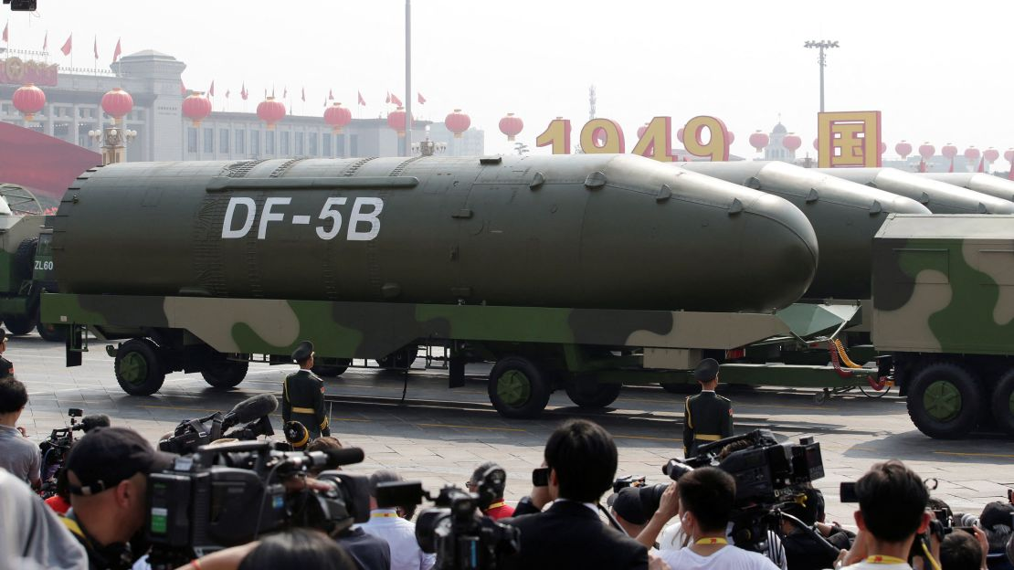
Military vehicles carrying DF-5B intercontinental ballistic missiles travel past Tiananmen Square during a military parade marking the 70th founding anniversary of People's Republic of China held in Beijing in 2019. Jason Lee/Reuters/File

Implications on combat

The Rocket Force will play a key role in any conflict over Taiwan or the South China Sea – two potential flashpoints between the US and China – by leading the first strikes on enemy forces and deterring US intervention, according to Schuster.
Given the strategic importance of the force, a key question is whether the far-reaching purge would gut its operations or combat readiness.
So far, Xi has left the operational-level commanders and staff untouched, Schuster noted.
“The senior leaders were involved in building the force but, at this point, not likely to have been involved in operations and planning,” he said.
While the wide-scale purge is sure to dent morale in the Rocket Force and bring it under tighter scrutiny, Char said overall “the PLA’s combat capabilities have unlikely been compromised to any substantial extent.”
As part of Xi’s military overhaul, “the Rocket force assets have in fact become more and more integrated into the PLA’s joint theater command system. So, that means the PLA’s ability to conduct missile strikes, as part of a larger joint campaign, will unlikely be compromised,” he added.
Amid flaring geopolitical tensions, experts say in the long run, it’s crucial for Xi to clean up the rot within the PLA, especially around its weapon systems.
If the purges result in a more disciplined, effective and personally loyal fighting force – it could prove a win for Xi.
The poor performance of Russia’s military in its war with Ukraine – from substandard equipment to expired ration packs and deadly tank weaknesses – has served as a stark lesson for Xi and his top generals about the perils of corruption.
“The cleaning up is important because going forward, he would want to ensure the PLA Rocket Force has functioning lethal equipment that works on a battlefield,” Char said.

‘Tip of the iceberg’

Signs of problems around arms procurement were already apparent in July.
Days before the Rocket Force’s surprise leadership shakeup, the Equipment Development Department ordered a fresh crackdown on corrupt procurement practices, calling on the public to report tips on questionable activities dating back to October 2017.
The probe overlapped with the period when the department was headed by Li Shangfu, the former defense minister who was removed from his post in October after vanishing from public view for months without explanation.
One of Li’s deputies in the equipment department, Zhang Yulin, was among the nine dismissed from the legislature last week.
“(Now) that they have been stripped of their NPC membership, their cases can move on to the next stage, which is the military indictment process,” Char said, adding that the purge is far from over.
“I’m sure there are more generals whose actions have been investigated. It seems to be just the tip of the iceberg.”
Some officers placed under investigation may not be senior enough to hold seats in the legislature, while others may have already retired.
High on analysts’ watchlist is former Defense Minister Wei Fenghe, who has not been heard from since last March, when he retired and handed the baton to Li Shangfu. Wei was the inaugural commander of the Rocket Force when it was revamped at the end of 2015.
When asked about Wei’s whereabouts in August, a spokesman for China’s Defense Ministry said the military has “zero tolerance for corruption” and vowed to “investigate every case and crack down on every corrupt official.”
Gen. Ju Qiansheng, the commander of the PLA’s Strategic Support Force responsible for space and cyber warfare, has also not been seen since the summer.
Ju raised eyebrows after missing a reception in late July to celebrate the 96th anniversary of the PLA’s founding and a reward ceremony for Chinese astronauts in September.
More than a decade since Xi assumed office, China’s most powerful and authoritarian leader in decades is still battling corrupt and disloyal generals and officers – some of them handpicked and promoted by him.
“I think he can remove anyone he wants. But the very fact that he is still removing people says a lot about his poor judgment previously with regards to these personnel appointments,” Char said.
“Everything that we’re seeing right now, all the purges, is really all down to China’s one-party centralized system and the fact that there’s no public scrutiny that the PLA is subjected to.”
Yun Sun, director of the China program at the Stimson Center think tank in Washington, said the purges show that corruption cannot be completely eradicated from the system despite Xi’s relentless efforts.
“Power tends to corrupt. Absolute power corrupts absolutely,” she said. “Xi’s determined to fight corruption, but corruption is a product of the system he is defending. It is a Catch-22.”
==========================================================
Xi Jinping Purges Military Following Reports Of Missiles Filled With Water Instead Of Fuel

Story by Bibhu Pattnaik , Benzinga, January 6 2024

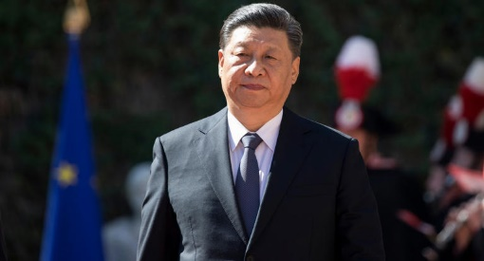

Xi Jinping Purges Military Following Reports Of Missiles Filled With Water Instead Of Fuel© Provided by Benzinga
U.S. intelligence sources recently disclosed that Chinese President Xi Jinping initiated a significant military purge due to concerns about rampant corruption undermining the country's military strength and jeopardizing its ability to wage war.
What Happened: The corruption reportedly extends to China's Rocket Force and its defense industrial base, with examples ranging from missiles filled with water instead of fuel to malfunctioning missile silos, reported Bloomberg.
Xi Jinping's anti-corruption campaign within the military has resulted in the removal of over a dozen senior defense officials in the past six months, marking one of China's most extensive crackdowns on military corruption.
Interestingly, U.S. assessments suggest that these purges have not weakened Xi's hold on power; rather, they reflect his commitment to improving discipline and eradicating corruption within the military, thereby ensuring China's military readiness in the long term.
The extent of corruption within China's defense sector has raised concerns about its ability to effectively modernize its armed forces.
Xi Jinping had devoted significant resources to transform the military into a modern force by 2027, including elevating the Rocket Force, which plays a pivotal role in any potential invasion of Taiwan.
Corruption within the military has not only set back Xi's modernization goals but also eroded confidence in China's military capabilities, particularly the Rocket Force.
U.S. intelligence sources have highlighted the challenges in verifying these assessments, as the Chinese military does not announce its corruption investigations publicly.
Despite the uncertainties, it is clear that Xi Jinping's anti-corruption drive within the military is continuing, with recent purges and efforts to wage a "war on graft" within the armed forces.
=====================================================
US Intelligence Reveals Why China’s Xi Took A Sledgehammer To His Military

https://dailycaller.com/2024/01/06/us-intelligence-reveals-why-chinas-xi-sledgehammer-his-military/?pnespid=7_l7VSJaP.sA2Ofd.2jkGJGL5x..SJImNeTt2.ZlqhxmSjLakT1dqsVumnUQNBW2p3eF9y0CbQ

By: JAKE SMITH, CONTRIBUTOR TO THE DAILY CALLER // January 06, 2024

U.S. intelligence has revealed why Chinese President Xi Jinping restructured his military cabinet, Bloomberg reported on Saturday.

Xi spent months in 2023 firing more than a dozen of his top military brass in China’s People’s Liberation Army and Rocket Force, some of whom “vanished” in the months leading to their firing or in the months after. Xi did this to root out widespread corruption and graft within his ranks that had greatly weakened China’s military, U.S. intelligence believes, according to people with close knowledge on the matter who spoke to Bloomberg.

Examples include a network of Chinese missile silos that were built so shoddily a missile could not be launched from them, according to Bloomberg. Some missiles couldn’t launch at all because their fuel tanks were filled with water instead. Other examples include “leaking information” to outside actors and conflicts of interest in securing bids for certain companies, according to Bloomberg.

So great is the damage done to the PLA through corruption that Xi is less likely to launch a major military operation in years to come, according to Bloomberg. China’s biggest weakness in this case is its Rocket Force, which was a priority for Xi because it would play a key role in a Taiwan invasion. The National People’s Congress, China’s legislative branch, ousted nine defense officials on Dec. 29, some of whom were in the PLA’s missile or armament corps, according to Bloomberg. China’s legislative advisory fired three state-missile developers days prior.

Chinese former defense minister and Rocket Force commander Gen. Li Shangfu was removed from his position in October; at that point, he had not been seen for months or in the months following. His removal was followed by another Rocket Force Commander’s expulsion in November, according to Bloomberg. It may be the biggest military shakeup in China’s modern history, according to Bloomberg.

Despite the revelation, U.S. intelligence still struggles to understand what is happening behind closed doors in Beijing’s government or what Xi’s plans long-term really are. “We have no real insight into leadership plans and intentions in China at all,” a former senior intelligence official with recent knowledge on the matter told the WSJ in December. The White House National Security Council did not immediately respond to the Daily Caller News Foundation’s request for comment.

