NRA Warns gun owners that their guns will be confiscated.
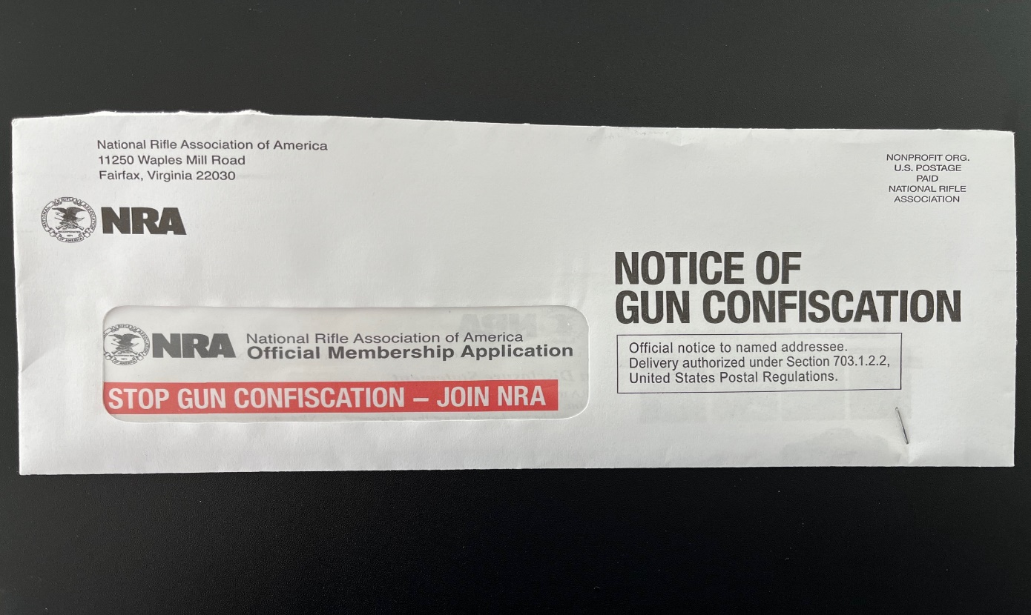
Gun owners were recently reminded to join or renew their NRA annual membership ($45.00) to fight gun confiscation.
Simultaneously, long time NRA CEO Wayne LaPierre is resigning on January 31, 2024 for health reasons. The New York attorney general has been alleged that LaPierre has spent hundreds of thousands of dollars in NRA charitable assets on private plane trips for himself and his family, vacationed several times in the Bahamas on the yacht of an NRA vendor, and accepted other gifts from NRA vendors .
LaPierre has only partially reimbursed the NRA for some of his expense.
With growing gun violence and mass murders, the NRA’s reputation and revenues and membership have plunged. Its influence is diminishing. Revenue in 2022 of $211 million was down 40% from 2018, while membership dues declined by more than half in that period and legal fees skyrocketed.
Gun ownership is still very important to many Americans, including the 20 million owners of AR-15s who believe the 2nd Amendment provides the justification for our guns. Of course, the 2nd Amendment was written in the 1700s when we did not know when the “Red Coats” were coming, and therefore needed to form armed militias to protect our nation.

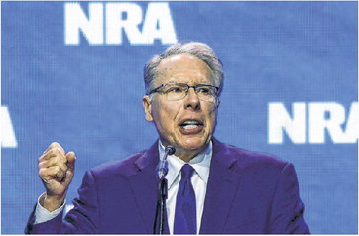 Wayne LaPierre, CEO, National Rifle Association
NRA’s Longtime Leader Will Step Down
BY MARK MAREMONT AND JACOB GERSHMAN, The Wall Street Journal | Page A002, 6 January 2024
Wayne LaPierre, the embattled longtime leader of the National Rifle Association, is resigning from the nation’s largest gun-rights group on the eve of a civil trial in which the New York attorney general is seeking his ouster, as well as financial penalties, for years of alleged corruption at the nonprofit organization. The NRA said LaPierre, 74 years old, cited health as the reason for his decision to step down and said the resignation would be effective Jan. 31.
LaPierre has run the NRA since 1991 and helped turn it into an unflinching force for the expansion of Second Amendment rights, with the ability to mobilize its millions of members against any gun restrictions. Under his leadership, the NRA became a powerful lobbying group, with its endorsements sought by many elected officials, particularly in the Republican Party. A surge in gun-related advertising by the NRA in 2016 is widely credited with aiding the election of Donald Trump as president that year, though the group has faced financial woes in the years since.
The NRA became a major target for gun-control activists, particularly after mass shootings such as those at Sandy Hook Elementary School in Newtown, Conn., and Marjory Stoneman Douglas High School in Parkland, Fla. LaPierre vociferously rejected any attempts to link gun access to such shootings and used the specter of more gun controls to raise money and stir his membership.
LaPierre had fended off earlier efforts to force him out. He survived an internal coup attempt in the 1990s, and in 2019 won a battle with then-NRA President Oliver North, who had pushed LaPierre to resign over allegations that LaPierre used NRA funds for lavish personal expenses.
New York Attorney General Letitia James, who had earlier been investigating the NRA, in 2020 sued the organization, LaPierre and three of his top lieutenants—alleging that they had treated the nonprofit charity as a personal piggy bank under the lax oversight of a compromised board, in violation of state law.
James’s office has alleged LaPierre spent hundreds of thousands of dollars in NRA charitable assets on private plane trips for himself and his family, vacationed several times in the Bahamas on the yacht of an NRA vendor, accepted other gifts from NRA vendors, and arranged lucrative no-show or little-show financial deals with board members and former executives, among other allegations.
LaPierre and the NRA have said the group has embarked on a major “course correction” by terminating certain vendors, promoting a whistleblower to its top financial job, and eliminating virtually all related-party transactions with board members. Since the New York investigation began, LaPierre has repaid the NRA nearly $1 million for some of the private-jet flights, gifts and other “excess benefits” he received, legal filings show.
Amid the corruption allegations, the NRA’s revenues have plunged, its membership is down and its influence has waned. Revenue in 2022 of $211 million was down 40% from 2018, while membership dues declined by more than half in that period and legal fees skyrocketed.
In an NRA statement announcing his resignation, LaPierre said: “I’ve been a card-carrying member of this organization for most of my adult life, and I will never stop supporting the NRA and its fight to defend Second Amendment freedom. My passion for our cause burns as deeply as ever.” An NRA spokesman said, during LaPierre’s tenure, the group’s membership grew from about one million to five million—although it is now down to about 4.2 million— and 27 states have adopted laws allowing people who can legally possess weapons to carry them in public without a special permit.
The NRA said its head of general operations, Andrew Arulanandam, would become interim CEO.
James, a Democrat who as a candidate once called the NRA a terrorist organization, initially sought to dissolve the nonprofit entirely, but the judge overseeing the case threw that out as too extreme a penalty.
The NRA has claimed the civil lawsuit is politically motivated and is retaliation for its political viewpoint. The NRA also is pursuing a separate legal case, now before the U.S. Supreme Court, in which it accuses New York regulators of violating its First Amendment rights by pressuring financial institutions to avoid doing business with the group. New York officials deny the allegations.
The planned six-week civil trial in Manhattan, with opening statements scheduled to start Monday, was expected to decide whether LaPierre and three current or former top NRA officials should have to pay back money to the organization and monetary penalties to the state.
The jury also was expected to recommend whether LaPierre and the NRA’s general counsel, John Frazer, should be expelled from the organization. The attorney general also is seeking a court-appointed monitor to oversee the NRA’s affairs.
LaPierre’s resignation, scheduled to take effect in the middle of the trial, could take some of the steam out of the proceedings.
“LaPierre’s resignation validates our claims against him, but it will not insulate him from accountability,” James said.
Josh Powell, one of the former top NRA officials being sued by the state, settled with the attorney general Friday by paying $100,000 in restitution and admitting he used NRA assets for his own benefit.
The NRA attempted to seek bankruptcy protection and reincorporate in Texas in 2021 but was rejected by a federal judge who ruled that the group was solvent and had filed bankruptcy to seek an unfair advantage in the litigation with the New York attorney general.
“Mr. LaPierre alleges that all of his actions were good faith and reasonable exercises of business judgment intended to further the best interests of the NRA and its mission,” his attorneys said in a recent court filing.
LaPierre’s downfall can be traced, in part, to a falling out with the NRA’s longtime advertising agency, Ackerman McQueen. For years, LaPierre and Ackerman’s top executive were virtually inseparable, and the NRA relied on Ackerman for many tasks, including setting up a cable news-style digital platform, the now-defunct NRATV.
After the NRA, worried about a potential crackdown by James, demanded details on its past bills from Ackerman, the ad agency in 2019 alerted North and other NRA officials about more than $500,000 in personal expenses by LaPierre that had been paid for by Ackerman.
The expenses included $275,000 in clothing purchases that LaPierre allegedly charged to the ad agency from 2004 to 2017, including $39,000 for one day of shopping at a Beverly Hills boutique.
LaPierre has said he needed the clothes to perform his job and that Ackerman had advised him to make the purchases. But in September 2023 he repaid the NRA $251,000 related to wardrobe expenses, court documents show.
The NRA fired Ackerman, and the two entities have since settled a legal dispute over financial matters stemming from the breakup.

