North Korea providing short-range ballistics for Russian use in Ukraine.
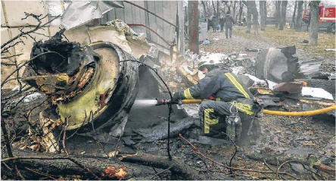
Earlier in January 2024, the Russians used North Korean KN-22 and KN-23 ballistic missiles to strike at locations in Ukraine. North Korea has conducted very few tests of these two missiles, so their true effectiveness needs to be ascertained. Testing of both these missiles by the North Koreans have been very limited, so even the North Koreans cannot have a lot of confidence in the preciseness of their new missiles.
It is possible that the Russians may have provided missile technology to the North Koreans, but there is no official knowledge of any cooperation. There are grounds for suspecting Russian cooperation, if that has resulted in more N. Korea weapons for the Russian “special mission” in Ukraine.
If North Korean missiles have been effective in Ukraine, that will provide future opportunity for the North Koreans to sell similar arms to a number of potential clients in the Middle East, Africa and elsewhere.
These developments will be watched with great interest by many parties.
===========================================
SOURCE:
War Lifts Pyongyang’s Illicit-Arms Trade The Wall Street Journal | Page A008, 19 January 2024
SEOUL—One of the world’s biggest illicit-arms suppliers just got a major advertisement.
In recent weeks, Russian forces have fired short-range ballistic missiles in Ukraine provided by North Korea, according to assessments from Washington, Seoul and Kyiv. Pyongyang has provided Moscow with dozens of the weapons, the U.S. says.
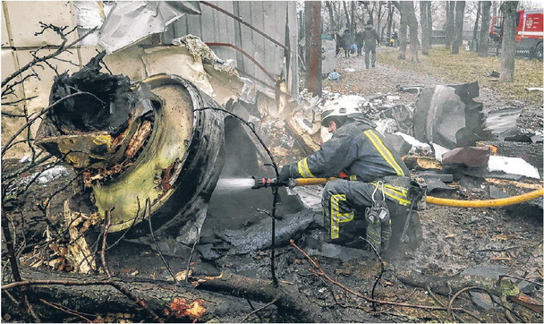
Officials concluded that North Korean weapons were being used by analyzing debris collected in Ukraine. Russia is believed to have used Pyongyang’s new KN-23 and KN-24 short-range missiles, defense experts say. Both countries have denied engaging in arms transfers.
Despite a barrage of test launches, North Korea hasn’t been able to gauge how its new generation of short-range ballistic missiles performs on the battlefield—particularly against Western defenses— until now.
The high-profile battlefield exposure is likely to afford the regime of leader Kim Jong Un new proliferation opportunities, security experts say. The country’s illicit-arms business stretches back decades, though it has trailed off in recent years. Traditional customers in the Middle East, Africa and elsewhere shifted to lower-cost drones, which performed better than Pyongyang’s outdated offerings. Tighter sanctions elevated the risk that shipments en route would get intercepted.
The use of the short-range missiles hands fresh endorsement to North Korea’s weapons sales, as militarization is rising globally and creating new demand from nations without access to legitimate arms sales.
“North Korea will be able to command a premium for these systems in ways it wasn’t before,” said Toby Dalton, senior fellow and co-director of the Nuclear Policy Program at the Carnegie Endowment. “This is the cash cow.”
Kim, the 40-year-old dictator, recently toured the country’s largest munitions factories, ordering officials to ramp up production. An increase in arms sales could provide a much-needed boost for a North Korean economy still recovering from the pandemic.
The country’s precise missile- production capacity is difficult to assess, given the Kim regime’s penchant for secrecy. But North Korea is believed to operate more than 300 munitions factories, including another 100 civilian facilities that can shift to weapons production, according to South Korean estimates.
North Korea does have some advantages over the West, where arms makers have struggled to keep up with the demand created by the Ukraine war. Pyongyang’s weapons manufacturing is state-controlled. Kim can put people to work in factories if he wants to ramp up production.
Pyongyang leans on homegrown producers and illicit networks to feed its missile industry. But it also leans heavily on Russia and a few other allies for certain supplies and technological know-how, said Tushar Sudesh Mangure, a defense analyst at analytics firm GlobalData. To supercharge production further, Russia could provide the raw materials that North Korea struggles to access, he added.
That Russia, a United Nations Security Council permanent member, has used North Korean missiles with apparent success sends some very clear messages to potential customers who may have been on the fence about conducting arms business with the Kim regime, said Darya Dolzikova, a research fellow at the Royal United Services Institute, a London-based defense and security think tank.
One such message is that Russia remains unlikely to interdict any such transactions shipped through its borders or greenlight punishment at the U.N. for buyers, she said. The other is that the North Korean missile systems may be more reliable than previously believed.
“If I were a potential customer of this, the technology is being used by the Russians, possibly improved by the Russians,” Dolzikova said. “I would assume these technologies are going to get better.”
The two countries’ closeness was on full display this week, as North Korean Foreign Minister Choe Son Hui visited Moscow, meeting with her counterpart, Sergei Lavrov, and Russian leader Vladimir Putin. Lavrov expressed gratitude for North Korea’s support for Russia’s fight in Ukraine.
The North Korean missiles used by Russia are far more advanced than the Scud missiles or other munitions exported in the past. The new missiles, based on Soviet designs, use solid propellant, allowing them to be deployed more quickly and covertly, and were unveiled at a splashy military parade about six years ago.
In recent years, North Korea honed the missile’s accuracy and flight maneuverability with frequent tests. The missile can carry a nuclear warhead and change direction midflight. It has a range of roughly 550 miles.
The West has provided Ukraine with many systems to shoot down Russian drones and missiles, but the supply of systems specifically targeting ballistic missiles has been less common. —Alistair MacDonald contributed to this article.

