China Experts skeptical about Chinese military’s ability to take Taiwan.

As our Post Historian has been stating for the past few years, China is not going to invade Taiwan. Now many China experts are also doubting that the People’s Liberation Army is capable of taking Taiwan – especially if the American Military steps up to defend Taiwan.

Also factual, we already have about a thousand Special Force warriors on Taiwan conducting training. The Taiwan combat troops have been, and continue to be, a weak force. Army troops have very little training and what training that is done is very minimal. Until very recently, military training for their Army was 2-4 months. It was recently increased to one year, to demonstrate to the U.S. that they were making more serious efforts to defend their homeland.

The main reason why Beijing is highly unlikely to attack Taiwan is economic. $800 million in two-way trade would be lost if we decide to fight China. The $100-200 million would be roughly the amount meat (pork and chicken), fruits and vegetables purchased from California. Few people realize that China cannot produce enough food to feed 1.4 billion mouths. The Chinese Communist Party (CCP) would be severely criticized if millions of Chinese do not have sufficient food to eat.

Economists have stated that major chain supplies would be severely disrupted if the U.S. and China go to war. Stock markets, including the Chinese stock market, would collapse. By initiating a major war, the Chinese would be blamed for the catastrophe.

At the 2023 APEC meeting, Chinese President said that China would not attack Taiwan in the coming years.

We now know that Xi knew that he would be firing more than a dozen PLA generals for corruption. The generals included five of the senior officers in their Rocket Force (their Space Force), and the Commander of the Chinese Air Force. This type of decapitation of senior general officers, in critical military organizations, will take years to replace with competent officers - perhaps as long as a decade. It is also highly likely that many mid-level officers (colonels) were involved, so the impact on the PLA is significant.

Xi Jinping was quite cordial at APEC 2023, agreeing to control Fentanyl precursor chemicals to be curtailed.

He also offered 50,000 scholarships to American students to study in China in the next 5 years.

Cooperation in scientific research, climate control, food production, and AI consultations were also included.

There were no experts who predicted this type of outcome ahead of APEC 2023.

Our Post Historian, a 50-year China specialist for the Air Force and Department of Defense was also quite surprised at the results of APEC 2023.

==============================================

SOURCE:

China doesn't have the military power to successfully invade Taiwan, the majority of 52 US experts said in a survey
Matthew Loh
Jan 24, 2024, 1:51 AM PST

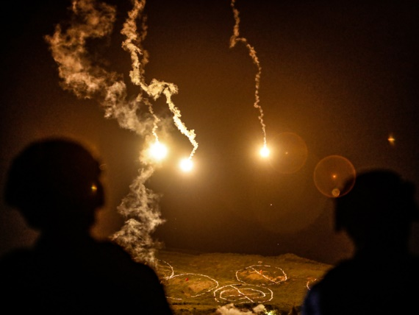
Taiwanese soldiers stand guard as flares are fired during a military live-fire drill in Pingtung, Taiwan, in September 2022.Ceng Shou Yi/NurPhoto via Getty Images

- A think tank surveyed 52 US experts on whether they thought China could successfully invade Taiwan.
- Only 27% said they thought Beijing could pull off a successful amphibious assault.
- Their belief that the US would intervene in an invasion may have led to their answers.

A new survey of leading experts from the US and Taiwan casts doubt on China's ability to invade Taiwan with its current military strength.
The survey, released on Monday by the Center for Strategic and International Studies, gathered opinions from 52 US experts in November and December last year.
These included people with extensive experience in the US government, academics, and think-tank experts who had testified in Congress before, the center said.
And only 27% of them said they strongly or somewhat agreed the People's Liberation Army had the might to pull off an amphibious invasion, per the report.
A deciding factor for many of these experts could have been the belief that the US military would directly intervene in the event of such an attack.
"An overwhelming 96% of US experts were completely or moderately confident that if China invades Taiwan in the next five years, the US military would intervene to defend Taiwan," the report said.
CSIS also surveyed 35 experts from Taiwan, of whom only 17% said they agreed China had the power to successfully execute an amphibious invasion.
Taiwan can 'never win' a war against China, its ex-president says
The survey came after multiple reports that China had been purging the PLA of corrupt officials, with cases of graft so severe that Beijing's considerations toward any major military action in the next few years may be affected.

Experts said a quarantine or blockade was more likely
When asked whether they thought China could effectively pressure Taiwan through a quarantine or blockade, the majority on both sides shifted in favor of Beijing.
Ninety-one percent of the US experts said they strongly or somewhat agreed China could create a quarantine of Taiwan, restricting the flow of goods in and out of the island through non-military means. Conversely, only 63% of Taiwanese experts said they agreed China was capable of this.
An example of this would be squeezing traffic to Taiwanese ports through a customs-inspections regime, the center said.
China could also impose a military blockade on Taiwan, which 81% of US experts said they agreed Beijing could do, while 60% of the experts from Taiwan concurred.
Both a quarantine and a blockade could escalate into an invasion, with China encircling Taiwan before it launches an assault, the report said.
Most US experts said Washington would intervene if China took either course of restrictive action, with 63% saying they were completely or moderately confident the US would step in during a quarantine and 79% saying they were confident Washington would intervene in the event of a basic blockade.
That confidence wasn't shared by experts in Taiwan. Only 40% of them said they were confident the US would intervene in a quarantine, and 60% said they were confident it would intervene during a basic blockade.

A pessimistic outlook for 2024
The majority of experts were pessimistic about the year ahead for cross-strait relations, with 58% of experts in Taiwan saying a crisis between both governments — such as large-scale military exercises and an escalation of threats from China — was likely or very likely in 2024.
US attitudes were even more negative. Sixty-eight percent of American experts said a crisis was likely to occur.
Taiwan's electing of William Lai Ching-te, its outgoing vice president, as the island's new leader earlier this month has stoked fears that China will double down on its aggression toward Taipei.
Lai is central to the Democratic Progressive Party, which largely campaigns on resisting Beijing. Taiwan's outgoing president, Tsai Ing-wen, has been increasingly hawkish toward China as Beijing, led by Xi Jinping, simultaneously heaped threats of invasion on the island.
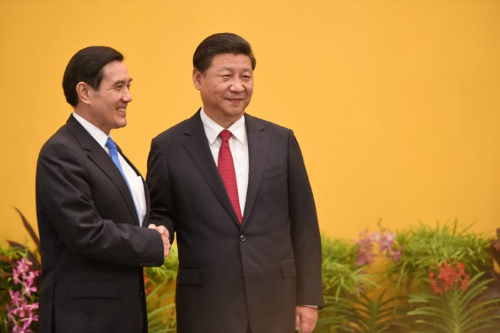
Ma Ying-jeou, Taiwan's former president under the Kuomintang party, met with Xi Jinping in 2015. ROSLAN RAHMAN/AFP via Getty Images
Lai's ascension as Taiwan's top leader is widely seen as a likely source of further conflict, though he has pledged to uphold the status quo. In a sign of the growing tensions ahead, Beijing has been issuing individual rebukes to countries around the world for congratulating Lai on his election victory.

