Air Force Academy graduate fly’s jets and may be the next Miss America
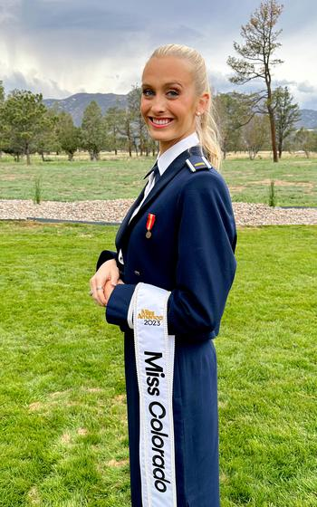
Miss America contest includes an Air Force Academy graduate who champions cancer research
2nd Lieutenant Madison March, when she is not in a jet fighter, is competing in the Miss America contest. Lt March is also attending Harvard Kennedy School and plans to be an astronaut. How high can this super star fly?
============================================================
SOURCE:

Miss America field features Air Force officer who champions cancer research
By JENNIFER H. SVAN, STARS AND STRIPES • January 2, 2024

U.S. Air Force 2nd Lt. Madison Marsh prepares for her familiarization flight at Nellis Air Force Base, Nev., Dec. 19, 2023. Marsh is one of 51 contestants who will compete for the Miss America crown in January. Marsh is believed to be the first Air Force cadet to win a state pageant in the competition, a title she earned days before graduating from the academy last spring. The Arkansas native is working toward a master’s degree in public policy at Harvard. (William R. Lewis/U.S. Air Force)
Madison Marsh was shooting for the stars four years ago when she entered the Air Force Academy, as a cadet with a pilot’s license and the dream of becoming an astronaut.
These days, Marsh is a second lieutenant pursuing graduate studies in public policy at the Harvard Kennedy School through a special Air Force partnership program. Oh, and she’s also a Miss America contestant.
After being named Miss Colorado in May, she became the first active-duty officer to vie for the Miss America crown, an Air Force Academy spokesman said. The competition will be held Jan. 6-14 at Walt Disney World in Orlando, Fla.
“I feel it’s good nerves,” she said. “I’m very excited. “We’ve never had a member of the armed forces win before. I just think it’s a tremendous opportunity.”
As Miss Colorado, Marsh, 22, enjoys talking with young girls about military service and being a pilot, she said. It was during her first year of undergraduate school that Marsh followed in her cousin’s footsteps and decided to compete in pageants.
Cadets struggle to find their identity in a new and challenging environment, she said, and she saw it as a chance to pursue an extracurricular activity that emphasized community service and public speaking.
Through the process, she became equally comfortable in a flight suit or a glittery gown.
While juggling her coursework in physics and astronomy, Marsh prepared for competition by practicing mock interviews and honing her pageant walk and “talent.”
She can’t sing or dance, but a new option allows contestants to do a monologue.
Air Force 2nd Lt. Madison Marsh is one of 51 contestants who will vie for the Miss America crown in January. Marsh is believed to be the first Air Force cadet to win a state pageant in the competition, a title she earned days before graduating from the academy last spring. The Arkansas native is working towards a master’s degree in public policy at Harvard. (Madison Marsh)
Marsh created one about her first solo flight, at age 16. For 90 seconds, she goes through what it’s like in the cockpit, from making radio calls to landing the plane, and talks about how the experience strengthened her leadership skills.
“I really try to captivate the audience by making them feel like they are in the cockpit with me,” she said.
Pageant contestants also must use their platform to promote a community service project. Marsh is advocating for an issue that hits home: pancreatic cancer research and education.
On Nov. 1, 2018, a day after Marsh found out she would attend the academy, her mother, Whitney, died of the disease at the age of 41, just 10 months after her diagnosis.
A high school senior in Fort Smith, Ark., at the time, Marsh didn’t feel like doing much of anything in the weeks following her mother’s death.
“I think I was sitting in the sauna when I started to have this idea: I need to use this bad energy and experience and try to turn it into something positive or I’m going to go crazy,” she said. “And so, I ended up doing a run.”
Whitney Marsh was an avid runner. Even during chemotherapy, she would run 10 miles daily, her daughter said.
In 2019, the family started the Whitney Marsh Foundation to raise money and awareness, with the ultimate goal of finding a cure. The foundation also seeks to provide opportunities for early detection and screening for the disease, which was misdiagnosed for two years in Whitney Marsh’s case.
The foundation hosts an annual 5K and 10K race in Marsh’s hometown and has raised more than $250,000 to date.
The work also changed her career plans. After eight years of thinking she would get a doctorate in astrophysics with the goal of being an astronaut, Marsh switched gears.
She hopes the master’s program in public policy will help teach her to advocate for better federal cancer legislation. She is also working with the Dana Farber Cancer Institute on research into early detection of pancreatic cancer.
“There’s just so many thanks to give, whether or not I win to kind of spread that message in the time that I have left in the organization,” she said.
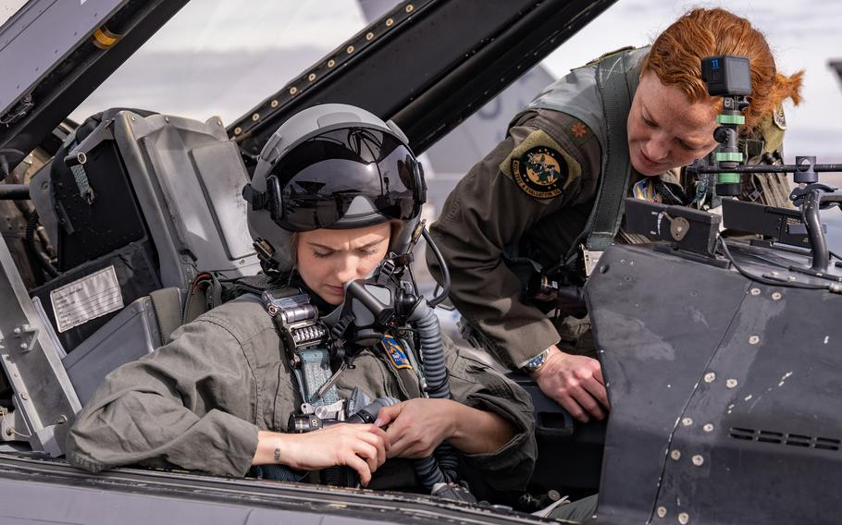
U.S. Air Force 2nd Lt. Madison Marsh, left, gets buckled in for her familiarization flight at Nellis Air Force Base, Nev., Dec. 19, 2023. (William R. Lewis/U.S. Air Force)

