Old Man claims he shot a Russian soldier 12,670 feet away.
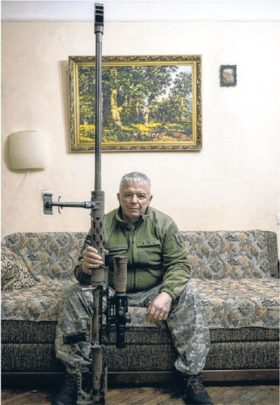
The odds to hit a specific target 12,670 feet away is about a billion to one. It would be more difficult for a strong golfer to sink a hole in one 600 feet away from the cup.
This article was published on the front page of a national newspaper.
Incredible that such a fib was printed to convince the public that this really happened.
============================================================
SOURCE:
Ukrainian Sniper Claims Record Hit of Over 2 Miles
The Wall Street Journal | Page A006, 5 December 2023
KYIV—The Ukrainian sniper had lain still for hours in near-freezing temperatures when the command came to take the shot at a Russian soldier almost 2½ miles away. “You can,” his spotter said, and Vyacheslav Kovalskiy pulled his trigger.
The bullet took around nine seconds to reach its target, who doubled up and fell, according to a video reviewed by The Wall Street Journal. Kovalskiy and Ukraine say the shot set a new sniping distance record, breaking the previously acknowledged mark by more than 850 feet.
While combat hits such as this aren’t verified by a third-party adjudicator, the shot has given Ukraine a morale boost when the country’s forces are struggling to make headway. Sniping has played a prominent role in the war with Russia, where static front lines in a flat landscape suit the discipline, but drones and mines change the way the marksmen operate.
The macabre record was also a shot heard around the world of snipers, a group of highly skilled shooters who have long pushed the boundaries of how far a bullet can travel with accuracy. Some are skeptical that Kovalskiy’s shot was a record.
To hit targets at ever-longer distances, snipers lean heavily on math, calculating a host of technical factors, from the air’s humidity to wind speed, temperature and the curvature of the earth. They also need a good rifle and a lot of luck.
On Nov. 18, Kovalskiy was already packing his rifle by the time the bullet reached its destination and a member of his team shouted that it was a hit. The shot was filmed and on reviewing the footage later, Kovalskiy and other snipers concluded it had been deadly.
“I was thinking that Russians would now know that is what Ukrainians are capable of,” said Kovalskiy, who hasn’t previously been named or spoken to the media. “Let them sit at home and be afraid.”
Several snipers and ballistics experts contacted by the Journal said that while the shot is possible with the equipment described, it would be hard to execute given the uncontrollable variables, not least the weather, that would have to be taken into account.
“For conventional sniping, there are so many variables that are hard to quantify, so the reality is anything over about 1,300 meters (roughly 4,300 feet) can be more luck than skill,” said Steve Walsh, a former U.S. Marines sniper instructor.
Kovalskiy’s shot hit around 12,470 feet, about a third longer than the Golden Gate Bridge. That distance would break a record of 11,600 feet set in 2017 by a member of the Canadian Special Forces in Iraq.
The 58-year-old former businessman’s journey to martial mythology started just before daybreak on Nov. 18, when he and his spotter, a partner who calculates distance, wind speed and other variables, set up positions across the river from a Russian military base in eastern Ukraine. The men, who are part of a military counterintelligence division of the Security Service of Ukraine, observed groups of Russian soldiers cutting wood. They considered these men’s ranks too low to shoot. Later, five soldiers appeared and Kovalskiy noticed one instructing. He had his officer.
The spotter set to work. He used a laser to measure the distance to the soldiers. Using specialist software and meteorological data he concluded that there was a strong wind that would move the bullet about 200 feet from its trajectory. He calculated humidity and temperature, which affects how fast the bullet travels. Even the spin and curvature of the earth has to be factored in. By the time the bullet gets to its set distance, the target has shifted with the earth’s rotation.
Kovalskiy tested a shot about 1,000 feet to the side of the target. It was a miss, the spotter told him. They had gotten the wind speed wrong. He reset, reloaded and aimed. “You have to [shoot] immediately because the wind changes constantly,” he said.
Kovalskiy and his spotter wonder why there is so much skepticism about a shot of this distance when targets have been achieved at these lengths several times in competitions.
Kovalskiy and his spotter say they have no regrets about killing Russians. Despite his age, he signed up as a sniper early in the war. “It doesn’t worry me a gram,” he said.

