Scientists who have studied apes for years have discovered that Chimpanzees are more humanlike and while the group called “bonobos” cooperate within families and get along with other bonobo families without conflict.

Do not be shocked but monkeys don’t just monkey around. A group known as the Bonobos are very sociable and usually behave much as they would in a single group. They groomed each one another, shared food and cooperated to chase away snakes.

When confronted with violent situations, Bonobos will defuse conflict with sex, a strategy that primatologists have not observed among chimpanzees. The more violent species of apes would sometimes even formed an alliance to harass a bonobos. BOO!

===============================================

SOURCE:

Scientists Find First Evidence That Groups of Apes Cooperate
Some bonobos are challenging the notion that humans are the only primates capable of group-to-group alliances.

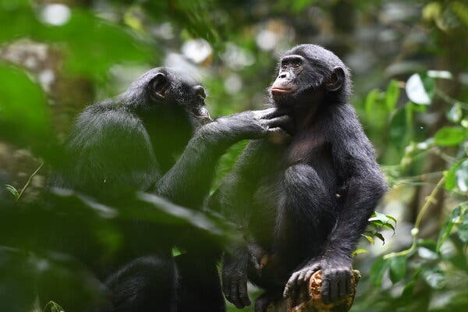

A female adult bonobo groomed an adolescent male from a neighboring group in the Kokolopori Bonobo Reserve in the Democratic Republic of Congo.Credit...Martin Surbeck/Kokolopori Bonobo Research Project

By Carl Zimmer, New York Times, Nov. 16, 2023
If a troop of baboons encounters another troop on the savanna, they may keep a respectful distance or they may get into a fight. But human groups often do something else: They cooperate.
Tribes of hunter-gatherers regularly come together for communal hunts or to form large-scale alliances. Villages and towns give rise to nations. Networks of trade span the planet.
Human cooperation is so striking that anthropologists have long considered it a hallmark of our species. They have speculated that it emerged thanks to the evolution of our powerful brains, which enable us to use language, establish cultural traditions and perform other complex behaviors.
But a new study, published in Science on Thursday, throws that uniqueness into doubt. It turns out that two groups of apes in Africa have regularly mingled and cooperated with each other for years.
“To have extended, friendly, cooperative relationships between members of other groups who have no kinship ties is really quite extraordinary,” said Joan Silk, a primatologist at Arizona State University who was not involved in the study.
The new research comes from long-term observations of bonobos, an ape species that lives in the forests of the Democratic Republic of Congo. A century ago, primatologists thought bonobos were a slender subspecies of chimpanzee. But the two species are genetically distinct and behave in some remarkably different ways.
Among chimpanzees, males hold a dominant place in society. They can be extremely violent, even killing babies. In bonobo groups, however, females dominate, and males have never been observed to commit infanticide. Bonobos often defuse conflict with sex, a strategy that primatologists have not observed among chimpanzees.
Scientists made most of their early observations of bonobos in zoos. But in recent years they’ve conducted long-term studies of the apes in the wild.
Martin Surbeck, a behavioral ecologist at Harvard, in 2016 set up a new observational site in the Kokolopori Bonobo Reserve in the Democratic Republic of Congo. Working with the Mongandu people who live in neighboring villages, he set out on hikes through the forests in search of bonobos.

On their first scouting trip, Dr. Surbeck was shocked to see what happened when the bonobo group they were following encountered another one. After some excited hooting, the apes settled down into a friendly gathering.

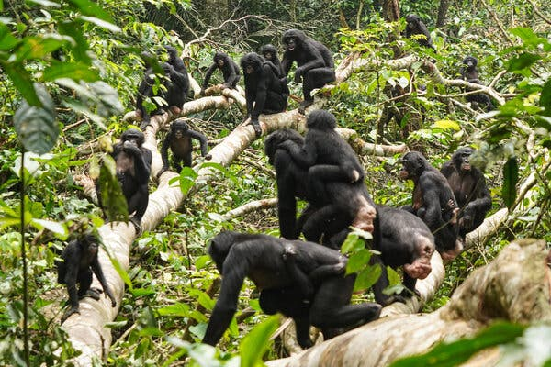
A peaceful encounter among bonobo groups in the Kokolopori Bonobo Reserve.Credit...Liran Samuni/Kokolopori Bonobo Research Project
The encounter couldn’t have been more different than what happens between chimpanzee groups. Male chimpanzees typically patrol the boundaries of their ranges, ready to battle males from other groups. They will even climb hilltops to scan the horizon for other groups.
“I just felt very privileged to witness this encounter,” Dr. Surbeck recalled.
After that, Dr. Surbeck and his colleagues came to know the two groups of bonobos very well. They called one group, with 11 adults, Ekalakala. The other group, with 20 adults, came to be known as Kokoalongo.
He and his colleagues observed 95 encounters between the two groups over the course of two years. Some lasted less than an hour, but others lasted days. Once, the Ekalakala and Kokoalongo groups lingered for two weeks before parting ways.
During these mixers, the bonobos behaved much as they would in a single group. They groomed one another, shared food and cooperated to chase away snakes.
Yet the two groups remained distinct. The scientists found no evidence of any offspring from Ekalakala and Kokoalongo apes. The two groups even maintained their own cultures. Although their ranges overlapped, they hunted for different kinds of game. Ekalakala bonobos went after small deer-like mammals called duikers. Kokoalongo bonobos caught squirrels.
Liran Samuni, an expert on chimpanzees at the German Primate Center in Göttingen who joined the Kokolopori research, said that the cooperation between the groups was not just the result of bonobos being friendly in general. “It’s not just random,” she said.
Dr. Samuni and her colleagues found that individual apes from the different groups gradually formed bonds as they offered favors and gifts back and forth. In some cases, two apes from the different groups even formed an alliance to harass a third bonobo.
Dr. Silk hoped that the new research would encourage similar studies elsewhere to see just how widespread this cooperation really is among bonobos. “You always want to see things happening over and over in different populations before you’re really convinced of how important this feature is,” she said.
Those observations may not come any time soon. It’s hard to establish bonobo research sites, and not only because the apes live deep in rainforests. Scientists also have to contend with the internal conflicts in the Democratic Republic of Congo. And bonobos, which may number only 15,000 individuals, are threatened by logging and poaching.
Dr. Samuni noted that chimpanzees, with their hostile encounters, are just as closely related to us as bonobos are. Our species resembles both lineages, in different respects. While human groups can cooperate in remarkable ways, they can also organize themselves to fight.
“I wouldn’t say it’s either-or,” Dr. Samuni said. “They are jointly teaching us about our past.”

