The Internet is getting really Fast.
In October 2023 China announced her 1.2 terabit/second (Tbps) internet capability which shocked the world.
Then in November 2023, the Department of Energy announced its Energy Sciences Network (Esnet) has been upgraded to ESnet6, capable of a 46 Terabits per second. However, this network is for research purposes only.
But that is not the fastest network in the world. Japan holds the fastest system operating at Petabit per second (Pbps), which is 1,000 Tbps. This tool is in research mode and is not yet available for commercial applications.
This type of processing capability merged with AI systems and Quantum computers will change the world at unbelievable momentum.
===============================================
SOURCES:
China launches world’s fastest internet with 1.2 terabit per second link, years ahead of forecasts
Network can send the equivalent of 150 films per second, 3 times’ faster than nearest rival in the US and 2 years earlier than industry forecasts.
Zhang Tong, South China Morning Post, November 14, 2023
China launches world’s fastest internet with 1.2 terabit per second link, years ahead of forecasts
Network can send the equivalent of 150 films per second, three times faster than nearest rival in the US and two years earlier than industry forecasts
3,000km of optical fibre links Beijing-Wuhan-Guangzhou as decade-long infrastructure plan nears completion
China has beaten a global deadline, launching the world’s first next-generation internet service – more than 10 times faster than existing major routes – two years ahead of industry predictions.
The backbone network – so called because it forms a principal data route between cities – can transmit data at 1.2 terabits (1,200 gigabits) per second between Beijing in the north, central China’s Wuhan and Guangzhou in the southern province of Guangdong.
The line, which spans more than 3,000km (1,860 miles) of optical fiber cabling, was activated in July and officially launched on Monday, after performing reliably and passing all operational tests.
==========================================================
TELECOMMUNICATIONS
World's fastest internet network upgraded to staggering 46 Terabit/s
By Michael Irving, News Atlas, October 11, 2022
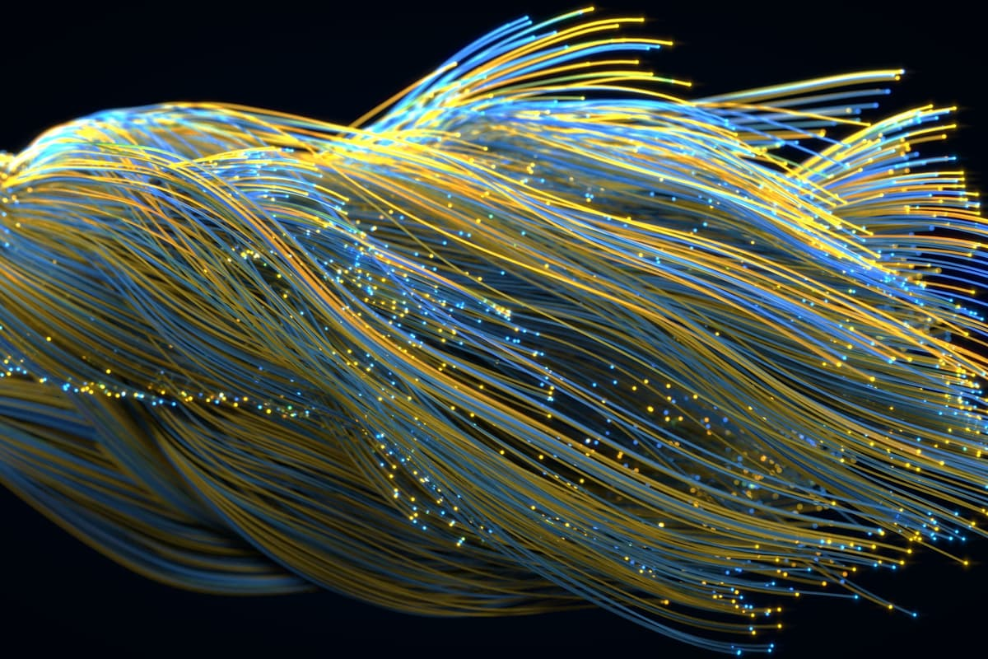
The US Department of Energy has unveiled ESnet6, the next generation of its high-speed science internet networkDepositphotos
The fastest internet network in the US just got a bit faster. The Energy Sciences Network (Esnet) has been upgraded to ESnet6, boasting a blistering bandwidth of 46 Terabits per second (Tbps). But don’t warm up your downloading fingers just yet – it’s strictly scientists only.
The original ESnet was established in 1986 to help connect scientists at various Department of Energy (DOE) labs around the US, allowing them to quickly share huge amounts of raw data. In the decades since, it’s had many upgrades to keep pace with the advances in technology and the sheer amount of data generated by scientific experiments. In 2021, a staggering 1.1 exabytes of data was transmitted over the network.
TECHNOLOGY
Solid-state micro-speakers bring the low end to ANC earbuds
And now comes the next generational leap. ESnet6 is made up of 15,000 miles (24,000 km) of dedicated fiber optic cables spanning the country, enabling network backbone links that can each transfer data between 400 Gigabits per second (Gbps) and 1 Tbps. It was already the fastest internet network in the world, but now it just solidifies that lead with a bandwidth of up to 46 Tbps. Intriguingly though, this isn't a record data transmission speed – that honor belongs to an experimental setup in Japan, which achieved a mind-boggling 1 Petabit per second (Pbps), which is 1,000 Tbps.
For comparison’s sake, you’re probably getting by on a few hundred Megabits per second (Mbps), while ESnet6 is equivalent to 46 million Mbps. If you’re one of the incredibly lucky few on a 10 Gbps fiber connection – the fastest internet speed available to consumers – ESnet6 still has you beat 46,000 times over.
Of course, this isn’t just to let scientists download all of Netflix to watch while they’re waiting for their cell cultures to grow. ESnet6 is designed to allow scientists to transfer large datasets between teams, instruments and facilities, and it’ll be equipped to help tackle major, data-intensive research areas like climate modeling, genomic studies, telescope observations, physics experiments and quantum information.
Source: Berkeley Lab

