Students from Washington state meet Chinese premier
Several dozen choir students from Tacoma, Washington flew to San Francisco to present a gift to Chinese Premier Xi Jinping and his wife Peng Liyuan.
The presentation of a painting done by the choir from Lincoln High School was part of a program organized by the U.S.-China Youth and Student Exchange Association. Some of these students have already visited China as part of a cultural exchange.
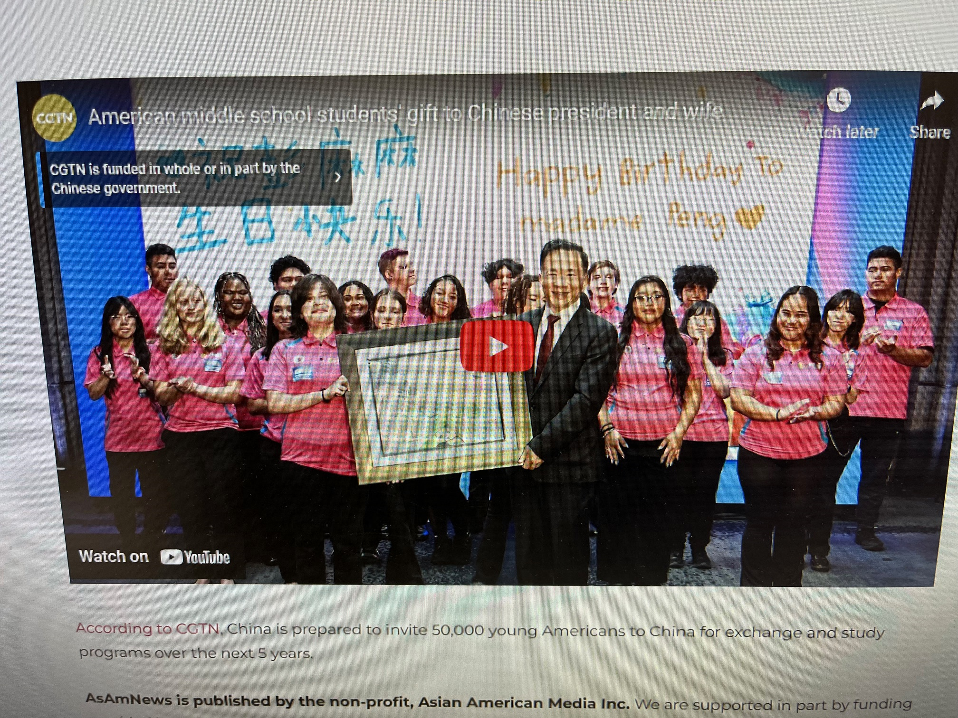
“I just remember how kind and how inviting everyone was everywhere that we went,” said Rigel Bruce Adams. “I met so many people as we toured different schools and they were so wonderful and so different as well.”
The premier himself along with his wife visited Lincoln High in 2015.
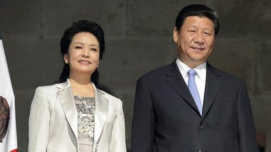
The students also marked Peng’s birthday with a special song.
Reportedly, China is planning to invite 50,000 young Americans to China for exchange and study programs over the next 5 years.
============================================================
SOURCE:

CGTN: People-to-people exchanges: These American teenagers send Xi Jinping and his wife a special gift
PR Newswire, Sun, November 19, 2023 at 8:17 PM PST·2 min read

BEIJING, Nov. 20, 2023 /PRNewswire/ -- A group of high school students from Tacoma, Washington recently sent Chinese President Xi Jinping and his wife Peng Liyuan a special gift as Xi is now in the U.S. for the Asia-Pacific Economic Cooperation (APEC) Economic Leaders' Meeting.
The students from Lincoln High School Choir on Thursday prepared a painting for the Chinese president and his wife, featuring Chinese elements like giant pandas, traditional gateways and elements signifying Washington state including prairie dogs and the Space Needle.
The teenagers also prepared birthday cards for Madame Peng as her birthday is approaching. They also sang her a birthday song.
They offered the gifts through the "Enduring Friendship" event organized jointly by China Media Group (CMG) and the U.S.-China Youth and Student Exchange Association. Head of CMG Shen Haixiong accepted the gift on the Chinese president's behalf.
President Xi and his wife Peng visited the school back in 2015, where Xi said to the students at that time that he hoped young people in both nations can enhance communication and serve as bridges between the two countries.
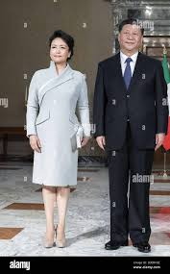
AsAmNews is published by the non-profit, Asian American Media Inc. We are supported in part by funding provided by the State of California, administered by the California State Library in partnership with the California Department of Social Services and the California Commission on Asian and Pacific Islander American Affairs as part of the Stop the Hate program. To report a hate incident or hate crime and get support, go to CA vs Hate.

