RobotTaxi service suspended in San Francisco.

For the right reasons, GM’s Cruise robot taxis are suspended from service due to recent incidents/accidents. Automobile drivers around San Francisco (and all other locations, foreign and domestic) must deal with many situations that require good driving judgment and special concerns for the safety of pedestrians.

If we use the same safety criteria to evaluate human drivers, we would have to suspend the licenses of many drivers.

This is the opinion of our Post Historian who has been driving since his 18th birthday, 62 years ago. He recently purchased a 2023 Toyota Camry SE and after several months, is still learning how to take advantage of all the new capabilities of his car.

One of the best new features is the roof top camera which provides 360 degree view of the situation surrounding him. And the sensors that monitor the camera warns of any approaching object to his vehicle.

The camera discerns human beings and gives a special sound and visual warning that a human being is approaching, or nearby. There is also a sound “beep” warning when other objects, especially other vehicles, get in proximity to his car. This type of situational awareness is a great safety feature, although each driver must respond properly to the warnings that are visually, or audibly provided by the many sensors that are installed.

The unfortunate fact of life is that the greatest threat to pedestrians and other drivers, are drivers with bad driving habits. Almost all accidents are due to human error or unsafe driving habits. Since the pandemic, more people have been killed due to speeding. Many young drivers are also guilty of speeding. Drunk drivers, or drivers under the influence of drugs, are another major cause of accidents. Drivers in a hurry, or driving when emotionally upset, are more likely to cause an accident. Many senior drivers will be eliminated.

Fact is, bad drivers are much more dangerous than robot taxis. And what is relevant is that auto drive, or taxis or the replacement of human drivers, is improving rapidly as sensor technology continues to improve.

Auto drivers will not speed, go through red lights, keep a safe space between vehicles and put the safety of pedestrians first.

That day is not today, but in a year or so, will be a reality.

Auto insurance premiums will decrease dramatically as accidents will be much less frequent. Warning: many auto insurance companies will go out of business, so we can expect these companies to fight against auto drive. Actually the resistance of auto insurance companies to auto drive, proves the potential value of auto drive.

===========================================

SOURCE:

California regulators suspend San Francisco robotaxi service for safety reasons
California regulators have revoked the license of a robotaxi service owned by General Motors after determining its driverless cars that recently began transporting passengers throughout San Francisco are a dangerous menace

By MICHAEL LIEDTKE AP technology writer, October 24, 2023

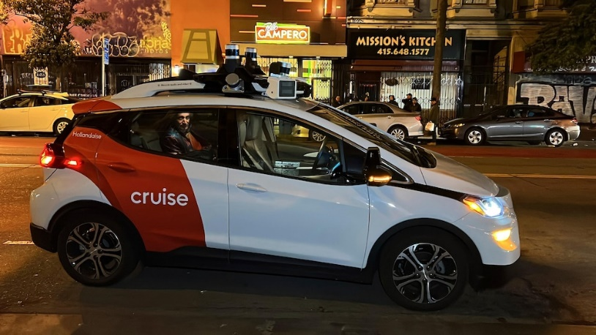

FILE - Associated Press reporter Michael Liedtke sits in the back of a Cruise driverless taxi that picked him up in San Francisco's Mission District, Feb. 15, 2023. California's Department of Motor Vehicles on Tuesday, O...Show more
The Associated Press
SAN FRANCISCO -- California regulators have revoked the license of a robotaxi service owned by General Motors after determining its driverless cars that recently began transporting passengers throughout San Francisco are a dangerous menace.
The California Department of Motor Vehicles' indefinite suspension of the Cruise robotaxi service comes just two months after another state regulator, the Public Utilities Commission, approved an expansion that authorized around-the-clock rides throughout San Francisco — the second most dense city in the U.S.
That approval came over a chorus of protests, including some lodged by police and fire officials who asserted the driverless vehicles had been impeding traffic in emergencies during a testing phase.
Now Cruise is being forced to slam on the brakes on its operations after the DMV concluded its robotaxis posed “an unreasonable risk to public safety,” according to a statement issued by the agency.
The DMV didn't elaborate on the specific reasons for the suspension, but the move comes after a series of incidents that heightened concerns about the hazards and inconveniences caused by Cruise's robotaxis. The worries reached a new level earlier this month after a Cruise robotaxi ran over a pedestrian who had been hit by another vehicle driven by a human, and then pinned the pedestrian under one of its tires after coming to a stop.
In a statement, Cruise confirmed it has ceased its robotaxi operations in San Francisco. It said it is continuing to cooperate with state and federal regulators in their inquiry into the Oct. 2 accident involving a robotaxi named “Panini” and the critically injured pedestrian, who had to be extracted from under the robotaxi with the help of the “jaws of life” before being taken to a local hospital. Cruise said its engineers are examining that accident and working on way for its robotaxis to improve their response “to this kind of extremely rare event.”
During the suspension, Cruise will be able to still operate its vehicles in autonomous mode, but with a human sitting in the driver's seat to take control whenever something goes awry. That's a precaution that has allowed dozens of companies to test autonomous driving technology throughout California for years.
While Cruise has been sidelined in San Francisco, another robotaxi operated by Waymo is continuing to give rides throughout the city. Waymo, which began as as secret project within Google more than a decade ago, has been running another robotaxi service in Phoenix for the past three years. Although its robotaxis haven't been involved in a major accident in San Francisco, Waymo's vehicles also have come to sudden stops that have backed up traffic in the city.
The California suspension is a significant blow to GM and its ambitious goals for Cruise, which the Detroit automaker has predicted will generate $1 billion in revenue by 2025 — a big jump from Cruise’s revenue of $106 million last year when it also lost nearly $2 billion. Cruise also is testing a robotaxi service in Los Angeles, where protests against it already have been percolating, as well as Phoenix and Austin, Texas.
In a conference call held Tuesday before California regulators moved against Cruise, GM CEO Mary Barra hailed Cruise and its autonomous vehicles, or AVs, as a big breakthrough in the future of transportation.
“As Cruise continues to push the boundaries and what AV technology can deliver to society, safety is always at the forefront and this is something they are continuously improving,” Barra said.
But Cruise's robotaxis appeared to be heading in the wrong direction even before Tuesday's abrupt suspension. After a pod of the vehicles came to an abrupt stop and blocked traffic on a Friday night in a popular San Francisco neighborhood less than 48 hours after they received approval to expand operations in the city, civic leaders initiated a move to revoke the Public Utilities Commission decision that allowed Cruise to charge for driverless rides throughout the city.
The problems that cropped up after that expansion began prompted the DMV initially asked Cruise to cut its driverless fleet in San Francisco in half, a request accepted by the company.
San Francisco City Attorney David Chiu applauded the DMV's suspension, while calling on the Public Utilities Commission to reconsider its decision that allowed an “unfettered” expansion. He said the commission needs to “come up with a sensible, measured plan for the future based on safety and performance metrics.”

