North Korean Kim Jong-Un boasts that if their recently launched single spy satellite is disrupted, that would be war and he threatened to destroy all American spy satellites.

Kim Jong-Un continues his bombastic boasting behavior and this time he makes threats, with minimal capabilities to pursue his threat. The United States has hundreds of satellites circulating the earth, not all are spy satellites, that would take hundreds of space-borne weapons to disrupt and destroy.

Mr. Kim, your incompetent threats serve very purpose, so suggest you just shut up and figure out how to feed your starving nation.

============================================

SOURCE:

North Korea threatens to start a war with the U.S. if the US shoots down her on spy satellite.

Story by Matthew Dooley, December 2, 2023
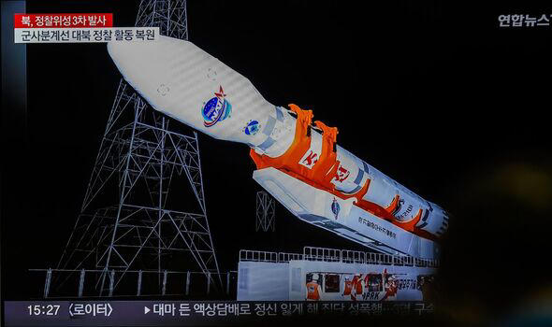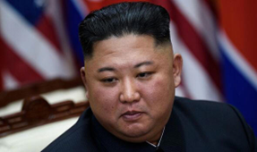
The rocket used to launch the spy satellite.© GETTY Kim Jong-Un.© GETTY

North Korea has warned that any attempt by the US to interfere with its newly launched spy satellite would be considered an act of war.
Pyongyang said any interference would result in the elimination of US spy satellite capabilities, according to state media KCNA which cited a statement from North Korea's defense ministry.
The statement read: "In case the US tries to violate the legitimate territory of a sovereign state by weaponizing the latest technologies illegally and unjustly, the DPRK will consider taking responsive action measures for self-defense to undermine or destroy the viability of the US spy satellites."
DPRK stands for the Democratic People's Republic of Korea - the country's official name. Pyongyang added that any interference would be seen as a declaration of war.
The isolated state said that it successfully launched its first spy satellite on November 21 in violation of a ban on ballistic missile testing.

