Meteorologists are forecasting that this winter is likely to be an El Nino winter. What does that mean?

While no one knows for sure, it appears that we will likely have an El Nino winter with lots of precipitation. There should be more rain or more snow, depending on what part of California you reside. Some weather wizards are forecasting a very strong El Nino winter with lots of precipitation.

Rain is normally a great thing except that this year our reservoirs are already much fuller than they were a year ago. California Gov. Gavin Newsom is planning to build a new state reservoir — the first in nearly half a century — but can’t be done by this winter.

State officials say we must be prepared with flood control measures and watch for risks. If there is heavy rain, the danger of flooding will be even greater than it was last year, when levee breaches caused serious damage on many communities in California.

“There is a lot of flood risk throughout the state,” Gary Lippner, deputy director for flood management and dam safety at the California Department of Water Resources, told reporters last month. He noted that California’s coast in particular did not have extensive flood control systems. Lippner is quite concerned about excess rainfall.

If heavy rains might flood your home, better make your game plan now.

=======================================================

SOURCE:
Winter is on us, and this winter might be a El Nino year.
What does that mean for California?

By Soumya Karlamangla, California Today, November 20, 2023

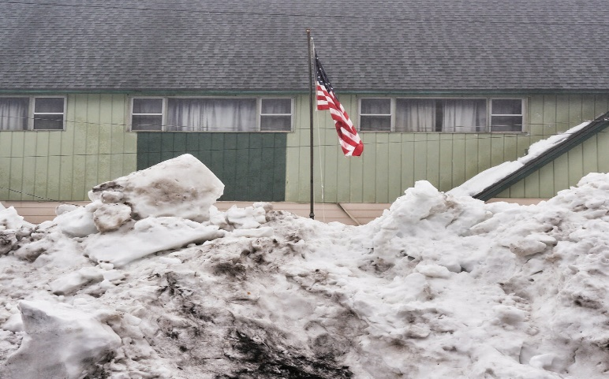
More than 150 inches of snow was reported in areas in California
from snowstorms last winter.
Philip Cheung for The New York Times

Odds are that this winter’s going to be a wet one.

The intermittent climate phenomenon known as El Niño, which typically means more rain and snow for California, developed over the summer and is expected to intensify in the next few months. And this year’s El Niño is predicted to be an exceptionally strong one — maybe even ranking in the top five on record, according to Daniel Swain, a climate scientist at U.C.L.A.
“This is likely to become an event that is historically significant,” Swain told reporters earlier this month. “All of California has elevated odds of a wetter-than-average winter.”

Of course, there are no guarantees. Experts emphasize that not every El Niño period is extra wet in the Golden State, and that the effects of the weather pattern often vary across the state (typically, El Niño’s effects are greater in dry Southern California than in the north).
“We’ve had wet years in California that are not El Niño, like last year,” Alex Hall, the director of the Center for Climate Science at U.C.L.A, told me. “And we’ve had dry years when El Niños are occurring.”

Even so, the deck is stacked in a soggy direction. Between 50 and 70 percent of El Niños since 1950 have led to above-average winter precipitation in California, according to the National Weather Service — meaning that we could be in for a second consecutive rainy winter.
Because of a torrent of atmospheric-river storms that slammed California last winter, the state received 141 percent of its average annual rainfall in the 12 months ended Sept. 30, according to state data. The period ranked as California’s 10th wettest water year since record-keeping began 128 years ago.

Hall told me that California could benefit from another wet winter, which would help return moisture to soil that was parched by years of extreme drought. A year ago, all of the state was experiencing drought conditions; now the figure is less than 5 percent.
“At a minimum, we need an average year,” he said. “It would be nice to get an average year, to keep us feeling very resilient.”

The state won’t be able to capture as much of the rainfall and snowmelt as it did last year, because reservoirs are already much fuller than they were a year ago. This month, Gov. Gavin Newsom fast-tracked a plan to build a new state reservoir — the first in nearly half a century — but it won’t be ready for some time.
State officials say they’re preparing flood control infrastructure and watching for risks. Experts say that if the winter is rainy, the danger of flooding will be even greater than it was last year, when levee breaches wreaked serious damage on communities in California.

“There is a lot of flood risk throughout the state,” Gary Lippner, deputy director for flood management and dam safety at the California Department of Water Resources, told reporters last month. He noted that California’s coast in particular did not have extensive flood control systems. “That keeps me awake a little bit at night, going into an El Niño year,” he said.

