Our Tax funds is being put to work by DARPA, which has developed laser-based technology, which can beam energy from one point to another point.
In this new world without wires, this new type of capability is “Persistent Optical Wireless Energy Relay,” or POWER, which facilitates the transmission of power, wirelessly, and at great distances.
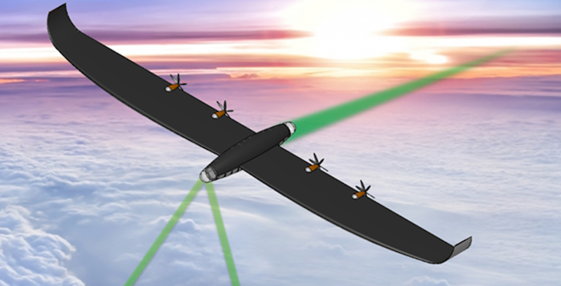 (DARPA)
Aircraft and vehicles can be provided with power giving these systems unlimited range! However, the transmission of power is limited by line of sight. When the technology is fully developed, aircraft could be used to relay energy, thereby making refueling aircraft and ground vehicles, including tanks, extremely valuable.
It appears that we are a few years away from an effective and operational power relay system, but today we need to have electric power to run everything we must plug into an electric socket, as well as charging phones, powering homes and offices, and we must also power electric vehicles so we need the POWER system ASAP.
Both for civilian power requirements and military applications, let’s hope the Defense Advanced Research Projects agency (DARPA) POWER system is ready to serve our entire nation sooner, than later.
===========================================================
SOURCE:
A Major DoD energy project is being developed that will be great back up power in emergencies and also very valuable for military applications.
It was the old Air Force commercials that claimed science fiction is what they do every day, but the latest high technology to come from U.S. military research came from the Department of Defense, or more specifically. The Defense Advanced Research Projects Agency (, DARPA), the U.S. government’s scientific and technological innovation squad, has developed an energy tech that can power machines thousands of miles away.
Power is not only the name of the game, it’s literally the name of this new laser-based technology. DARPA calls it the Persistent Optical Wireless Energy Relay, or POWER. As anyone who pays an electric bill knows, generating electricity will only get us halfway to our goal. The other half, which is just as important and essential, is delivering the power to your home, car, or the things you keep in your top drawer that you hope your parents don’t find.
When it comes to transporting energy, we often have to depend on wires that are a hundred years old. That might have been okay for the turn of the 20th century, but today, we are not just powering lights, phones, and stock tickers, we are charging phones, powering buildings and we definitely need them to power electric vehicles. The availability of efficient power transmission is what keeps the U.S. military looking side-eyed at things like electric cars, tanks, and aircraft.
Enter the Persistent Optical Wireless Energy Relay. We can already transmit and relay numerous different kinds of signals and beams wirelessly to our devices, but the idea of charging devices in this way with any kind of meaningful efficiency has eluded us for years. With the POWER system, DARPA is looking to beam energy from a ground source to a distant receiver. If you haven’t yet figured out what this could mean for the U.S. military, it means it could forever power aircraft and vehicles across vast distances, giving them unlimited range.
For aircraft, this means they could loiter until the pilot couldn’t take it anymore, relieving the need for intricate (and in wartime, dangerous) in-flight refueling situations. For tanks, just imagine what Patton could have done in the days following the breakout from Normandy during World War II, if fuel hadn’t limited the range of the Third Army. The possibilities are endless, but there are a few barriers to making it realistic.
The most pressing barrier is that lasers only work along line of sight, meaning they will need to be able to directly see the target to refuel it. This can’t just be mitigated by air; it would need to have relay stations in the upper atmosphere to minimize any kind of degradation caused by air or water vapor. Also, the vehicles, as with in-flight refueling, will need to stay stable and on-target when charging.

(DARPA photo) © Provided by We Are the Mighty (WATM)
But the POWER system is only in its first phase, which means the technology exists, but it’s in a conceptual stage in designing the devices that will act as relays. The next phase will see DARPA actually put the technology into an existing aircraft before finally (in the third phase) using the POWER system to transmit 10 kilowatts of electricity (enough to power a five-bedroom home) to an aircraft from 125 miles away.
A breakthrough in this kind of technology would not only be good for the military, but it would also have myriad civilian uses, too. Imagine a space-based solar power system capable of beaming electric power from the generator directly to a house, no matter where in the world it is. DARPA was designed to keep the U.S. from being surprised in wartime, but it continually surprises the peacetime world.
The post DARPA is developing laser technology to transfer power all over the world appeared first on We Are The Mighty.
===========================================================
DARPA Wants to Power Distant Military Bases with Laser-Beaming Drones
“This is the internet for energy.”
KYLE MIZOKAMIPUBLISHED: OCT 24, 2022
DARPA power program would use lasers to beam energy from drones.
Lance Cpl. Robert D. Williams Jr., Public domain, via Wikimedia Commons
The Pentagon wants to use a flying chain of drones to beam energy over long distances.
The system would allow forward military bases to become less dependent on diesel fuel for generators.
Laser energy transference, while promising, would also be subject to the same issues affecting lasers in general, like energy loss over distance.
Future U.S. military outposts may no longer rely on convoys delivering diesel fuel for electrical power, but instead a system of drones wirelessly beaming it across the sky.
The Defense Advanced Research Projects Agency’s (DARPA) new Persistent Optical Wireless Energy Relay (POWER) initiative would use lasers to beam electricity across military theaters, saving lives by reducing the number of military convoys required to keep forward bases running. While the system would likely run into the same issues affecting other lasers, it would be a huge advantage for the Pentagon’s expeditionary forces worldwide.
The POWER program will design and implement what the agency calls “airborne optical energy relays.” Uncrewed drones will loiter at altitude, equipped with relays capable of passing on high-powered laser beams.
The system would work like this: a military power station, possibly even nuclear powered, would generate electricity and then turn it into a coherent laser beam. The beam would be aimed at a relay drone, which would in turn beam it farther down the line to another drone. Finally, the last drone would aim it at a military base or outpost where the laser would be converted back into electricity.
“This is the internet for energy,” says Colonel Paul Calhoun, DARPA’s POWER program manager, in the announcement.
In 2009, Wired reported that the U.S. war in Afghanistan used an average of 22 gallons of diesel fuel per soldier each day. In addition to the market price, fuel costs $45 a gallon to haul to the battlefield. “Fuel,” Wired reported, “has to be driven into Afghanistan’s isolated bases. Which opens up U.S. convoy to improvised bomb attacks. Which invariably leads to troops dying.”
A straightforward way of sending electrical power to a military outpost would have several advantages. It would reduce the amount of fuel needed to be trucked to remote bases, removing the cost of transport fees and the risk to drivers. It would remove the need for generators to convert diesel fuel into electricity, eliminating the need for generator maintenance and, as a quality-of-life issue, the constant smell of diesel exhaust.
Such a system would not eliminate the need for all diesel fuel, at least for now. Most U.S. military vehicles, including the replacement for the 1980s-era Humvee, the Joint Light Tactical Vehicle, would still require real diesel fuel. Future vehicles, built with hybrid engines, could require more electricity and less fuel, or even cease using fuel entirely.
Laser-based power transmission would come with some issues inherent to lasers, though. A truck transferring 1,000 gallons of diesel will arrive at its destination with 1,000 gallons of diesel. Lasers, on the other hand, lose coherency over distance, so some loss of energy would be expected. The problem grows worse as the laser passes through smoke, dust, or water particulates. Drone relays would have to stay one step ahead of the weather, avoiding clouds and severe weather. If weather or other issues shut down transmission entirely, on-site battery storage could provide power until it passes.
DARPA believes the biggest challenge is in the conversion process, from electricity to laser and back again as the power hops between drones. “In a multi-hop network, converting from a propagating wave back to electricity and back to propagating wave at each node quickly accrues unacceptable losses. Each one of those conversions is relatively inefficient, and multiplying them across a chain is impractical,” the announcement explains.
The solution, Calhoun says, “is efficient power beaming relays that redirect optical energy transmissions while maximizing beam quality at each point along the way.”
As armies turn to lasers, high-powered microwaves, and other directed-energy weapons, supplying those in the field with electricity will become more important than ever. If successful, DARPA would enable the U.S. military to turn fuel-laden trucks into photons moving at the speed of light, fulfilling a base’s energy needs faster and without endangering troops.
Kyle Mizokami is a writer on defense and security issues and has been at Popular Mechanics since 2015. If it involves explosions or projectiles, he's generally in favor of it. Kyle’s articles have appeared at The Daily Beast, U.S. Naval Institute News, The Diplomat, Foreign Policy, Combat Aircraft Monthly, VICE News, and others. He lives in San Francisco.

