What is China Post #1?

Not many people, including American Legion members, know much about China Post #1. Formed in 1919, by veterans at the American Club in Shanghai. Ironically, Chinese American veterans were not welcomed in the American Legion, and that resulted in Chinese American veterans forming our Cathay Post.

Here is more information on China Post. Our Historian has reached out to their website and invited the current China Post members to visit us here in San Francisco. China Post does not have a permanent home anywhere. When they meet, they meet at different “Watering Holes.”

=================================

Welcome to the China Post #1® Website
China Post 1 is an American Legion post, unique in that, it is a post – the only post within the American Legion – operating in exile. China Post 1 was formed in 1919 at the American Club in Shanghai. During WW II members of China Post 1 were imprisoned by the Japanese in Pootung Civilian Assembly Camp (Prisoner of War Camp) as allies of the Chinese people.
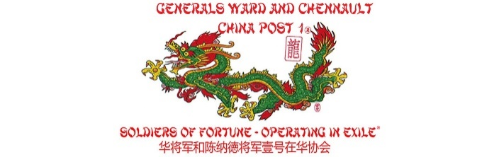
Today, China Post 1 is part of the Department of France and a member of Foreign Departments and Posts of The American Legion (FODPAL). The post still has no permanent home, although “watering holes” around the globe offer a space for meetings, which are considered to occur “wherever two or more members meet.”
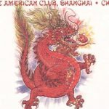
The unique quality of China Post #1 is reflected in the character of its membership. In addition to meeting the qualifications established by the National Constitution of the American Legion, China Post #1 members are usually further distinguished by the character of their service. Post members generally have had a significant career in active service, a meritorious period of duty or of acts while in service, or they have civilian careers or professions after honorable service working in, or in support of operations in the international community.

More History of China Post #1
Post Commanders 1945 to Present
There have only been six China Post 1 Commanders since 1945. To understand the succession of Commanders in China Post 1 between World War II and today, one must understand the dynamic and the environment within which that process was advanced. What gives rise to much of the legend and mystique of China Post is firmly rooted in the nature of the exploits of its members. The vast majority of those adventures will never see the light of day due to Federal Law and iron clad nondisclosure agreements.
Nevertheless, there are those courageous few authors, also members of China Post 1 who dare to walk the tightrope, writing volumes “loosely based” on our members, and giving the uninitiated some insight into the men and women who comprise China Post 1 general membership and who’ve “sacrificed it all” in defense of this nation. One such author is W.E.B. Griffin. Christopher Robbins is another. To grasp the truly unique qualities that constitute the fabric of our leadership, you will have to wait for the Government to declassify their records. Until then, our Post History, will have to suffice.
Having said that, the succession of Commanders of China Post 1 begins in mainland China in 1940, Air Force Colonel Claire Chennault was in mainland China to organize and train the American Volunteer Group (AVG) which would gain world fame as the “Flying Tigers.”
Using tactics devised by Chennault, the AVG amassed record of more than a ten to one aerial kills against the Japanese. Disbanded in July 1942 the AVG was replaced by the China Air Task Force (CATF) still commanded by Chennault; however, by Oct 1942, he had less than 50 flyable fighters. On 10 March 1943, the 14th Air Force – with now Major General Claire Lee Chennault Commanding – was activated.
Between 20 Dec 1941 and V-J Day – the AVG, CATF, and 14th AF lost only 500 aircraft in combat while destroying 2,600 enemy planes plus 1,500 more probables. They sunk and damaged 2,230,000 tons of enemy merchant shipping vessels, 44 naval vessels, 13000 river boats or small tonnages, knocked out over 500 bridges, and killed thousands of ground troops.
As the war drew to a close, General Chennault was recalled to the States and retired from military service. He returned to China where he established a civilian flying operation using surplus C-46 and C-47 aircraft and some of his old flight and line people. What had begun on a shoestring would later be called Civil Air Transport or CAT.
September 19, 1945 the Post was reactivated and General Chennault, now a civilian, became the Chairman of the China Post 1 Executive Committee. General Chennault continued to lead the Post through its post-war reconstitution and frequently hosted events at the American Club in Shanghai attended by world dignitaries.
Civil war erupted in China and by 1948 the situation deteriorated to the point that a meeting of China Post 1 Executive Committee was convened to develop a plan secure the Post’s survival. General Chennault, as Commander, ordered that all Post records be boxed up and forwarded to American Legion National Headquarters in Indianapolis. This was accomplished in November 1948 with the Post going into exile from Shanghai on 22 November 1948.
On 3 August 1949, a meeting was held at the Peninsula Hotel in Kowloon and a set of guidelines were established for keeping the Post alive until it could return to China. General Chennault ordered that Cash Helseth was to be Commander, Adjutant, and Historian and empowered to do whatever was necessary to ensure survival of the Post.
Post Commanders
General Claire Lee Chennault 1945-1949
C.A.S. Helseth 1949 – 1986
J.C. Bond 1987 – 2000
Alfred “Fred” Platt 2000 – 2016
Ronald Burkett 2016 – 2019
Scott Riebel 2019 – 2021
Jeff Carson 2021-Present

