It has evolved to this. Robots will be providing security at schools.
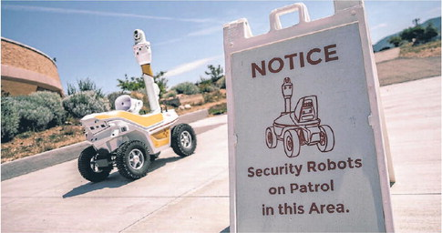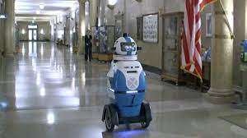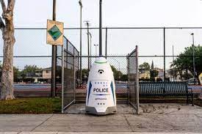
When even our human security staff cannot provide enough security for our school children, we must now use security robots. At least these robots will not stay stationary when an armed suspect is shooting school staff, school teachers and/or school children.
These robots will to be upgraded so that they can perform more complicated functions when a shooter shows up during school hours, which needs more complicated actions when there are school children present.
None of us needed this type of protection when I/you were in school.
Another flag that we are all living in different times.
====================================================
Schools Deploy Robots for Security
BY MEGAN TAGAMI, The Wall Street Journal | Page A005, Saturday, 8 July 2023
When Lori Andrews attended her daughter’s graduation at Santa Fe High School, she spotted a 5-foot-10, 400pound robot roaming the football field alongside the newest alumni.
Andrews, a visual arts teacher at the school, said she initially thought the robot was taking photos of the graduates. She was taken aback when her husband described it as a police robot and she learned that it was providing 360-degree camera footage to the school security team.
“My reaction was, ‘Yuck,’” Andrews said. “What is it filming, what kind of camera is on it?”
The New Mexico school district started a pilot program in mid-June with the robot, which patrols the multi-building campus grounds 24 hours a day, seven days a week.
Amid growing concerns about gun violence and mass shootings in schools, several companies are starting to offer similar robots to schools across the country. Few schools have deployed the machines thus far, primarily for campus surveillance. But they have the potential to do much more, including potentially confronting attackers and others who come onto campuses without permission.
Using artificial intelligence, the robot in Santa Fe learns the school’s normal patterns of activity and detects individuals who are on campus after hours or are displaying aggressive behavior, said Andy Sanchez, who manages sales for Team 1st Technologies, the robot’s distributor in North America.
In the case of an active shooter or other threat, the robot could alert the security team, Sanchez said. It could move toward the intruder and transmit video footage that informs the officers’ course of action, he said. The robot isn’t armed but can confront intruders, and human security team members would be able to speak to the intruder through the robot’s communication system. The school chose to disable the robot’s weapons detection features during the pilot, although the security team is determining whether it might be added at a later time, said Mario Salbidrez, executive director of safety and security at Santa Fe Public Schools.
The robot doesn’t have facial recognition features, and Santa Fe High School owns the robot’s video footage, meaning it can decide whether or not to save it, Sanchez said.
The robot hasn’t yet detected intruders on campus, but it has alerted the security team to new workers entering the school’s construction site and individuals trying to open locked doors in harmless attempts to enter buildings, Salbidrez said. Its cameras have also caught faculty members waving to the cameras and students making peace signs.
Callie Trader, a rising senior at Santa Fe High School, said she is unfazed by additional surveillance on campus. She doesn’t think the robot will change students’ behavior any more than existing security cameras do.
“I think it will just be funnier, just different,” she said.
Other districts are considering robots in a security role. Robert Stokes, co-owner and president of Stokes Robotics, said his company is working with multiple districts across the country. In most cases, schools will use robots in the classroom to teach students about coding, Stokes said. But in the face of an armed intruder, the robot could take more aggressive action, pointing a laser beam at a suspect’s chest or using flashing lights to try to induce them to drop their weapons.
Humans would be responsible for deciding the robot’s course of action in real-time but could remain out of the line of fire in the case of an active shooter, Stokes said.
Brad Wade, superintendent of Wyandotte Public Schools in Oklahoma, said the district hopes to introduce four robots from Stokes Robotics in the fall.
Team 1st Technologies is piloting the robot at Santa Fe High School free of charge for the summer. The cost for the 2023-24 school year is estimated to be around $60,000 to $70,000, Salbidrez said. The school is still determining if the robot is worth the investment, he said.
A security robot patrols Santa Fe High School’s multi-building campus grounds 24 hours a day, seven days a week.

