CHING Wah Lee, (1901-1980) a real Chinese American Hero
Our Post Historian Roger Dong met Ching Wah Lee 60 years ago when Roger was giving tours in San Francisco, Chinatown.
Little did he know that Ching Wah Lee (CWL) was a veteran of WWII, and the Commander, of our American Legion Cathay Post 384 in 1945. Neither was he aware of the many tremendous, unusual, and special contributions CWL made in his life when they met in 1975.
How was Ching Wah Lee so important and unusual?
He was the Co-founder of our Boy Scout Troop 3 (in 1923) and published “Scout Wig Wag” the historical publication of Troop 3.
Lee was the Co-founder of the first English language publication of Chinese Americans known at the Chinese Digest, co-founder of the Chinese Historical Society of America (with Thomas Chinn), served as a leader at the Chinatown YMCA, cofounded the Chinese Cultural Center.
CWL also founded the Vacation Daily Bible school in Chinatown after WWI and several other social organizations in San Francisco including the Chinese Christian Students Association.
CWL graduated in 1928 at UC Berkeley in anthropology.
Ching Wah Lee was a WII veteran who served in the 6th Army Headquarters at the Presidio of Monterey. Sorry, but no additional information is known about his Army service time.
He was our American Legion Post Commander in 1945. Sorry no image located.
Lee opened his own local shop in Chinatown collecting artifacts and giving Chinatown tours to tourists and provided a positive image of Chinese Americans who were cursed with stories of Chinese gangs, Tong wars, and opium dens. CWL was the sole source of any positive information about Chinese Americans during the first half of the 20th Century. He preached that Chinese Americans admired Confucius and Jesus, liked literature, art, festivals, danced to American music and liked Chinese American music and attended theaters like other Americans.
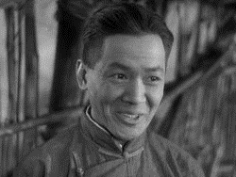
Lee was such an unusual, talented and person that he even became a movie star, featured in “The Good Earth,” “Flower Drum Song,” “China Smith,” “Thirty Seconds over Tokyo,” “Bloody Alley,” and several other movies. He worked with
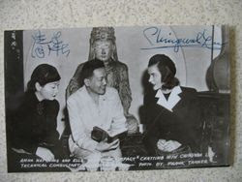
Anna May Wong, Ching Wah Lee and Ella Rains
Anna May Wong (she’s now on our 2022 silver quarters) and Key Luke.
In 1951 he even was part of a TV series, “Number Nine Chinatown Lane.”
While his efforts to project a positive image of Chinese and Chinese culture, he had very limited success, as movie industry made money from stories of the seedy side of the Chinese and Chinese culture in America.
Ching Wah Lee is certainly a true Chinese American Hero for his service to American, the American Legion Cathay Post 384, Boy Scout Troop 3 and several of the Chinese American social and historical organizations he was intimately involved and provided leadership.
Ching Wah Lee died on January 2, 1980 in San Francisco.
Many Thanks to Atha Fong, whose manuscript “Chingwah Lee, San Francisco Chinatown’s Renaissance Man,” provided the guts of this report.
Click here for Atha Fong’s report:

