Someone we must all admire – Mr. Charles Feeney

This is an amazing story - totally unrelated to the American Legion or our AL Cathay Post, that needs to be told about someone really special. Who is that?

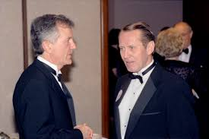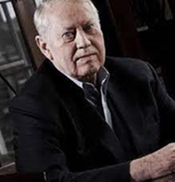

This the story of Mr. Charles Feeney, who was a billionaire and he planned to give away all his money to charities. He did, after he died at 92. Some of his vast fortune was distributed before his death.

Charles Feeney served four years in the Air Force in Japan after WWII, studied hotel management in college and got into the duty-free shopping business by selling liquor, cigarettes and perfume to homeward-bound American servicemen in Europe in the 1950s. The business went global and was a smashing success.

His philanthropic donations were made anonymously. After donating $7 million to his Alma Mater, Cornell University, his remaining wealth of billions of dollars was donated to public-health facilities in Vietnam; the University of Limerick and Trinity College in Ireland; AIDS clinics in South Africa; the Rotary Club’s Operation Smile’s free surgeries for children with cleft lips and palates; a medical campus for the University of California at San Francisco; and earthquake relief in Haiti.

A truly modest man who distained luxury, Feeney always flew economy class, bought his clothing off the rack and did not eat in fancy restaurants. He sold his limousines and took subways or cabs. He donated his money away anonymously, a course followed by only 1 percent of American donors.

Before his death, Feeney confessed “I cannot think of a more personally rewarding and appropriate use of wealth than to give while one is living, to personally devote oneself to meaningful efforts to improve the human condition.”

Charles Feeney, we all salute you, you are a real HERO.

======================================================

SOURCE:

Charles Feeney, Who Made a Fortune and Then Gave It Away, Dies at 92
After piling up billions in business, he pledged to donate almost all of his money to causes before he died. He succeeded, and then lived a more modest life.

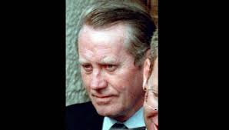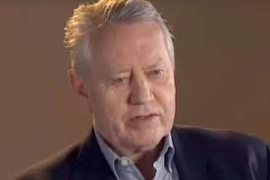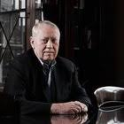

Charles F. Feeney who gave away billions to a number of causes, he reversed an extravagant lifestyle, selling his limousines, flying coach and taking subways and cabs. Credit...Brad Vest/The New York Times

By Robert D. McFadden, New York Times, Published Oct. 9, 2023
Charles F. Feeney, a pioneer of duty-free shops and a shrewd investor in technology start-ups who gave away nearly all of his $8 billion fortune to charity, much of it as quietly as he had made it, died on Monday in San Francisco. He was 92.
His death was announced by the Atlantic Philanthropies, a group of foundations he had started and funded since the early 1980s. He lived in a modest rented apartment in San Francisco.
In December 2016, with his donation of $7 million to his alma mater, Cornell University, for student community-service work, Mr. Feeney officially emptied the Atlantic Philanthropies’ accounts. It also fulfilled his pledge to give away virtually all of his wealth before he died, a rarity in the philanthropic world.
With what he called decent but unextravagant provisions made for his five adult children, Mr. Feeney said he retained about $2 million for himself, a small fraction of the billions he had amassed over six decades in business and given away over 35 years while often going to great lengths to conceal his identity, wealth and philanthropies.
“Chuck Feeney is a remarkable role model, and the ultimate example of giving while living,” his fellow billionaire Bill Gates told Forbes in 2012. Another of the world’s richest people, Warren Buffett, presented a Forbes 400 Lifetime Achievement Award to Mr. Feeney in 2014, calling him “my hero and Bill Gates’s hero — he should be everybody’s hero.”
Unlike philanthropists whose names are publicized, celebrated at banquets and emblazoned on building facades and museum wings, Mr. Feeney gave anonymously to universities, medical institutions, scientific endeavors, human rights groups, peace initiatives and scores of causes intended to improve lives in the United States, Vietnam, South Africa, Australia, Israel, Jordan and other lands.
An Irish American, he was far more open about his giving in Northern Ireland, which he visited frequently. His aid to Sinn Fein, the Irish Republican Army’s political arm, and the Ulster Defense Association, the Protestant loyalist paramilitary group, helped secure the Good Friday Agreement in 1998 after decades of sectarian violence. In 2007, Mr. Feeney was invited to join leaders of the United States, Britain and Ireland at the birth of a power-sharing government in Belfast.
But his name appeared on none of the 1,000 buildings on five continents that he gave $2.7 billion to fund. Grants to institutions and individuals were paid by cashier’s checks to conceal the source. Beneficiaries were told that the money came from a generous “client” who wished to remain anonymous. Those who learned his identity were told not to reveal his involvement.

His philanthropic organizations were incorporated in Bermuda to avoid United States disclosure requirements, although the arrangements disallowed United States tax deductions for his donations.
Image
Mr. Feeney’s was a life of remarkable contrasts. Raised in New Jersey by Roman Catholic working-class parents who struggled during the Depression, he served in the Air Force, studied hotel management in college and got into the duty-free shopping business by selling liquor, cigarettes and perfume to homeward-bound American servicemen in Europe in the 1950s.
The business went global. Profits were enormous. By the early 1980s he was plowing tax-free annual dividends of $35 million into hotels, land deals, retail shops and clothing companies. He later invested in tech start-ups and multiplied his income exponentially. By age 50, he had palatial homes in New York, London, Paris, Honolulu, San Francisco and Aspen, Colo., and on the French Riviera.
But he was troubled by an opulent life of black-tie dinners, grand yachts and values far from those of his family and friends in New Jersey.
“He was beginning to have doubts about his right to have so much money,” Conor O’Clery wrote in a biography of Mr. Feeney, “The Billionaire Who Wasn’t” (2007). “When asked many years later if he was rich at this point in his life, he replied: ‘How much is rich? Beyond all expectations. Beyond all deserving, so to speak. I just reached the conclusion with myself that money, buying boats and all the trimmings didn’t appeal to me.’”
Mr. Feeney reversed his extravagant lifestyle, quitting wealthy social groups, flying economy class, buying his clothing off the rack and giving up fancy restaurants. He sold his limousines and took subways or cabs. He also resolved to give his money away anonymously, a course followed by only 1 percent of American givers, experts say.
“All Feeney’s instincts, instilled in him by the example of his parents, by the sharing culture of his blue-collar upbringing in New Jersey, by his desire not to distance himself from his boyhood neighbors and friends, and by his own innate kindness and concern for others, undoubtedly shaped his decision,” Mr. O’Clery wrote.
It was in 1982 that Mr. Feeney established in Bermuda the foundation that would become Atlantic Philanthropies. In 1984, he transferred to the foundation his 38.75 percent stake in the company he had co-founded, Duty Free Shoppers. Since there was no sale, the company’s value was speculative, but some estimates said it may have exceeded $500 million.
Over the ensuing decades, as his other enterprises and profits also went to the foundation, Mr. Feeney funded public-health facilities in Vietnam; the University of Limerick and Trinity College in Ireland; AIDS clinics in South Africa; Operation Smile’s free surgeries for children with cleft lips and palates; a medical campus for the University of California at San Francisco; and earthquake relief in Haiti. He gave $1 billion to Cornell, including $350 million for an affiliated technology institute in New York City.
His secret identity as a humanitarian benefactor was disclosed in 1997 after he and a partner sold their interest in Duty Free Shoppers to Louis Vuitton Moët Hennessy. Legal filings put the value of his share at $1.6 billion and said it belonged not to Mr. Feeney but to his philanthropic entity in Bermuda, which had been making huge anonymous donations for 15 years.

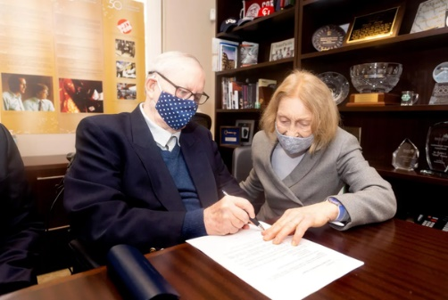

Mr. Feeney with his wife, Helga Feeney, in San Francisco as he dissolved the Atlantic Philanthropies in September 2020.Credit...Noah Berger
Charles Francis Feeney was born in Elizabeth, N.J., on April 23, 1931, to Leo and Madaline Feeney. His father was an insurance underwriter who attended Mass daily. His mother was a nurse who discreetly helped others; each day, she gave a neighbor with Lou Gehrig’s disease a ride to a bus stop, pretending it was on her way to work. Charles and his sisters, Arlene and Ursula, grew up in a household that struggled to pay a $32 monthly mortgage.
Charles had a Catholic education, attending St. Genevieve’s Grammar School in Elizabeth and, on a scholarship, Regis High School on the Upper East Side of Manhattan. Unhappy there, he cheated on an exam, was expelled in his second year and switched to St. Mary of the Assumption High School in Elizabeth, graduating in 1948. He served four years in the Air Force, mostly with American occupation forces in Japan.
He graduated from Cornell’s School of Hotel Administration in 1956 and moved to Europe. In Barcelona, Spain, he met a fellow Cornell alumnus, Robert Miller, and formed a partnership to sell duty-free luxuries to American servicemen on their way back to the states.
As postwar international tourism burgeoned, the demand for duty-free goods, including cars, exploded. Duty Free Shoppers grew into a global enterprise, with shops in airports and major cities across Europe, Asia and the Americas. Mr. Feeney became a multibillionaire.
In 1959, he married Danielle Morali-Daninos, a French citizen, in Paris. After producing five children, the marriage ended in divorce in the 1990s. Mr. Feeney gave all seven of his homes and a large financial settlement to his wife. He later married his longtime assistant, Helga Flaiz.
She survives him, along with his children from his first marriage — his daughters Juliette Feeney-Timsit, Caroleen Feeney, Leslie Feeney Baily and Diane Feeney and his son, Patrick — as well as 16 grandchildren.
In his last decades Mr. Feeney did not own a home or a car, wore a $10 wristwatch, preferred buses to taxis and, until he was 75, flew coach. He and his second wife lived in a two-bedroom rented apartment in San Francisco.
In 2010, Mr. Gates and Mr. Buffett founded the Giving Pledge, whose signatories, including Mr. Feeney, promised to give most of their wealth to charity, though not necessarily in their lifetimes.
With virtually all of his fortune gone, Mr. Feeney officially shut down Atlantic Philanthropies in 2020.
Forbes said that no one of such riches had ever given away a fortune so completely while still alive. But as Mr. Feeney said as he signed on to the pledge: “I cannot think of a more personally rewarding and appropriate use of wealth than to give while one is living, to personally devote oneself to meaningful efforts to improve the human condition.”

