WWII veteran honored with the Purple Heart posthumously
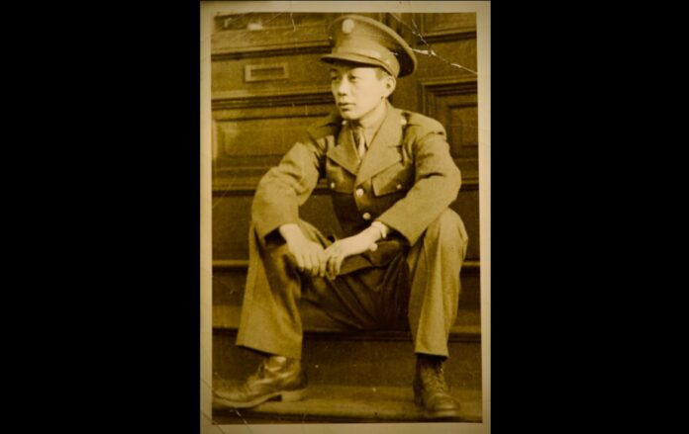
Photo of Private Wing O. Hom of Boston, MA as displayed at the funeral in New York City. Private Hom enlisted in the US Army and was missing in February 2, 1944. // Image via the Hom family
by Shirley L. Ng, AsAmNews Staff Writer, October 12, 2023
Nearly 80 years after World War II, Chinese American veteran Private Wing O. Hom of Boston, MA, was posthumously honored with a Purple Heart. Private Hom went missing during the war, but his remains were recently discovered, giving his family a sense of peace.
A funeral service on Wednesday in New York City’s Chinatown was held for the hero. Private Hom was only 20 years old when he went missing in a “fierce battle near the town of Cisterna di Latina, Italy, ” on February 2, 1944, as described by his nephew Kenneth Hom of New York. Private Hom was a member of Company B, 7th Infantry Regiment, 3rd Infantry Division.
Photo of Private Wing O. Hom of Boston, MA as displayed at the funeral in New York City. Private Hom enlisted in the US Army and was missing in February 2, 1944.
Private Hom was not reported as a prisoner of war nor was his body found. The military declared him deceased in February 1945.
- 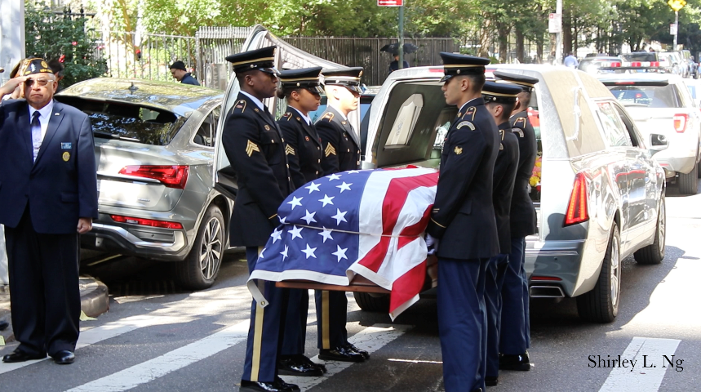 Private Wing O. Hom’s casket is carried out of the funeral home in NYC Chinatown. Photo by: Shirley L. Ng
- 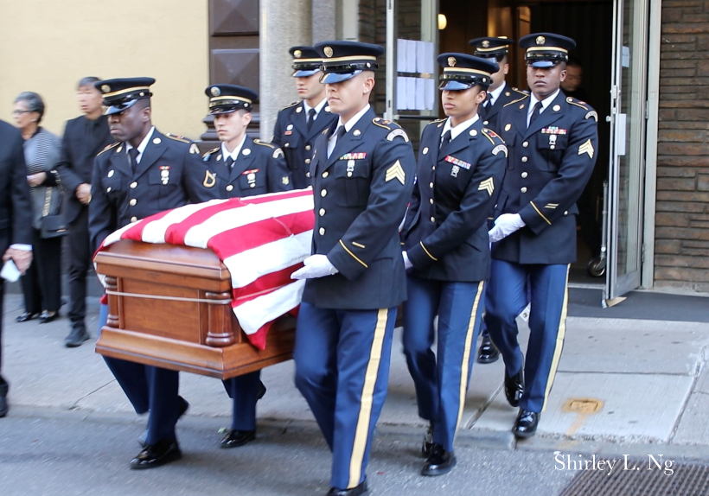 Private Wing O. Hom’s casket is carried out of the funeral home in NYC Chinatown. Photo by: Shirley L. Ng
The private’s nephew Kenneth Hom and his brothers were always curious about their uncle. They had early memories of their mother honoring her brother, Private Hom during Memorial Day, Veteran’s Day and Ching Ming, a Chinese festival also known as “tomb-sweeping,” when families pay their respect with offerings to their ancestors. Kenneth Hom’s parents and grandparents didn’t speak much about him as he felt there was too much pain involved in sharing about his missing uncle.
======================================================

The discovery of Private Hom’s remains was nothing short of a miracle. It began with Kenneth Hom’s simple Instagram post, a 2019 Memorial Day tribute to his uncle. The US Army noticed his post and in October of that same year, and Kenneth Hom was contacted by a genealogy company commissioned by the US Army.
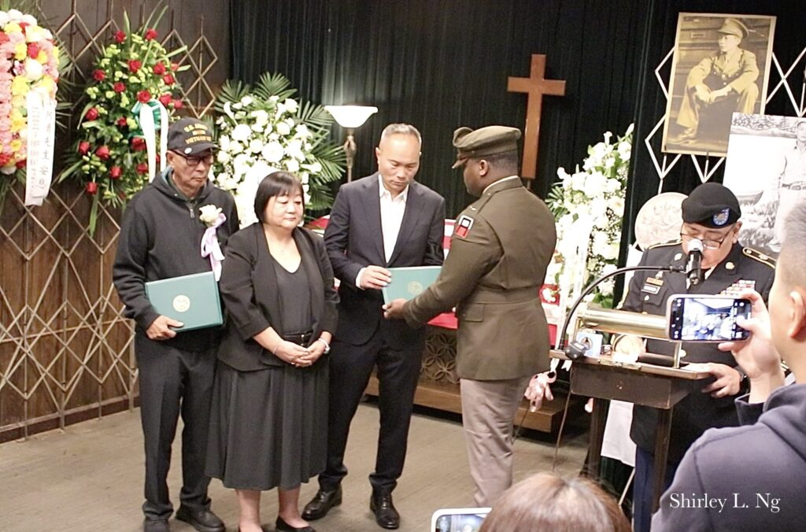T The US Army awards Private Wing. O. Hom The Bronze Medal and The Purple Heart posthumously. Photo by: Shirley L. Ng
“I thought it was a scam,” Kenneth Hom told AsAmNews on how he was contacted by the US Army about his Instagram post for his uncle.
Kenneth’s brother, Gene Hom from San Francisco could not believe how his brother’s Instagram post transpired into a journey of finding their uncle. Gene Hom grew up seeing the portrait of his uncle on the wall and also knew very little about him other than being told he was killed in combat. He described to AsAmNews how it felt to finally bring his uncle home.
“This is great. It let others know that when the Chinese first arrived in the US, they had struggles and tried to get a better life here and also served in the military,” Gene Hom said.
Kenneth Hom said it took a series of telephone calls and emails before he was convinced it was really the US Army that was reaching out to assist in finding his uncle. A few months after, Kenneth Hom received DNA kits to begin the identification process.
“DNA samples were provided in the way of mouth swabs, from me, my aunt and my brothers. A Mitochondrial DNA test matched up with a DNA sample from my uncle’s remains,” Kenneth told AsAmNews.
In an earlier statement, Kenneth Hom said, “This moment is a tribute to his memory and the unwavering dedication of those who ensured his story was not forgotten.”
Grace Lee, Assemblywoman for the 65th district, which includes Chinatown said at the funeral, “Many of the brave Americans lost their lives in defense of our freedoms and at the very least they deserve the recognition and commemorate everything they gave.”
Kenneth Hom registered his uncle for the Congressional Gold Medal for Chinese American WWII Veterans a few years ago and received the Congressional Gold Medal on behalf of his uncle in 2020.
Over 20,000 Chinese Americans served in all branches of the military during WWII. Many enlisted to serve and defend a nation that discriminated through laws like the Chinese Exclusion Act. In November 1943, a few months before Private Hom went missing, the Chinese Exclusion Act was finally repealed, although civil rights were still a struggle to gain for the Chinese in America.
Robert Santiago, Commissioner of The Office of Veterans’ Services announced during the funeral that Private Wing O. Hom’s name will be included in Boston’s Hero Square, an intersection that honors military members who were killed in combat. Private Hom had lived in Boston’s Chinatown when he enlisted in the military.
“It’s a sign with his name with a gold star on it to recognize the Hom Family. It will include a biography plaque so passersby can read about Private Homs’ life. We are working on the resolution and have reserved a spot for the Hom Family. It might happen this year, perhaps around Veteran’s Day,” Santiago told AsAmNews.
“I am so proud to represent the people that is so underrepresented in this matter. It’s beyond my wildest dreams,” Kenneth Hom told AsAmNews.
Several veterans and active military personnel came to pay their respects to Private Wing O. Hom including many members of the local American Legion Lt. Kimlau B.R. Post. 1291 in Chinatown. One by one, the members, mostly veterans and family members of veterans saluted at the casket. Some bowed three times, a Chinese custom to pay respects to others.
Kenneth Hom, his wife Nancy, Hom’s two brothers, and the niece and nephew of Private Hom from California attended the funeral. Assemblyman, Lester Chang and District Council member Christopher Marte were also at the funeral.
Private Hom will lay to rest next to his parents and brother at the Evergreen Cemetery in Brooklyn. The funeral was facilitated by the American Legion Lt. Kimlau B.R. Post 1291.
AsAmNews is published by the non-profit, Asian American Media Inc. Please fill out this 2-minute survey which we will use to improve our content. We are supported in part by funding provided by the State of California, administered by the California State Library in partnership with the California Department of Social Services and the California Commission on Asian and Pacific Islander American Affairs as part of the Stop the Hate program. To report a hate incident or hate crime and get support, go to CA vs Hate.

