WARNING TO HOME INTRUDERS. YOU MAY RUN INTO A TOUGH MILITARY VETERAN.

A few weeks ago, an intruder broke into the home of a senior citizen who took immediate action to protect his ailing wife. This old man was previously a Special Forces veteran who decked the intruder, then used his cane to drive the younger intruder away from his home.

The old veteran did not escape unharmed, as his arms were badly bruised, but the intruder was the loser.

Warning to intruders who think that all seniors are easy targets. You may be surprised!

=============================================

SOURCE: 82-year-old Florida man fights off home invader
By ActionNewsJax.com, News Staff, September 22, 2023

NOW PLAYING ABOVE
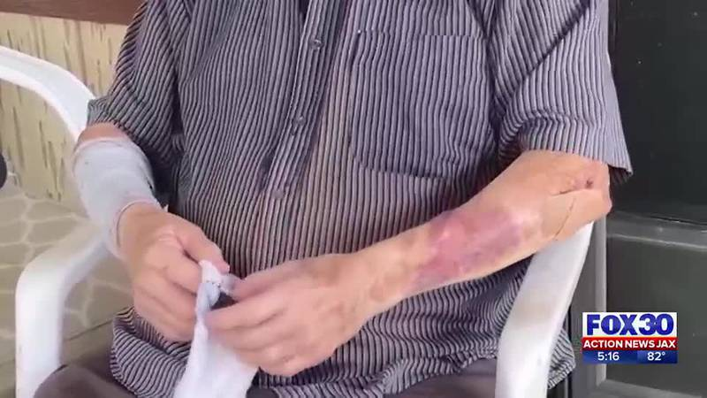

82 Year old bruised military veteran

FORT MYERS, Fla. — An 82-year-old Florida man from Fort Myers fought off a home intruder. He said he had no fear and only acted on instinct.
On Tuesday, in the middle of Suncoast Estates in broad daylight, Ronald Lucas said someone entered his home. He said he faced the intruder head-on.
“As soon as I saw it, my wife had an operation, so I knew I had to get her out,” Lucas explained. “I just got in between them and boy, that was it. That’s when I started taking him out. I had to do it. The old veteran knows how to fight. That guy took on a special forces guy in Vietnam … I hit him so hard that he fell all the way down the steps and hit the rocks. That’s when I came at him with the cane again. I kept fighting him all the way up to that highway up there, and finally, another guy comes along and says, ‘You better leave that old man alone,’ and I said, ‘Well, it’s too late. I’ve already beat the tar out of him.”
Lucas suffered bruises all over his arms in the days following the home invasion, but he protected his wife and his home. If needed, he said he’d do it again.
“He might hold a grudge if he gets out, but if he does, he comes looking for it, he’s going to find it,” Lucas said.
The sheriff’s office said it did identify the intruder and is currently filing charges with the State Attorney’s Office.

