US Navy Introduces First Orca Drone Submarine

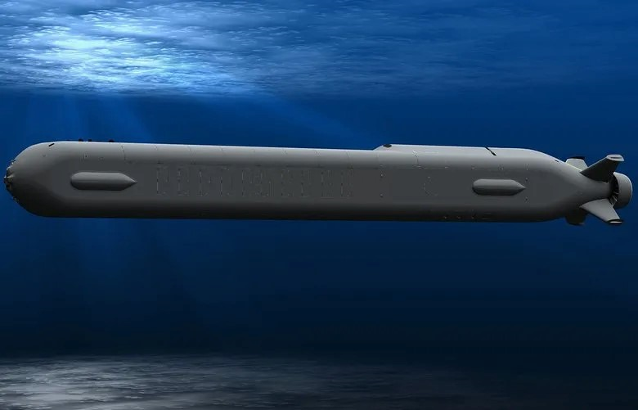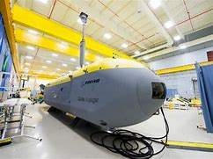
JOE SABALLA, DEFENSE.COM, MAY 10, 2022

The US Navy’s Naval Sea Systems Command (NAVSEA) has unveiled its first-ever Orca Extra Large Unmanned Undersea Vehicle (XLUUV).

The organization posted photos on its social media account of the submarine christening and first in-water test conducted late last month.

The Orca project was awarded to Boeing in a $274 million contract in February 2019 that includes the fabrication, testing, and delivery of five such drone submarines. Ingalls Shipbuilding is teamed in this project.

According to NAVSEA, the unveiling of the Orca marked an important milestone in its efforts to further develop reliable undersea capabilities.

The service explained that the development of a test asset system will also play a critical role in the production and future performance of the submarine.

The Orca XLUUV

Based on Boeing’s 51-foot Echo Voyager, the Orca is designed to conduct mine countermeasures, anti-submarine warfare, anti-surface warfare, and electronic warfare missions.

It has a top speed of eight knots (14.8 kilometers/9.2 miles per hour) and a maximum range of 6,500 nautical miles (12,038 kilometers).

During a briefing in 2019, Captain Pete Small explained that the drone submarine program would focus primarily on system characteristics, payload integration, and mine warfare capabilities.

It features a modular design with the core vehicle providing guidance and control, navigation, and improved situational awareness.

The submarine also has an open architecture to enable future integration of advanced technologies.

===============================================

The U.S. Navy’s New Orca Drone Submarine Could Get Offensive Role
H I Sutton, Forbes, Dec 17, 2019

The U.S. Navy's Boeing Orca underwater drone could play an offensive role in future conflicts. Writing in the highly regarded U.S. Naval Institute (USNI) blog, retired Commander Brian Dulla argues that the U.S. Navy should invest in mine laying capabilities. It's an arena where large drones like the Orca could have advantages.

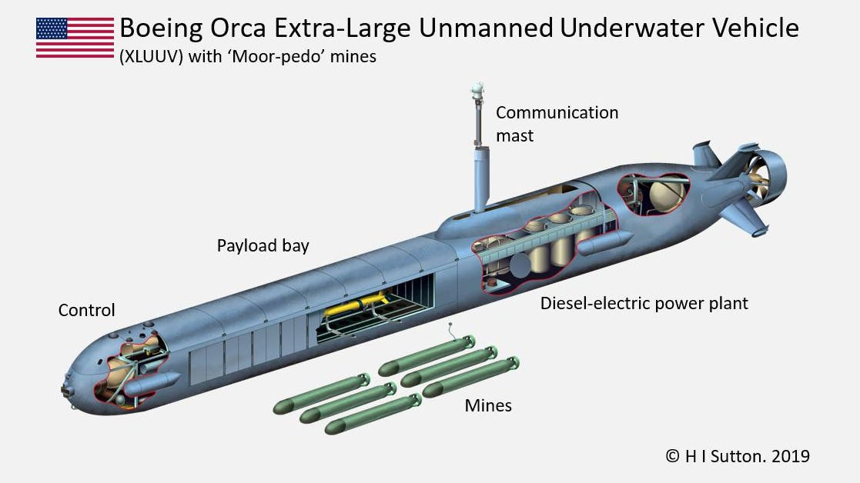
The U.S. Navy's first extra-large UUV, the Boeing Orca, could carry multiple 'moor-pedo' mines into ... [+]
Mine warfare feels neglected in the popular defense media. It may be perceived as old-fashioned or uninteresting. The reality can be quite different. Put yourself in the mind of a captain whose ship has just strayed into a minefield. Or the EOD (explosive ordnance disposal) diver sent to defuse the mines. Even low tech or vintage mines pose a very real threat to modern navies.
Commander Dulla's mine proposal is innovative. Yet like many good ideas it will seem obvious when you read it. He proposes to combines the range, autonomy and flexibility of a UUV (unmanned underwater vehicle) with the warhead of a mine. This allows it to be used as a moored mine that can propel itself into position, keeping the launch platform far from harms way. It could also be used as an extra slow torpedo to target ships in harbor. Because of its combined features Dulla terms this concept the ‘moor-pedo.’
At the same time, underwater drones are a hot topic for the Navy. It's a natural pairing because mine laying is dangerous to perform, especially in the enemy's back yard. Aircraft, ships or submarines are put in harm's way and distracted from their primary purposes. Crewless platforms mitigate some of the inherent risks involved.
Although unmanned air vehicles (UAVs) have become a common sight on the battlefield, development has been slower in the undersea domain. And until now the majority of UUVs used by navies have been very small. To lay a minefield a UUV would have to be much larger, large enough to carry a useful number of mines.
Not surprisingly the U.S. is the first sea power to start building extra-large unmanned underwater vehicles (XLUUVs). But other navies are also entering the arena, including Britain and Japan. And China, Russia, and South Korea also have large UUV projects.
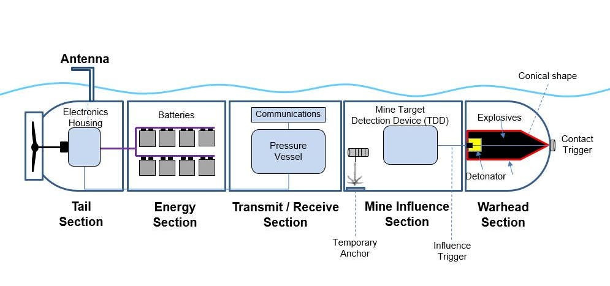
Commander Dulla envisions a weapon which mixes features from Unmanned underwater Vehicles (UUVs), ... [+]
Dulla proposes that the Navy’s large-displacement drones (LDUUV) could be employed. The Orca design will be even larger and therefore could patrol further and could carry more. The Orca is up to 85 feet long, an order of magnitude larger than anything else out there as the moment. It has a flexible payload section which is large enough to carry multiple torpedo sized payloads. Initially these could be smaller UUVs. In the future they could be Tomahawk cruise missiles, or as the USNI article implies, mines.
==================================================== U.S. Navy christens and conducts first in-water test of ORCA XLUUV
By Dorian Archus, US Navy News, May 7, 2022

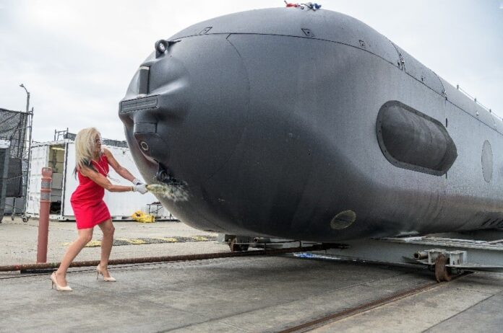Boeing photo
The U.S. Navy marked an important milestone in its effort to develop reliable undersea capability with the christening and first in-water test of the Orca Extra Large Unmanned Undersea Vehicle (XLUUV) Test Asset System April 28, 2022 in Huntington Beach, California.
Capt. Scot Searles, program manager for Unmanned Maritime Systems (PMS 406), representatives from the office of the Deputy Assistant Secretary of the Navy for Ship Programs and the Undersea Warfare Division of the Chief of Naval Operations, and Boeing executives marked the occasion. The test asset system is critical in the performance and production of the five operationally relevant prototype Orca XLUUVs.
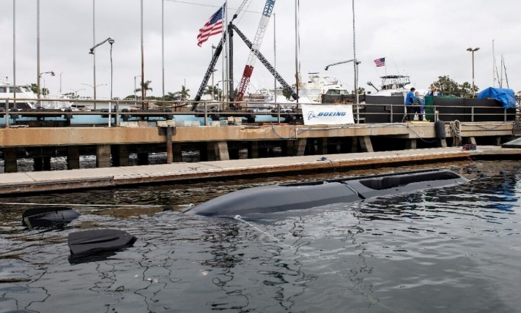

The Orca XLUUV Test Asset System prepares for the first in-water test following a christening ceremony April 28, 2022, in Huntington Beach, California. The Orca XLUUV program is tailored to address joint warfighting needs with a sense of urgency.
The Orca is an autonomous underwater vehicle (AUV) that is under development by Boeing and Huntington Ingalls Industries (HII) for the United States Navy.
The Orca project dates back to September 2017, when the Navy awarded contracts worth about $40 million each to Boeing, which had previously partnered with HII to build unmanned submarines, and Lockheed Martin to develop competing designs for an extra-large unmanned underwater vehicle (XLUUV) capable of operating autonomously on missions lasting up to several months. In February 2019, the Navy awarded the Boeing/HII consortium a $43 million contract to begin construction of four XLUUVs, with a design based on Boeing’s previous Echo Voyager AUV. The following month, the Navy added a fifth vehicle to the order, bringing the total value of the contract to $274.4 million. Orca deliveries should be completed by the end of 2022.
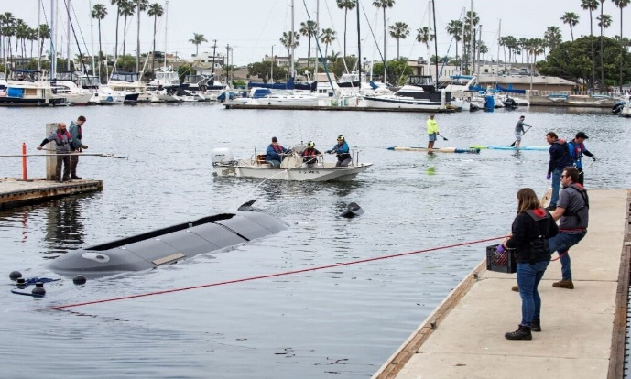

The Orca XLUUV Test Asset System prepares for the first in-water test following a christening ceremony April 28, 2022, in Huntington Beach, California. The Test Asset System will allow the Navy and Boeing to test and refine the Orca XLUUV program while reducing schedule and cost risk.
The basic design of the Orca shares a length of 51 feet (16 m) with the Echo Voyager, but the Orca will have a more modular design, primarily to be built with an additional payload module up to 34 feet (10 m) long and a capacity of 8 metric tonnes (8,000 kg) for a total length of 85 feet (26 m). The Navy specified the ability to adapt the Orca platform depending on the mission, with surveillance, underwater, surface and electronic warfare, and minesweeping capabilities.
The vessel is powered by a hybrid diesel/lithium-ion battery system that powers the Orca with batteries underwater and recharges the batteries on the surface with diesel generators. Top speed is 8 knots (15 km/h), but typical service speed is about 3 knots (5.6 km/h). This gives the Orca a range of up to 10,500 km (6,500 miles) and an endurance of several months.

ORCA (Echo Voyager) Key Data:
- Weight in Air: 50 tons (45,360 kg)
- Envelope (no payload): 51 ft x 8.5 ft x 8.5 ft
(15.5 m x 2.6 m x 2.6 m)
- Envelope (with a 34 ft payload section): 85 ft (25.9 m)
- Maximum Depth: 11,000 ft (3,000 m)
- Maximum Speed: 8.0 kts (14.8 km/hr)
- Minimum Speed: 2.5 kts (4.63 km/hr)
- Optimal Speed: 2.5 – 3 kts (4.6 – 5.6 km/hr)
- Range between recharges: ~150 nm (~280 km) at
nominal speed

Facebook Twitter LinkedIn Pinterest Reddit Pocket Share via Email Print

