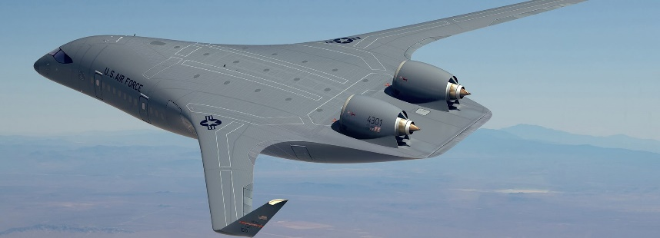 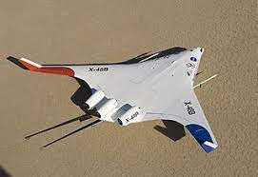 Wikipedia
What’s New with the Air Force? It’s the BWB!!
Driven partially by rising fuel costs and the need to increase the range of our aircraft, our Air Force has ramped up the concept of blended-wing-body (BWB) for future aircraft.
BWB will increase 30-50% fuel economy (and range), increase direct missions, reduce runway requirements, and confront our enemy(ies) with a smaller radar cross section to complicate the opposition’s defenses. Will also reduce runway requirements and increase the number of airfields we can operate giving more flexibility to our AF.
The blended wing’s engines are mounted above and to the rear of the aircraft which reduces noise which is deflected above and away from the aircraft.
To support our expected increased operations in the Indo-Asia theater, the Air Force must be more efficient to meet mission requirements. As our Secretary of the Air Force Frank Kendall has voiced, our mission focus is now “China, China, China. … BWB will help us maintain our edge over China.”
BWB aircraft will not just increase AF efficiency, it will also have a positive impact on climate.
Scale Composites, which is part of Northrop Grumman, will build the BWB aircraft in the Mojave desert. Target completion date is in 2027.
In the Indo Pacific theater, extended range for our Air Force aircraft, including fighter and bomber aircraft is urgent.
Commercial Applications:
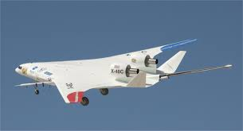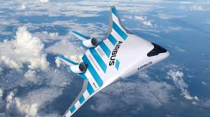Commmercial BWB passenger and Freight versions Wikipedia
Commercial passenger and freight companies will also benefit from the efficiencies provided by BWB technology. They are concerned about rising fuel costs. BWB transports can carry 200+ passengers. Airline requirements are imminent, so BWB development will also receive funding from the commercial sources.
=============================================
SOURCE:
Strategy & Policy: USAF Explores Blended-Wing Body Jet
John A. Tirpak, Air & Space Forces Magazine, Aug. 31, 2023
The Air Force picked JetZero, a California startup, to design, fabricate, and test a new blended-wing body (BWB) aircraft. Neither a protototype nor an “X-plane,” the as-yet-unnamed technology demonstrator aircraft seeks to inform the design of future cargo and/or tanker jets.
The new design concept promises greater fuel efficiency, and therefore range, and reduced runway requirements. It also seeks to prove new materials and a new approach to rapid prototyping. It could play a crucial role in shaping the upcoming analysis of alternatives for the Next-Generation Air-refueling System, or NGAS, a future tanker project.
Air Force Secretary Frank Kendall kicked off the program at a public rollout event at the Air & Space Forces Association in August. “It is intended to accelerate the next generation of the large aircraft the Air Force needs in the future,” Kendall said. “There’s a real potential in this technology to help increase fuel efficiency significantly. That’s going to lead to improvements in not just the efficiency and capability of our force, but also in our impact on the climate.”
These are heady goals. Intended to be about the size of the KC-46 tanker, the planned aircraft aims to cut fuel consumption by 30 percent and increase range by the same amount compared to conventional cylinder-and-wing designs. JetZero’s aims are even more ambitious, its website suggesting 50 percent improvement is possible. The ability to operate from much smaller airfields than existing mobility aircraft could bolster USAF’s Agile Combat Employment concept, which anticipates rapidly dispersing forces to remote or austere bases.
The blended-wing body aircraft is to be powered by Pratt & Whitney turbofan engines mounted above and to the rear of the airframe, making operations around the aircraft at ground level easier and sharply reducing noise, which will be deflected above and away from the aircraft, rather than down to the ground.
JetZero, of Long Beach, Calif., is working with Scaled Composites—a subsidiary of Northrop Grumman—which will build the aircraft at its Mojave, Calif., plant. They aim to complete the build in 2026, with flight testing to begin in 2027.
USAF and its industry partners are sharing the cost. The Air Force is putting up $40 million in fiscal 2024, and up to $230 million over its five-year future years defense plan. JetZero co-founder Tom O’Leary said in an interview that the company and other investors will at least match that, and probably invest significantly more. He declined to estimate a final figure.
Partnering with Northrop gives JetZero a proven partner with a history of building unusual and stealthy aircraft. The technology involved could lend itself to NGAS, should Northrop pursue that program. NGAS calls for a stealthy tanker by the mid-to-late 2030s.
Fuel Savings
Mobility aircraft account for about 60 percent of all the fuel consumed by the Air Force, already the largest fuel consumer in the Defense Department, which in turn is the largest user in the federal government.
Ravi Chaudhary, assistant Secretary of the Air Force for installations, energy, and the environment, said savings changes the nature of operations.
“Greater range increases lethality,” he said. “Fuel efficiency conserves our energy resources and allows us to generate more sorties; a smaller noise footprint [improves] survivability; and seamless ground ops reduce ground time, and gets us airborne quicker in an era when our installations will no longer be the sanctuary they were in previous conflicts.”
But interest is not limited to the military market. Kendall cited “a lot of commercial interest in this technology,” and O’Leary suggested some airlines are investing in the program.
To Kendall, it’s also about global competition. The BWB can help in “maintaining our edge over China.”
The environmental and commercial implications drove other changes to the Air Force’s approach. Instead of being led by Air Force Materiel Command’s Life Cycle Management Center or the Air Force Research Lab, this project falls under the auspices of Chaudhary’s office.
“We have direction from Congress to be the lead organization for this,” Chaudhary told Air & Space Forces Magazine. “This is an operational energy issue that we have to address as a service.”
The ability to fuel aircraft, ships, and vehicles and to power the comfort and computing needs of a military force is arguably the most crucial piece of the entire logistics chain. That “is going to be the margin of victory in great power competition,” Chaudhary said.
“Operational energy … is about saving gas,” he said. “Ultimately, that portfolio is where the Deputy Secretary of Defense and Congress thought would be appropriate to address this issue.”
“Developing a blended-wing body is “connected to the administration’s greenhouse gas reduction goals,” Chaudhary said. “But ultimately, … mission action is climate action.”
Others contributing to the project include the Defense Innovation Unit, NASA, Georgia Tech, the Pentagon’s Office of Strategic Capital, and operational requirements staff from Air Mobility Command. Other “oversight and interaction” will come from Air Force A5 (Plans and Integration) and acquisition experts, Chaudhary said.
Roberto I. Guerrero, Chaudhary’s deputy, an aerospace engineer, will oversee the effort for the Air Force.
Chaudhary wouldn’t say who else competed for the program, but, “what we essentially did was look at the best opportunity to iterate to our design goals as quickly as possible. … Ultimately, it came down to design choices that were preferred.”
The competition was announced a year ago, in July 2022, when the Defense Innovation Unit solicited industry about a BWB aircraft, with further details included in USAF’s Climate Action Plan last October.
The BWB concept isn’t new. Boeing’s X-48, a subscale prototype, flew from 2007 to 2013, but neither the Air Force nor airlines rushed to embrace it. Spiking fuel costs, however, have spurred new interest, and O’Leary asserted that the effects of climate change “can no longer be ignored.”
Recent technology advancements “in structural design, materials technology, manufacturing, and other areas” are making the BWB possible now, the Air Force said in a release. Those advances make “large-scale production achievable.
One reason tube-and-wing aircraft have remained the standard is because a cylinder is the classic shape for a pressure vessel. But achieving pressurization with right angles has been done “for some time now,” a government source said, and can now be achieved on a production line.
The key to BWB, O’Leary said, is that it offers tremendous lift. That, in turn, makes it possible to reduce weight in other parts of the aircraft, such as control surfaces.
For takeoff, O’Leary added, the nose gear will have a spring-like function, pushing the nose up, and allowing the overall platform’s lift to do the work of climbing, without heavy control surface inflection.
“We have a lifting body, and a sleek airframe. And it’s going to be made from composite materials, state of the art,” he said. “And when we combine all that, the net effects … are phenomenal.”
Future Tanker?
Maj. Gen. Albert G. Miller, AMC’s director of strategy, plans, requirements, and programs said a BWB tanker offers the potential to venture further forward to get fuel to a critical receiver. “So … what this blended-wing body prototype brings is very interesting to Air Mobility Command because of the increased lethality it brings for the joint force and increased maneuver capability,” he said.

Miller cautioned that “there’s no presumption … that this is necessarily the answer for NGAS.” Rather, he said, “We think that it could be informative in this process” both for that future tanker and the Next-Generation Airlifter.
The demonstrator will help determine what kind of range is possible, what runway lengths are feasible, and what kind of signature management might be needed, all crucial questions for NGAS, which will have to operate “in threat environments that we’ve never had to operate in before.”
The analysis of alternatives period for NGAS is “very short,” he said. “We need this effort to move fast … we’re going to have to learn what we learn very rapidly.”
Commercial Applications
Both commercial passenger and freight customers are interested in the BWB concept, O’Leary said. The project was sized “to build the biggest blended wing we could, using a single-aisle engine that is available today,” he said. He declined to specify which of Pratt’s geared turbofan engines will be used.
“There is no mid-market airplane in the market today,” O’Leary said. “It’s in kind of an awkward space between single-aisles and twin-aisles, where the geometry of ‘the tube’ breaks down, from an efficiency standpoint. The BWB would fit that space.”
In the passenger realm, that’s an aircraft that could carry 200 to 250 passengers. JetZero and others have published artwork depicting BWB airliners with wide rows, some with video displays showing the scene outside the aircraft in place of windows. Airline demand is urgent, he said: “We feel the need for speed.”
Future BWB iterations could include folding wings, so that more such aircraft could get closer to airline terminals at once, and require less ramp space at forward bases.
The prototype will include neither a side-loading cargo door nor a fold-down rear ramp, nor will it have folding wings. That would come later, once the concept is proven. “That’s why we’re working with Northrop Grumman,” O’Leary said: “To develop the mission systems that would be used on this platform.”
Initially JetZero is “just focused on proving out the technology; what the [lift over drag] is of this new, ultra-efficient airframe, and then, after that’s proven out, then there will be years and years of development.”
Miller said the prototype could be tried in exercises and experiments to explore its value and see “what Airmen make of it.”
As a major in 2007, Chaudhary wrote a paper in the Air and Space Power Journal, arguing that the cost, in political and maintenance terms, of operating “lily pads”—enroute stops in other countries—was too great. More fuel-efficient aircraft, he said, could yield great savings, increase direct flights, and accelerate air mobility. BWBs could break that mold, he said then, and could complicate an enemy’s targeting problem, one of the foundational ideas in ACE.
In Chaudhary’s job interview with Kendall, he recalled, the Secretary asked, “What do you know about blended-wing technology?” Chaudhary smiled and replied, “Wow, maybe we’ve come together to meet the moment on a pretty tough problem.”
The blended-wing body is right for the moment, he said.
The stakes couldn’t be higher. … In the Indo-Pacific, everything is a little bit further, requires a little more capacity, and expends a little more gas. If we’re going to be successful, we’ve got to come together—government, industry, academia—all with a sense of urgency. Because if we don’t, our adversaries will.”

