Some People are shining lasers at our commercial aircraft. On September 21, laser lights were illuminating commercial jets in Boston and in Miami, Fl.

Attempts to illuminate commercial jetliners is very dangerous and should be stopped immediately. There are reports that the laser beams can blind the pilot and crew and that, endangers any airliner that may be carrying many air passengers. Whoever is doing this at our local airports must be warned to cease their activities that can endanger the lives of air crew and passengers.

Some people are possibly blaming the Chinese, or the Russians, or the North Koreans, or Iranians for conducting this type of cruel activity.

If a plane does down because of laser attacks by a foreign party, that will be an act of war – not as big as 911, but serious enough to receive a strong American response. Likely significant sanctions would be immediately invoked, and the case may be brought to the attention of the United Nations. If a foreign country was responsible, there would be strong legal and retaliatory actions undertaken.

IMO, it is unlikely that any of our current challengers would conduct such a provocative act. The experts should know that America will not accept such an act of terror. Even though many Americans now are pretty wary of war, an aircraft that crashes due to a deliberate laser attack will anger many Americans who will want retaliation. And a strong military response could lead to World War III.

===============================================

2 JetBlue planes reportedly struck by lasers near Boston, FAA says

ABC$News, September 21, 2023$

Two JetBlue planes were struck by lasers near Boston on Thursday, the Federal Aviation Administration said.
The crews of JetBlue flights 494 and 972 reported being illuminated by a green laser early Thursday morning, the agency said. There were no injuries, according to the FAA.
Last year the FAA received 9,457 reports of laser strikes against aircraft -- that number was down slightly from a record 9,723 in 2021.

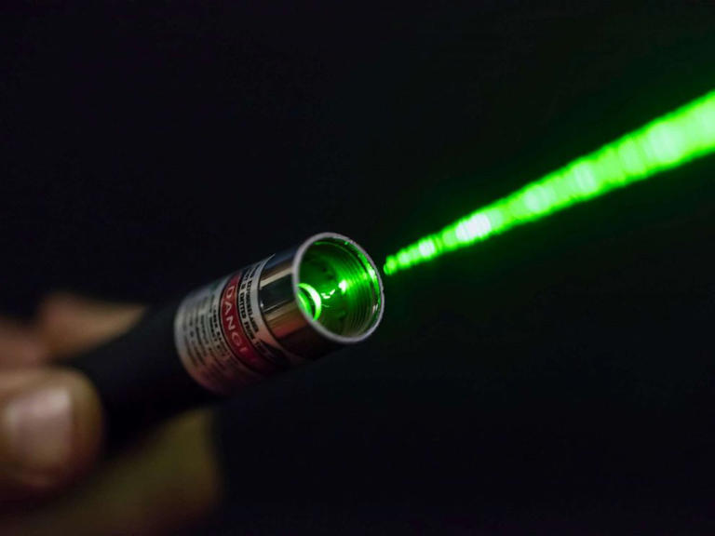

A laser in an undated stock photo.© STOCK PHOTO/Getty Images
Former FAA acting administrator Billy Nolan previously called on manufacturers to warn consumers of the risks of pointing lasers at planes, saying the products can "incapacitate pilots putting thousands of passengers at risk every year."
MORE: FAA calls on laser manufacturers to warn consumers of risks for planes
Since 2010, 277 pilots have reported injuries from laser strikes, according to data from the agency.
Individuals caught shining lasers at aircraft can face fines of up to $11,000 per violation.
JetBlue did not immediately respond to a request for comment.

