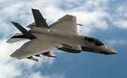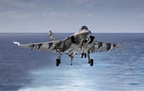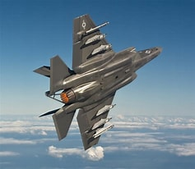
The $1.7 Trillion Warplane.
Lockheed’s F-35 Lightning Fighter has exceeded all cost estimates and will continue to exceed all cost projections.
It seems insane that any responsible senior Department of Defense, or US Air Force senior officer, would agree to allow the continuing development of an aircraft that continues, year after year, to exceed costs.
One partial explanation, or excuse, is that requirements keep changing, and that we have no excuse to not continue to fund and develop a state-of- the-art system that is extremely critical to our current and future national defense.
The current approximate cost for each F-35 is approximately $100 million. We hope and expect some of our close allies will be willing to pay $150-200 million for each advanced F-35. They have little choice as no one else has the resources to fund and develop a similar system.
Simultaneously, the Air Force is squarely focused on developing the next major fighter, the New Generation Air Dominance (NGAD). That does not even sound like a jet fighter, but it is. The NGAD will be a super expensive system that is currently highly classified, ultra stealthy manned system that will be complemented with an unmanned system called the Collaborative Combat Aircraft (CCA). The CCA is intended to be NGAD drone.
Looming over all these expensive developments is the Space dimension. Both offense and defense warfare concepts and weapons will be different in the Space warfare scenario.

======================================================
SOURCES:
Tactical Air Dominance, John A. Tirpak, Air & Space Forces Magazine, Aug 2023, p 36-43

=======================================================
The Fall and Rise of a $1.7 Trillion Fighter Plane, Christopher Leonard, Fortune 500 Magazine, September 2023, p 64-71

Lockheed Martin’s $1.7 trillion F-35 fighter jet is 10 years late and 80% over budget—and it could be one of the Pentagon’s biggest success stories.
Christopher Leonard, Fortune 500, August 2, 2023·

One Sunday in early 2022, German Chancellor Olaf Scholz gave a speech that reversed more than 70 years of pacifist foreign policy in his nation. Vladimir Putin had just invaded Ukraine, and Scholz’s address to parliament was short, urgent, and written for the ages. Scholz announced that Germany would immediately invest about $100 billion in its military—more than doubling annual spending levels—and boost its defense budget to 2% of its annual GDP from then on. Scholz framed Putin’s invasion as the beginning of a new era of global tension, and he promised that Germany would meet the moment. But while his rhetoric was sweeping, Scholz took time to mention a specific product that he wanted Germany to buy: the ultra-expensive F-35 fighter jet, made by American defense contractor Lockheed Martin.
This might seem puzzling to anyone who follows the news. Since the F-35 program was announced in 2001, it has been the symbol of America’s dysfunctional military-industrial complex. The jet is 10 years behind schedule for final approval and almost 80% over budget, its production repeatedly stalled by defects and miscalculations. Last fall, comedian Bill Maher captured the conventional thinking about the fighter during a monologue on his HBO show. “We spent $1.5 trillion on the F-35, which has never worked, and never will, and yet we still buy it,” Maher declared, concluding, to peals of laughter, “It’s the Yugo of fighter jets.” Maher’s critique was a little off: The estimated cost of developing, building, and maintaining the F-35 fleet over its anticipated life span of about 60 years is $1.7 trillion.
Nonetheless, Germany ended up buying 40 of the jets, at a reported cost of $8 billion. Soon after Scholz’s speech, Canada announced that it wanted eighty-eight planes. As the war in Ukraine dragged on, Greece, the Czech Republic, and Singapore all expressed interest in the F-35. And this came on the heels of massive new orders in 2021 from Finland and even the famously neutral Swiss.
If the F-35 is such a boondoggle, why are so many governments clamoring to buy it? The answers to this question are vitally important to America and its allies, and to every U.S. taxpayer.
The F-35 is the largest program inside the Pentagon, by far, with an annual budget of about $12 billion. Taxpayers have invested heavily in the F-35 for more than 20 years, to the exclusion of other defense and domestic priorities. The opportunity cost is measured in hundreds of billions of dollars.
The program is also a measure of the health of Lockheed Martin, the largest weapons company that has ever existed. Lockheed brought in about $66 billion in revenue in 2022, all of it for arms. (The company makes missiles, missile defense systems, warships, and a host of other combat aircraft, among other products.) It sits at the top of an industry that is more important to national security than ever: About 58% of the Pentagon budget went to private contractors in 2020, the highest share in 20 years, according to the Center for Strategic and International Studies.
The F-35 is a test case of Lockheed’s and the Pentagon’s ability to deliver results. Put simply, the calculus runs like this: Either the F-35 was a massive waste of resources—the worst-ever example of the defense industry overpromising and underdelivering—or it was a savvy long-term investment that gives America and its allies a substantial advantage over their enemies.
Not surprisingly, Lockheed Martin and the Pentagon endorse the latter interpretation. Lockheed says the F-35 will be a central node of the U.S. war machine for years to come. “The F-35 is, without question, the most advanced fighter aircraft in the world. We continue to make advances to it, to keep it ahead of the threat,” says Bridget Lauderdale, Lockheed’s vice president and general manager of the F-35 program. Michael Schmidt, the Air Force three-star general who oversees the program for the Department of Defense, says the plane is not just a success, but a necessity. “These are investments that we’re making on behalf of our country and our allies to ensure that we own the skies,” Schmidt tells Fortune, in an office with sweeping views of the Pentagon and Capitol Hill. “That’s the only way you’re going to win in war.”
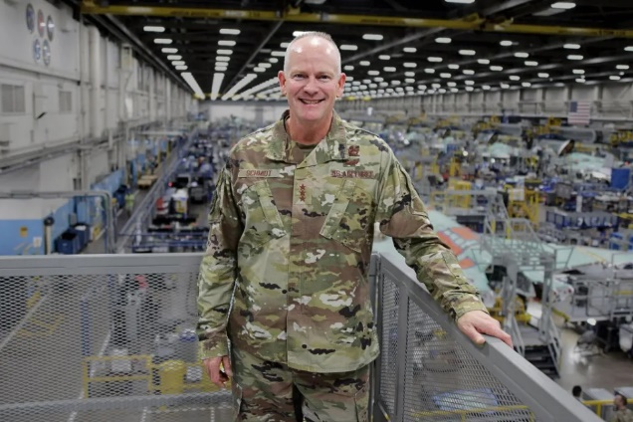

FORT WORTH, TEXAS (Nov. 03, 2022) – F-35 Joint Program Executive Officer (PEO) Lt. Gen. Michael Schmidt stands elevated above the production floor at Lockheed Martin’s Air Force Plant 4 in Fort Worth, Texas, Nov. 03, 2022, with the F-35 assembly line in the background. This was Schmidt’s first visit to the facility since having assumed the duties of F-35 PEO. The F-35 Joint Program Office is the Department of Defense's focal point for the 5th generation strike aircraft for the Navy, Air Force, Marines, and our allies. The F-35 is the premier multi-mission, 5th-generation weapon system. Its ability to collect, analyze and share data is a force multiplier that enhances all assets in the battlespace: with stealth technology, advanced sensors, weapons capacity, and range. The F-35, which has been operational since July 2015, is the most lethal, survivable, and interoperable fighter aircraft ever built. (U.S. Navy Photo by Chief Mass Communication Specialist Matthew Olay/Released) More
Contrary to widespread belief and Bill Maher, the F-35 does work. Lockheed has delivered about 960 of the jets so far, with about 630 going to the U.S. military—and the plane has performed effectively in combat multiple times. The F-35 has yet to face protracted battle against a sophisticated foreign military. But if or when it does, its design incorporates technological breakthroughs that could confer a huge edge in battle, enabling it to evade detection while linking U.S. and allied forces in a data-sharing network that could outmaneuver and overwhelm an enemy.
The F-35 is indeed plagued by cost overruns and delays. But those problems are inextricably linked to the advances that have gradually won over pilots and governments—advances that until recently have flown under radar.
The original point of the F-35, ironically, was to save money. In the 1990s, with the Cold War over, military budgets were being cut, and the Pentagon wanted to launch a cheaper, more efficient fighter jet program. The F-35 is called the Joint Strike Fighter because the objective was to build a single plane—lightweight, stealthy, heavily armed, and easy to fly—that could be slightly modified to work for the Air Force, Navy, and Marines, like a uniform car chassis that could be adapted for different models.
Lockheed Martin itself was born from the cost-saving mindset of the 1990s, as defense contractors merged to survive leaner times. Daniel Tellep, then-CEO of Lockheed Corp., oversaw its merger with Martin Marietta in 1995. Long before then, Lockheed had become an expert at winning enormous long-term contracts. Its core business was based on managing extraordinarily complicated projects, pushing the boundaries of the scientifically possible. Tellep said in a 2019 interview that Lockheed’s greatest strength was its ability to read where the Pentagon was headed, and to get there first. “We did not skimp on investing in advanced technology, research and development, and so forth,” said Tellep, who died in 2020. Lockheed’s famed Skunk Works research base built top-secret planes for the CIA, for example, and helped invent stealth technology, which enables aircraft to evade detection by absorbing or dispersing radar signals.
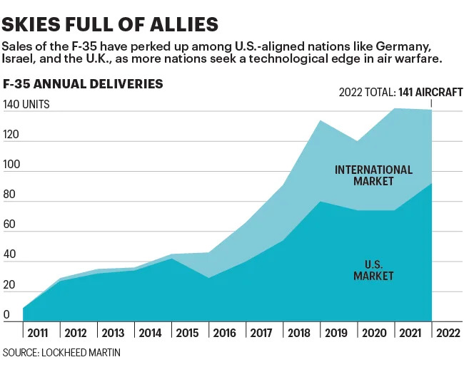
Chart shows F-35 annual deliveries.

In the late 1990s, Lockheed won the Pentagon contract to build the Joint Strike Fighter. But the program was a fiasco from the start.
Lockheed and the Pentagon immediately slammed into technological hurdles. The F-35 version for the Marines, which was designed to take off vertically rather than from a runway, proved to be exceedingly difficult to get right. (The program eventually abandoned the uniform-chassis idea.) By late 2009 Lockheed had delivered only four of thirteen promised test aircraft. The number of labor hours it took to build each plane had ballooned by about 50%. The effort was also plagued by the Pentagon’s decision to make the program “concurrent,” which meant that Lockheed was contracted to keep building F-35s even as it invented capabilities that impacted their design—which in turn required the government to pay for constant upgrades to earlier versions of the jets.
Things hit a breaking point in 2010. By then, the acquisition cost for each F-35 had nearly doubled, from $81 million to $156 million. Then–Secretary of Defense Robert Gates held a press conference during which he publicly fired Marine Corps Maj. Gen. David Heinz as the F-35 program director, while punishing Lockheed by withholding $614 million in performance-related payments. Gates imposed reforms across the program. But he did not fire Lockheed: Indeed, he pushed back deadlines and authorized more funding to address previous mistakes.
Over the next decade, the F-35 continued to falter in very public ways. In 2015, it performed poorly in a dog fight against older F-16s. Its engine, made by subcontractor Pratt & Whitney, burned so hot that it turned atmospheric sand and grit into glass inside the plane, hurting performance and requiring redesigns. And yet, as new capabilities were added to the F-35, it became apparent that the engine was not powerful enough to provide energy to cool the plane’s internal systems. Most frustrating, the F-35 required several million lines of software code to operate. That code, like all code, turned out to be buggy and in need of constant rewriting. By 2021, the cost of the F-35 had nearly doubled—overall outlays for the project, originally estimated at $233 billion for the first 20 years, had in fact reached $416 billion.
By then, the F-35 seemed adrift, and so did Lockheed Martin. The U.S. had just withdrawn from Afghanistan in defeat, and the end of America’s “Forever Wars” there and in Iraq raised the prospect that there might be less need for a Forever Contractor as large as Lockheed. In October 2021, Lockheed warned that its sales outlook was diminishing amid flat-to-declining defense budgets. But Russia solved Lockheed’s problems with the invasion of Ukraine. Military budgets swelled. And global defense dollars started to tell a story at odds with public perception of the F-35. Beneath the blizzard of terrible news, Lockheed had quietly built a revolutionary weapons platform.
In 2019, an Air Force squadron used the F-35 to attack an ISIS weapons depot and tunnel system in Iraq. This followed combat deployments of the jet by the Marines and the Israel Defense Forces in 2018. The Pentagon and Lockheed will not discuss what happened on those missions, saying such details are classified. But Air Force Col. Yosef Morris led the squadron on the 2019 mission, and when he describes flying the jet, it is like listening to someone who grew up in the age of radio describe watching television for the first time.
There are three things that make the F-35 so powerful. The first is its stealth technology. The plane was designed to penetrate the thick wall of air defense systems that Russia has been developing for years, especially its S-400 radar-and-missile suite. The S-400 can destroy anything it detects, but the F-35 can get through the wall.
The second benefit could be called “the alliance effect.” Here, an analogy to Apple is inescapable. When a nation buys the F-35, it buys the aeronautical version of the latest iPhone and gets access to the entire software and hardware ecosystem surrounding the product. American jets, for example, are designed to communicate seamlessly with the air defense systems of the U.S. and its allies to avoid getting accidentally shot down. It is as if America and NATO run on iOS, while China and Russia run on Android—and nations must pick one system over the other.
This alliance effect is also a key to the F-35’s third big advantage. When Lockheed and the Pentagon talk about jets, they do not talk about bombs and missiles. They talk about sensors, data, and instantaneous communication. It is that infrastructure, pilots like Morris say, that is changing warfare.
Up until 2012, Morris had been flying Lockheed’s F-16s. That meant he was using monitors and dashboards designed in the 1970s. Inside an F-16 cockpit, a pilot had a lot of mental work to do. Morris had to check his radar monitor for incoming threats; consult other monitors, like infrared sensors, which might detect a missile launch; look through the plane’s large glass canopy to spot threats his monitors might have missed; and, finally, make sense of it all. To make matters more complicated, F-16 pilots also must interpret signals beamed in from surveillance systems like AWACS or JSTARS, which are hyper-strong but so complex they need their own planes to host them.
Being inside the F-35, Morris says, is completely different. The airplane carries a suite of sensors that are the equivalent of having an AWACS and JSTARS on board. The F-35 does not listen to surveillance systems, it is the surveillance system. Its internal computer reads and analyzes reams of data collected by the sensors—a process called sensor fusion, designed by Lockheed—then displays the results on the pilot’s dashboard instantaneously. Morris could now spend much less time figuring out what was going on, and more time deciding what to do about it.
“You have an extremely better picture of what’s going on in the battle space, at extremely long ranges, that you didn’t have in [older] fighters like an F-16,” explains Morris, who retired last year.
Much of this technology was developed at a secretive shop run by Santi Bulnes, Lockheed’s vice president of engineering and technology for aeronautics. Bulnes has been at Lockheed for decades, helping to develop the original F-35 prototype in the 1990s. His shop has taken the lead role on the jet’s sensors and monitors—and, even more important, in networking the F-35s.
Thanks to their sensors, F-35s present a much clearer picture of the battlefield. But Lockheed has also designed them to share this picture with one another, at ultrafast speeds. The jets have evolved to become the central nodes of a massive communication network, creating a giant field of awareness that can share information with all the elements in a military effort, including ground-based missile launchers, drones, older fighters like the F-16, battleships, and satellites.
“Imagine you are fishing. You could use one fishing line, or you can use a net and more easily collect everything,” Bulnes says. “Well, the F-35s are netted together. Whatever one person sees; everybody sees. And that is something that I do not think folks really understood—how powerful it was going to be.”
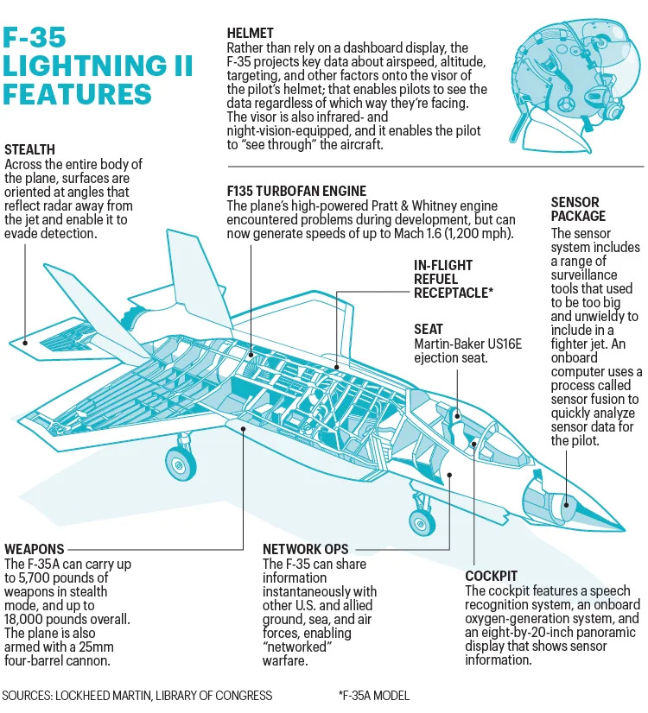
The infographic shows the F-35 Lightning II features.

In modern warfare, where reaction times are measured in milliseconds, this information web offers a critical advantage. In the fog of war, when strategy and communications often break down, forces anchored by F-35s could stay connected and respond rapidly in ways that are effective and unpredictable—bombing a supply line during a wave of cyberattacks. Niccolò Petrelli, an Italian defense analyst, called the jets’ information systems a “quantum leap.”
That leap has been a long time coming, and its course has been altered—and made more expensive—by myriad technological changes. But the system’s long, slow development illuminates the core of Lockheed Martin’s business strategy. The company is patient, quietly matching its engineering talent against the desires of the Pentagon until it achieves the right fit. It is like building a house when the client keeps asking you to add new rooms and, along the way, to invent a new kind of air-conditioning system. At the same time, Lockheed endures public humiliation in the town square of congressional hearings. One hangover from the F-35’s 2010 budget crisis: Every year, Congress’s General Accounting Office publishes an audit of the program, which inevitably (and accurately) reports that the F-35 is late and over budget—stoking more ugly headlines.
It is U.S. taxpayers who foot the bill, with interest. The cost overruns obey what is almost an iron rule of the military-industrial complex, says Norman Augustine, who served as CEO of Lockheed Martin in the late 1990s. Big programs follow the same cost curve, he explains: Initially, development costs are stratospheric and almost always higher than expected because there’s actual invention involved, and the innovation process is unpredictable. But then costs can decline as companies refine their production process and more units are sold to the U.S. and allies.
The F-35 may finally have reached that second phase, where trial and error have brought it in line with the Pentagon’s—and taxpayers’—expectations. But Augustine notes that the cycle inevitably repeats itself, in part because national security imperatives always dominate. “I’m not arguing in favor of overruns and delays,” he says. “But it is more important to get it right than to get it fast. There are no trophies given for fast failures.”
It can be difficult to tell sometimes where Lockheed Martin ends, and the government begins. Lockheed’s aeronautics division is based in a giant government-owned factory in Fort Worth that was built to produce bombers for World War II. The Pentagon agency that oversees the F-35 program, meanwhile, occupies a private office building in a complex called Crystal City, in the Washington, D.C., suburbs. In both places, civilians in business-casual attire work alongside active-service military. When Lt. Gen. Schmidt walks past the cubicles outside his sixth-floor offices, soldiers in uniform stand up behind their desks at attention.
Schmidt took over the F-35 program last year, inheriting a sprawling system of expensive and complicated subprograms. When critics note that the jet still has not been “approved,” they are referring to the milestone known as “final, full-rate production.” Approval at that level would move the F-35 out of the development stage and allow Lockheed to produce it as quickly as possible. (It currently builds about 125 planes a year.) But approval has been delayed repeatedly, for countless reasons. For one, the flight simulator needed to evaluate the F-35 to Pentagon specifications does not exist yet. This is not because Lockheed does not know how to build a simulator; it is at least partly because the F-35 keeps expanding the horizon of what needs to be simulated. The fighter sucks in signature emissions from radar, submarines, phone towers, other planes, and even visual cues like puffs of smoke. A simulator has not yet been built that can imitate all this data in a fast-moving, interwoven way that would resemble a war zone.
Every improvement, it seems, begets expense, delays, or both. The F-35 engine is being upgraded: The Air Force has requested $255 million just for design contracts and has not estimated how much the improvements will cost, according to the GAO. Schmidt is pushing forward “Tech Refresh 3,” a major upgrade to the F-35 computer infrastructure that will cost more than $1.6 billion. The first F-35 with the refresh came off the assembly line this summer, but the Pentagon could not accept delivery because more software testing needs to be done. The Pentagon expects that issue to be resolved by April 2024, while Lockheed thinks it might happen sooner, but regardless, the planes will sit idle until testing is completed.
Whether the program eventually becomes a financial success for Lockheed may depend on America’s allies. The U.S. is seeking to buy the same number of F-35s as it wanted more than 20 years ago—about 2,500. Any additional sales would come from overseas partners, and that demand is growing. Schmidt estimates that within 10 years, the U.S. will operate 60 F-35s in Europe, while European nations will operate 600. The prices reported for recent foreign sales have averaged out to between $150 million and $200 million per plane, including service and maintenance. That may seem steep, but in a sense, it is a bargain: Those nations’ taxpayers have not paid additional billions for the plane’s long development. And the money from those additional foreign sales goes back to Lockheed.
Criticism of the F-35 remains strong, and it has been stoked by the conflict in Ukraine, where a shortage of basic munitions has endangered the war effort. Such shortfalls highlight concerns that the U.S. overinvests in “gold-plated” weapons systems even though most warfare is defined by long, grinding fights that eat up equipment, says Richard Faulkner, a military historian who teaches at the Army’s Command and General Staff College at Fort Leavenworth, Kans.
“The biggest problem, of course, is the damn [F-35s] are almost handmade,” Faulkner says. “So, if you lose one, you are not getting another one for two to three to four years. If you get yourself stuck in attritional war—and warfare is inherently attritional—you start losing these things, you are going to have a problem finding anything to replace them.”
It is hard to gauge how vulnerable the F-35 is. J.R. McDonald, Lockheed’s vice president of business development for the jet, suggests that the world’s two other superpowers, or at least their equipment, are the bar against which the plane will be measured. “While it’s unlikely that we fight Russia and China, it is 100% likely that we will fight Russian and Chinese weapons,” McDonald says.
It is noteworthy that American pilots have flown in Syria, where Russian-made air defense systems are active, and in the Pacific region, where Chinese systems operate. The F-35 has not been shot down in either arena. Active-duty pilots say that is a meaningful sign. “I have guys who I have served with for 25-plus years tell me: ‘Without this jet, we lose the fight,’” said Navy Capt. Scott Buchar, who works at the Pentagon’s F-35 office.
Even as the F-35 is ironing out its problems—and even before it has faced full-scale warfare—decision-makers are thinking about its replacement. The Air Force has announced a competition for a new class of combat aircraft, a project that it calls Next Generation Air Dominance, or NGAD. The project calls for a sensor-rich, tightly interlinked system—not unlike the F-35—that will rely at least partially on unmanned aircraft. It’s not clear which companies have submitted bids for the project (that’s classified), but Bank of America analyst Ron Epstein says Lockheed is almost certainly in the running. “It’ll be astonishing if they don’t get some sort of position, if not the lead position on NGAD,” he says. “Why? That is what they do.”
Lockheed’s position seems secure because it is still America’s foremost workshop of war, despite its stumbles. Just as important, nearly $500 billion in spending has put the F-35 where it was intended to be—at the heart of the evolution toward networked, data-heavy warfare. “F-35 is absolutely in the middle of the game. Today it is the quarterback,” says Lauderdale, Lockheed’s general manager of the F-35 program. “And as the game changes it will continue, for decades to come, to be exceptionally relevant.”
This article appears in the August/September 2023 issue of Fortune with the headline, “The fall and rise of a $17.7 trillion fighter plane."

