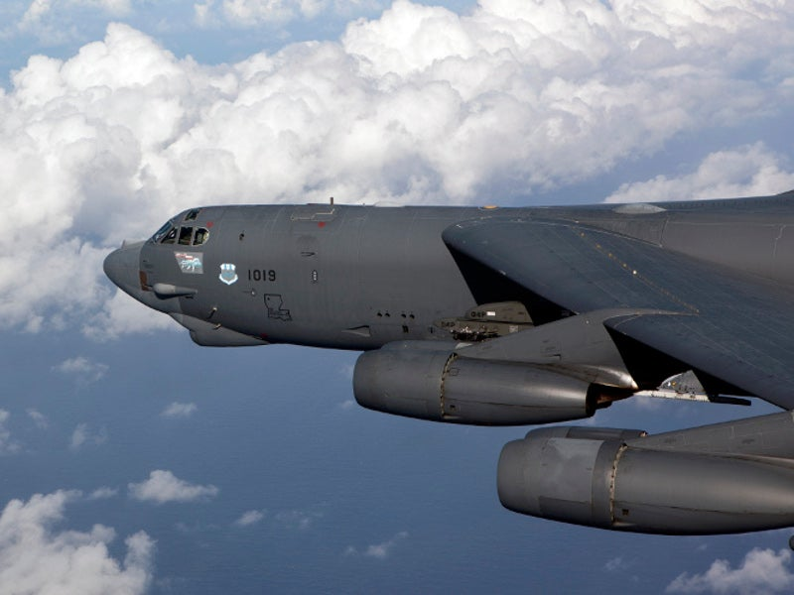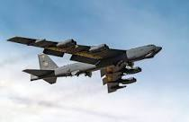
Air Force upgrading engines on the B-52 bomber to extend it use for 30 more years.
In September 2021, the USAF awarded a $2.6 billion contract to Rolls-Royce to deliver 608 F-130 engines to replace the aging TF33 engines on B-52 strategic bomber.
This is hard to believe that we are going to spend money to keep the B-52 flying for another 30 years. One of the big issues confronting our Air Force is the cost to keep legacy systems operating which takes funds away from the innovations we need to keep our Air Force as advanced as it needs to be to compete effectively against China. China has been spending a lot more money developing her military than we have. If we do not spend wisely and focus on innovation, our future success is in serious jeopardy.
===============================================
Air & Space Force magazine, September 25, 2023 reports that:
Boeing Is Using Fortnite’s Game Engine to Upgrade B-52s
Defense One
A popular gaming engine is helping Boeing to refit 60-year-old B-52 bombers for another three decades of service. To see how new Rolls-Royce F-130 engines would work on the U.S. Air Force’s Stratofortresses, the plane-maker turned to Unreal Engine 5, the software that powers the Fortnite shoot-’em-up game. The game engine’s 3D environment lets pilots and maintainers virtually interact with a digital representation of the upgraded B-52, like starting up and shutting down an engine.

