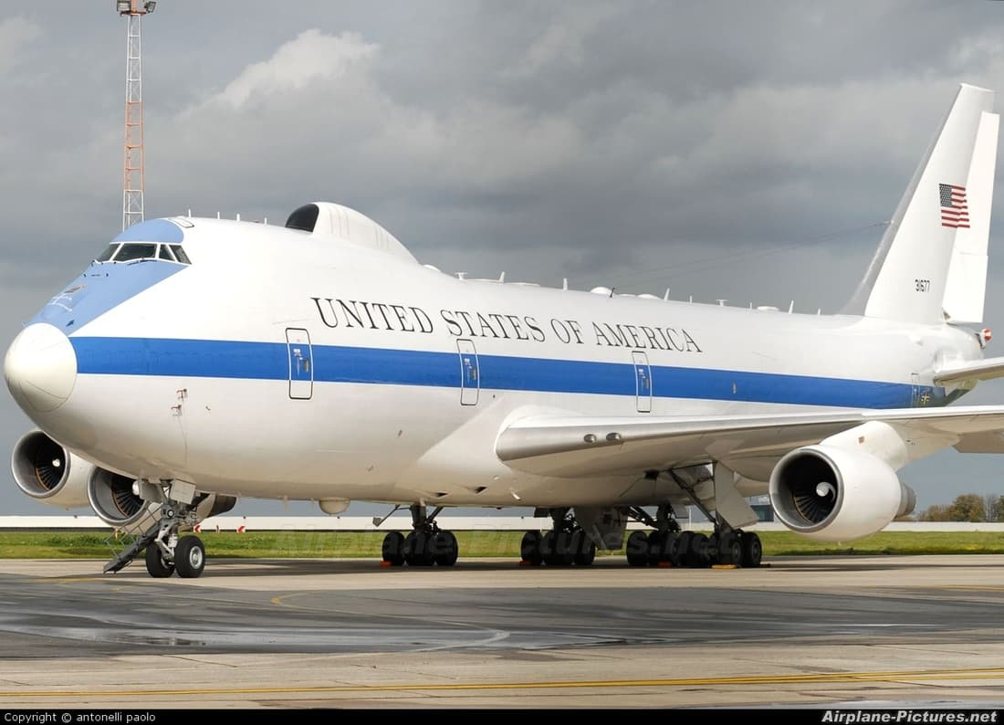

Amazing Air Force One Facts About Air Force One
BY JOEL KLEIN | OCT 07 2022
Air Force One is a massive flying container of secrets. There’s still so much we don’t know, but lucky for us, a few presidents have leaked facts about Air Force One that are pretty unbelievable.
Air Force One is so much more than a private jet for the POTUS. It’s a top secret vault in the sky, and that vault has just been cracked. Here are some things that nobody knew about Air Force One, until now…
Let’s take a closer look.

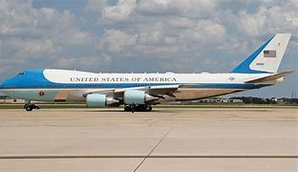

How Fast And How High?

Air Force One can fly over 700 miles per hour. That’s really fast! It can also fly higher than most commercial planes, at a height of 45,000 feet. That’s 10,000 feet higher than the normal cruising altitude of any other passenger airliner.
Despite its crazy speed, Air Force One flies very smoothly.

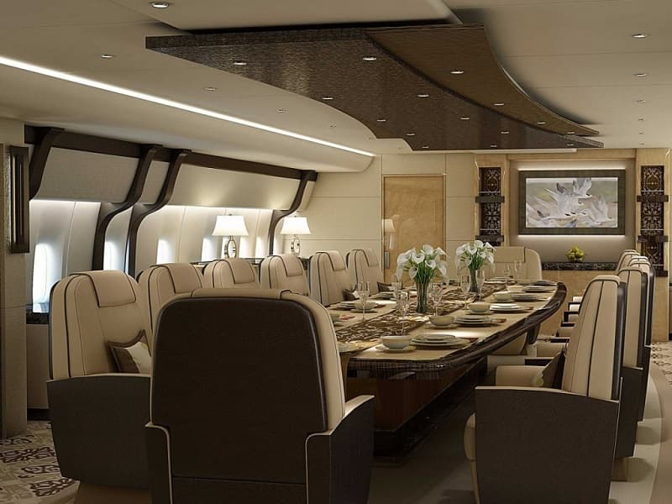

Air Force One Never Has To Touch Ground

This is probably one of the coolest facts about Air Force One. Air Force One can refuel in the sky. It never has to touch ground. If it wanted to, it could fly forever.
It can keep the president in the sky as long as it has to. Another cool fact: Air Force One has a 3,000 gallon fuel tank.

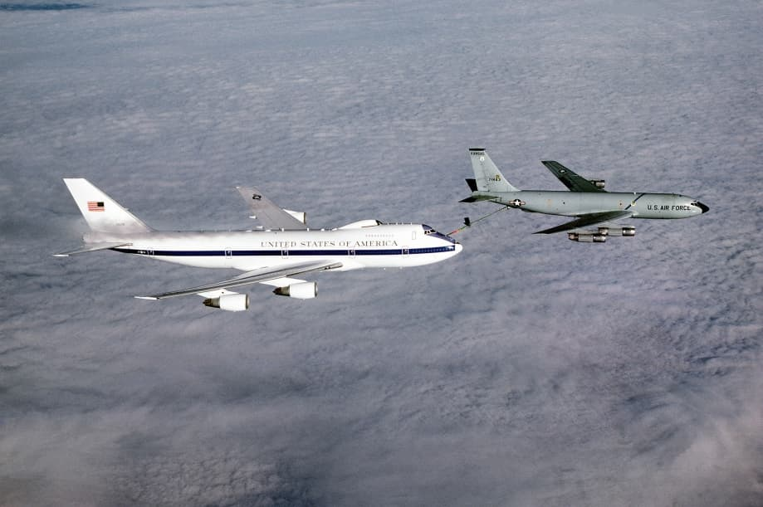

Air Force One Has Two Restaurants On Board
There are essentially two restaurants aboard Air Force One – well, they’re two massive kitchens that always have food available. The president and his guests can have anything they desire Air Force one is staffed with top rated chefs, and each kitchen holds up to 100 people.
That’s pretty big!

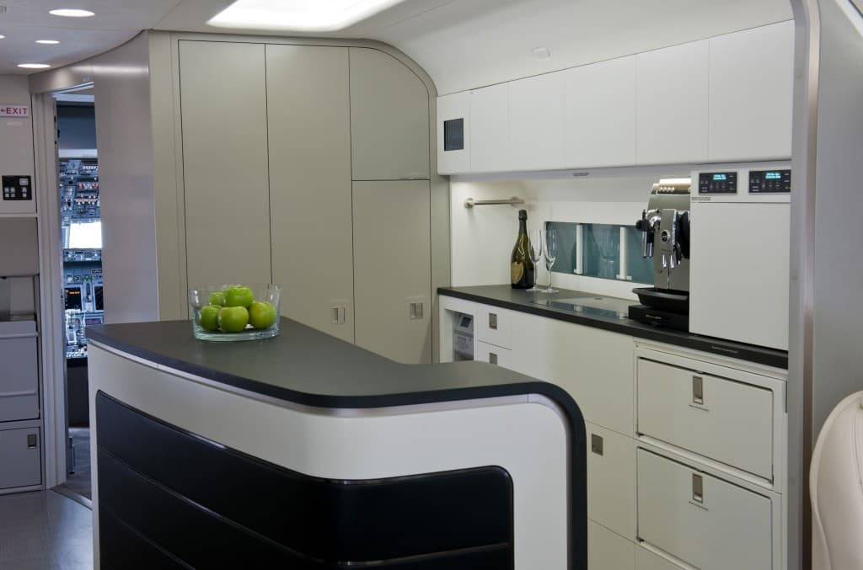

Phones Are Everywhere

Air Force One has over 85 phones. But why? Well, it’s the most secure place the president can talk, even over the White House. The Airborne Executive Phone has a light on the back that lights up red when secure.
There are dozens of less secure lines aboard for the press and staff that travel with the president.

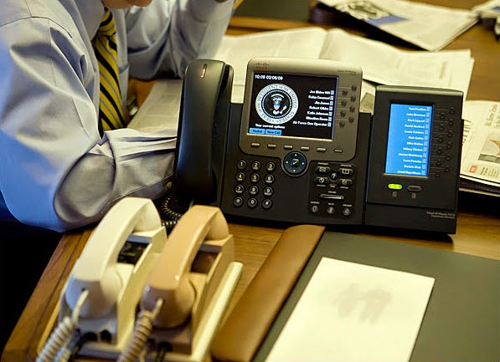

There Are Super Spy Cameras In The Wheel Wells
In 1959, President Eisenhower instructed Allen Dulles, the Director of Central Intelligence at the time, to install cameras in the wheel wells of Air Force One. These cameras were so powerful that even in 1959 they could read license plates from the sky.
No matter the reason for the installation, you can’t deny how unbelievable that is! It it continued to be believed by aviation experts that updated sky-to-ground camera tech continues be in use in various locations on the underbelly of the aircraft, including the wheel wells.

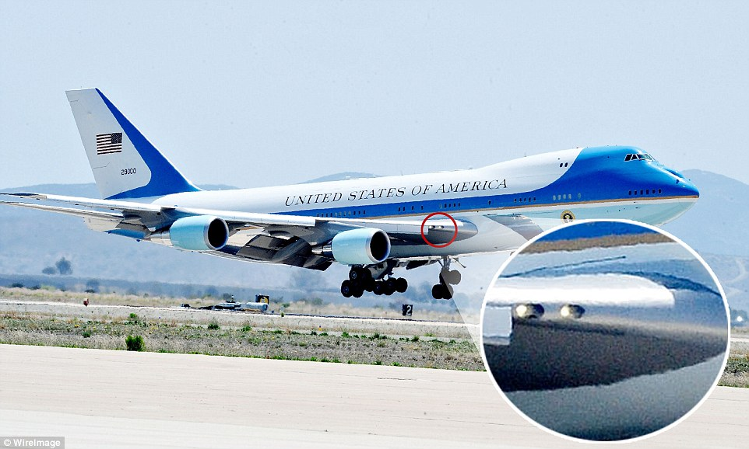
Who Are The Frequent Travelers Of Air Force One?
Air Force One is a place for family. It’s a place to exhale from all the hustle and bustle of the presidential life. The Secret Service travel with the family, as well as staffers and the journalists who live in a cabin at the very back of the plane.

Air Force One Is Large Enough To Be A House

Air Force One is large enough to be a house. It has three stories of 4,000 square feet. The president has his own large office, lavatory, and conference room.
There are private quarters for special guests, and all the furniture is exquisite like it belongs in some exotic mansion.
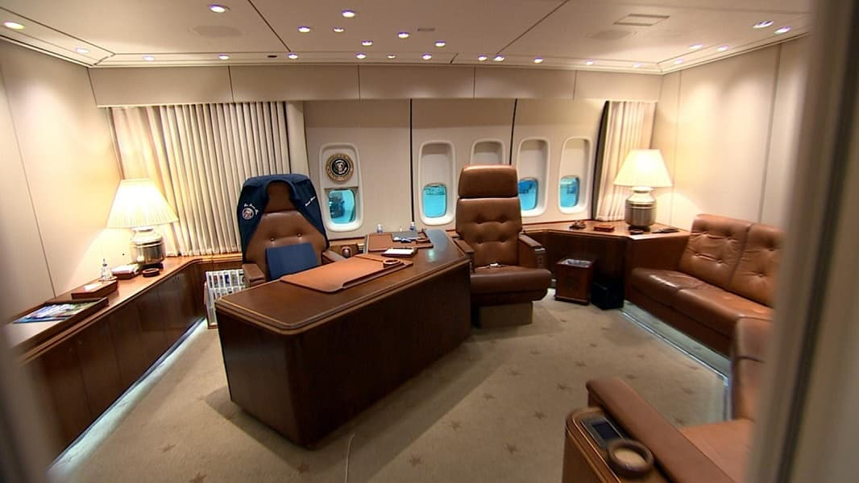

How Many People Does Air Force One Hold?

Air Force One can hold hundreds of people, but only safely seat 70. There are living quarters to accommodate more bodies, such as all of the senior advisors, Secret Service officers, reporters and special guests.

Yes, there are usually people without seats. The central seating area of the plane is reserved for the president and his family.

How Much Does Air Force One Cost To Fly?

The Air Force One costs $206,000 an hour to operate. That’s staggering compared to the $20,000 an hour it costs for a commercial airline.

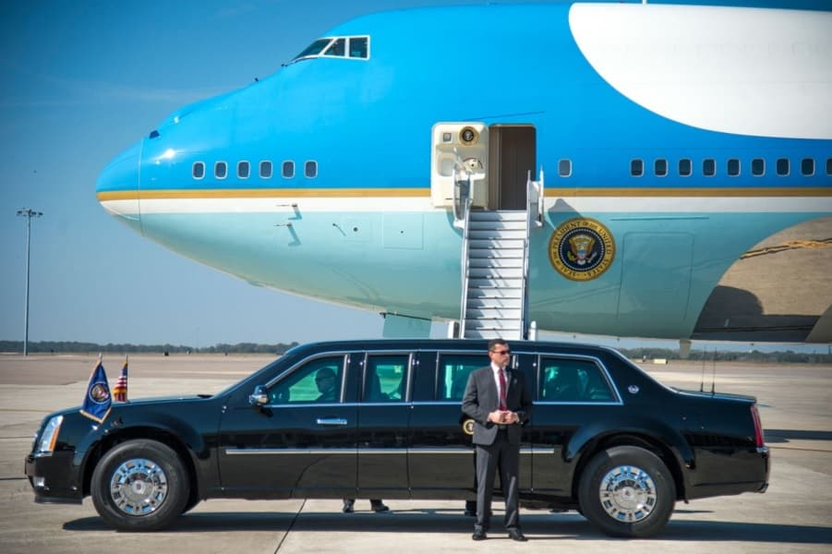

Air Force One Is Where Homeland Security Was Birthed

President George W. Bush signed the Department of Homeland Security into existence from onboard a flight on the Air Force One.

It was thousands of feet above Germany that this decision was made immediately following the attacks of September 11th. This decision has changed the inner-workings of our country forever.

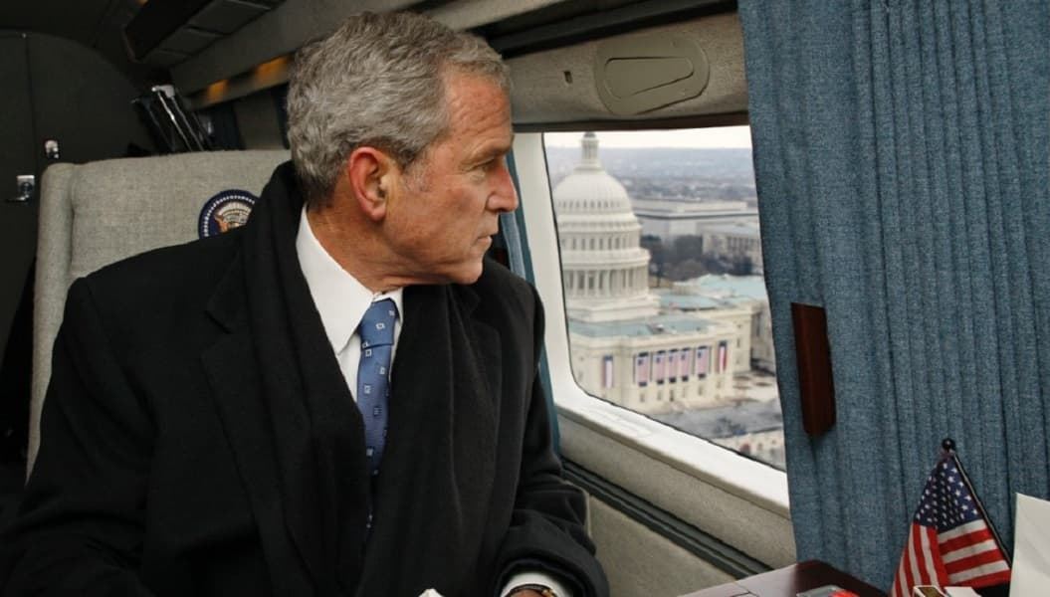

Air Force One Is Nuclear Resistant

Air Force One is pretty much a nuclear-resistant Oval Office. The plane can withstand a nuclear blast even if on the ground.

It has been put through testing to the equivalent of a nuclear attack. That’s comforting for sure. Let’s hope it’s never tried in real time.

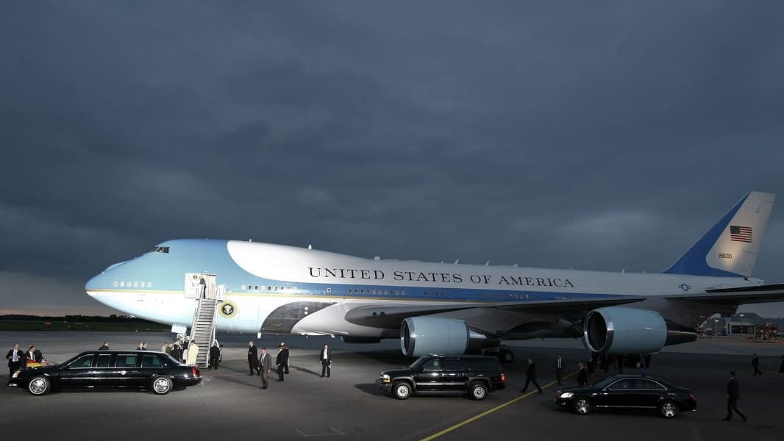

What Happens When The President Is Coming To Town?

When the president comes to town, the airport that hosts Air Force One is made aware. Then, the air space is cleared an hour before the president’s arrival.

When Air Force One lands, it’s self-contained. No need for outside services. From there, the president is transferred to Cadillac One aka “The Beast.”

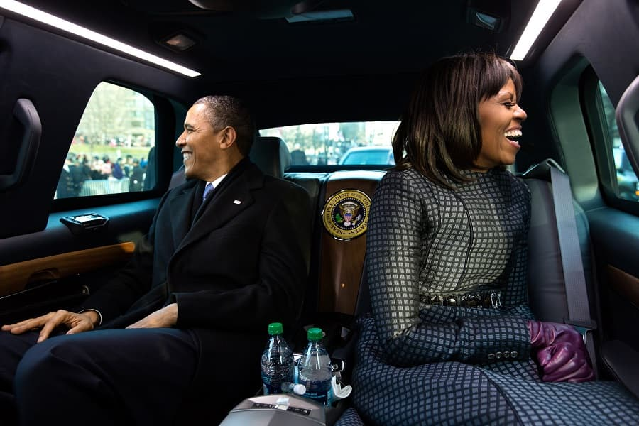

Sick On Air Force One? No Problem

If a passenger aboard the Air Force One gets sick, it’s no problem. There’s a miniature hospital built into Air Force One, with a doctor staffed at all times.
Air sickness is not an excuse to avoid travel on this well-equipped plane! And how cool would it be to be known as the “Air Force One doctor?”

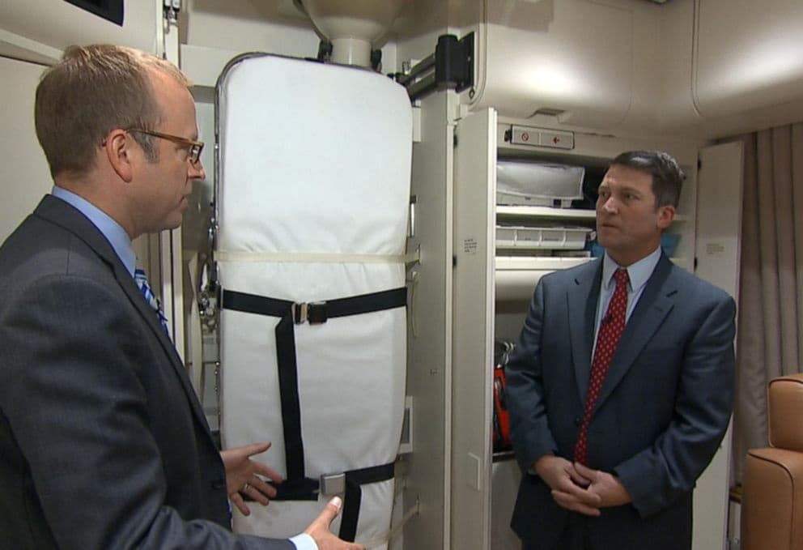

Jackie Kennedy Styled Air Force One

Most of the styles seen on Air Force One can be attributed to Jackie Kennedy. She carpeted it and picked out the china, crystal and silverware.
The USAF Museum in Dayton, Ohio still has all of her original furnishings, and Air Force One will always have some of Mrs. Kennedy’s flair.
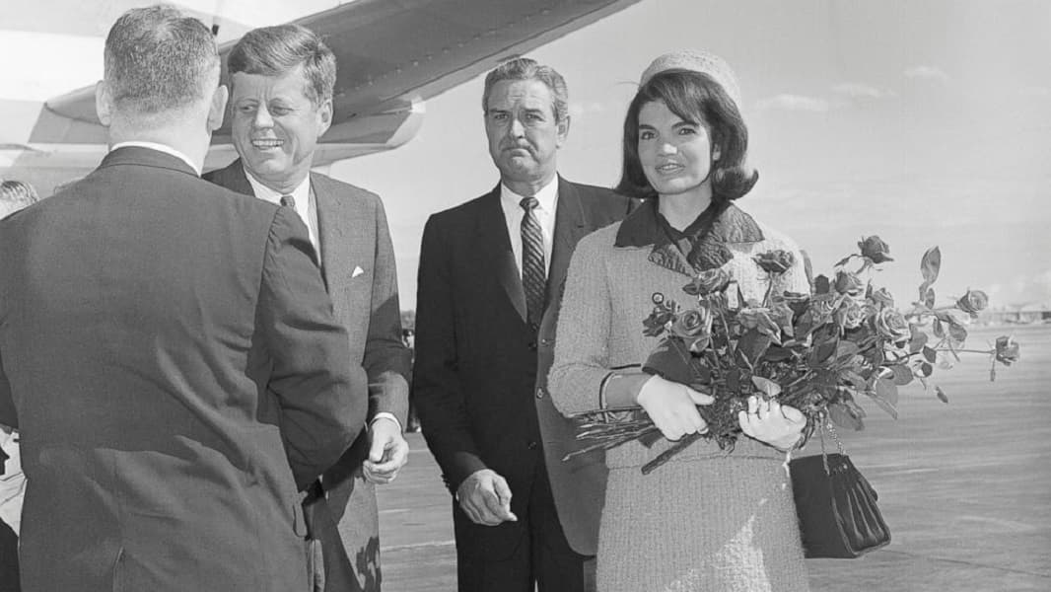

Air Force One Is An Airborne Command Center
The gear aboard Air Force One is top-notch with superb satellite communications networks and extremely classified defensive measures that not only protect the plane during an attack, but can carry out attacks as well.
Most of us will never know the commands that have been made aboard Air Force One.
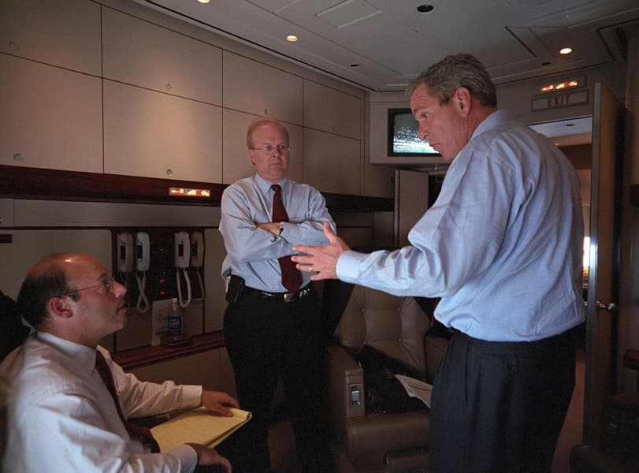

Why They Call Him “The Jelly Bean President

”
President Reagan had a quirk about him– he loved jelly beans! A jar of jelly beans awaited him every time he boarded Air Force One.

When Reagan was a child, a nice man gave him jelly beans during his tour to the White House. “I didn’t know then, but the jelly beans were much more than a sweet treat, they represented the uniqueness and greatness of America,” said Reagan.
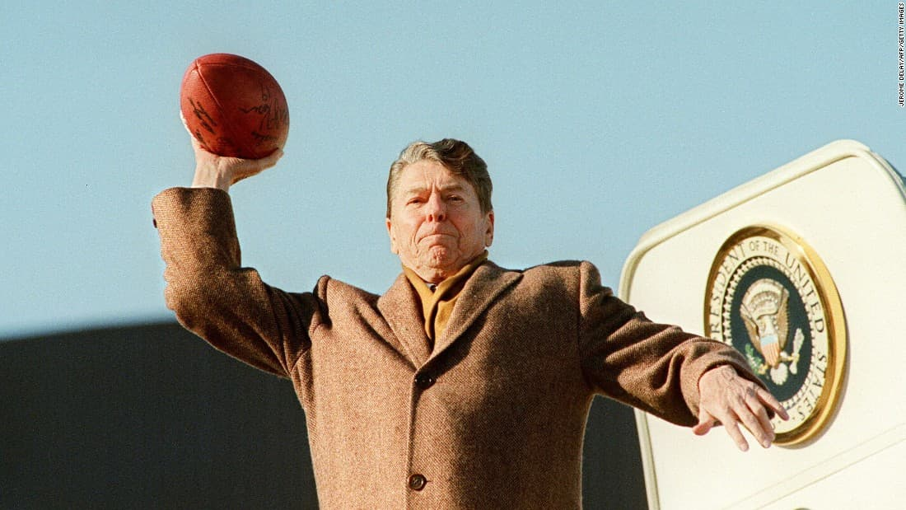

Air Force One Is Actually Air Force Three

There are two Air Force Ones, but only one is the real deal. They fly together so no one knows which one the president is actually on. “The Gulfstream,” known as the C-20C, is a jet that supposedly trails the other two planes, but the government and the Air Force deny it exists.
Interesting…
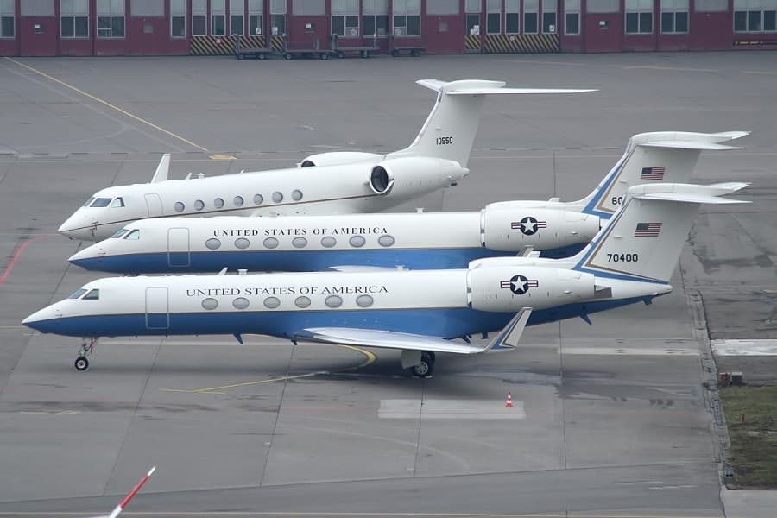

What Did President Bush Senior Outlaw On Air Force One?

President George H. W. Bush banned broccoli from the White House, but also on board the Air Force One. He didn’t want broccoli near anything his chefs where cooking up for him.

That’s pretty particular, but when you’re the president of the United States, what’re they going to say? Nothing.

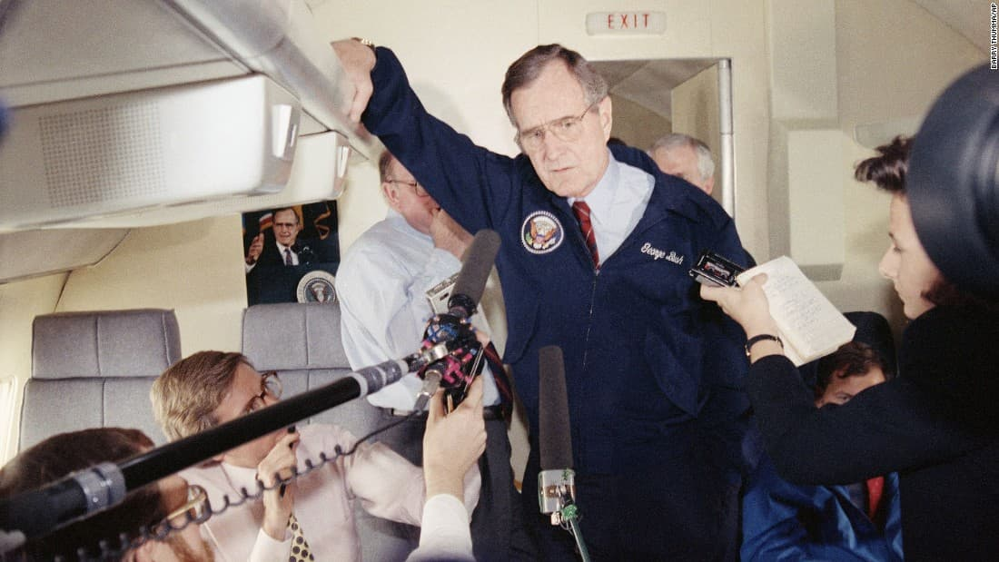

What Did President Ford Smuggle Onto Air Force One?

President Ford probably wins the gold for most outrageous request aboard the Air Force One. He always managed to get someone to smuggle Coors beer onto his flights. At that time, it was still illegal to buy in most states, but that doesn’t matter when you’re the president!
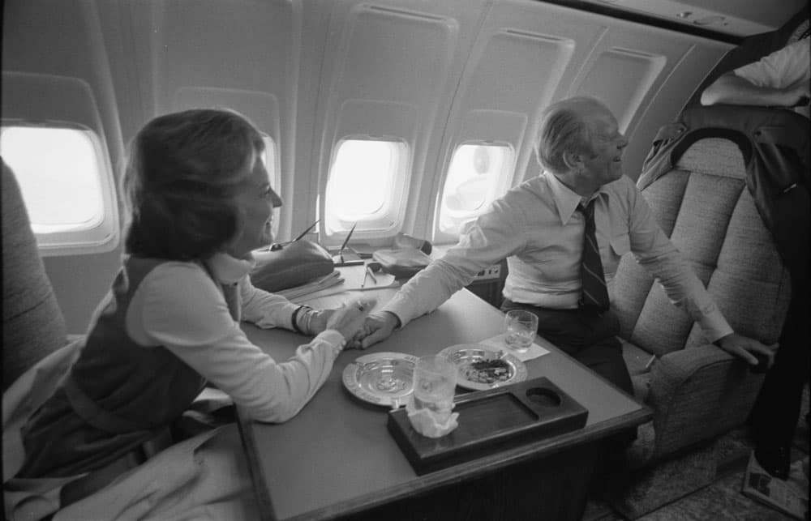

Source:

https://livestly.com/cl/look-inside-air-force-one/ss?utm_source=outbrain&utm_campaign=LIVDB2_OB_ALL_ALL_ShadowsAirForceOne_VM29&utm_medium=CNN+%28Turner+U.S.%29_CNN_008c008cc87ed9fc05c2a00070d487ce57&dicbo=v4-aD3IMuM-1081379394&utm_content=ab_ss_20230126_50_50-ss_cloud_layout

