Been to Las Vegas recently?

For all of us who haven’t visited Las Vegas recently, the next time you, or I, go, we will see how Artificial Intelligence (AI) has been so well adopted to make our visit different and hopefully, more gratifying. Many bartenders are no longer are pouring drinks – and no one is sure what they are now doing. In the restaurant, we will be served by a robot.

When we check it, we will check in, there will be a robot. Food is also prepared with robotics. In a few years, more jobs will be replaced with robots. Labor costs are reduced with robots who can work 24 hours a day.

No maternity leave, no retirement funding, no sick leave, no threats to strike, no pay issues, elimination of space, lockers, restrooms for staff.

Wherever the resort industry can replace their workers and not affect productivity, profits or the customer experience, is already happening, and no one expects that automation will be reversed.

A few accounting and data entry jobs are still alive.

Casino management recognizes that so much automation dehumanizes the resort experience, and they are trying to keep some “human touch” in the business, as many customers miss dealing with humans, who are not cold blooded machines.

This is a challenge for casino management.

==============================================

Robots are pouring drinks in Vegas. As AI grows, the city's workers brace for substantial changes.
Deepa Shivaram, NPR, September 4, 2023
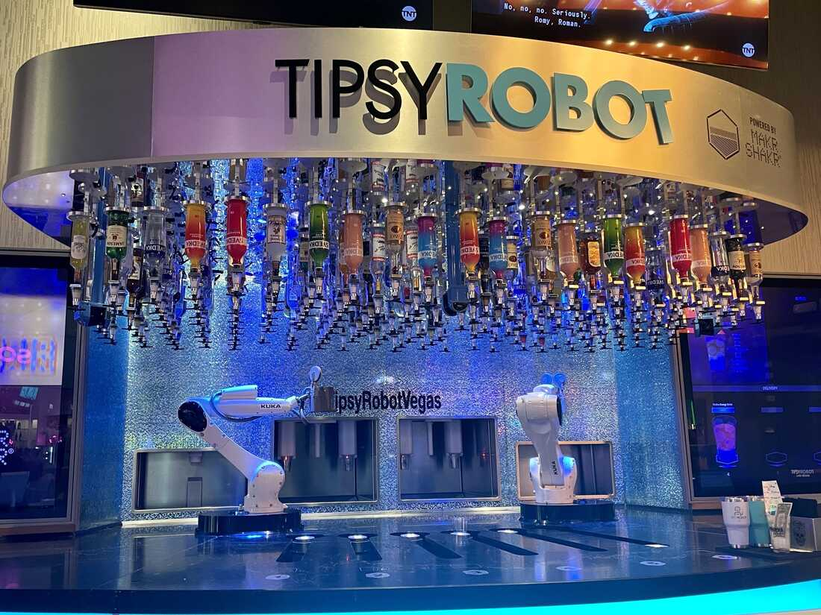
This bar inside Planet Hollywood on the Las Vegas strip has two robots that serve customers drinks. The Tipsy Robot opened a second location on the strip this year.

Walk any direction in Las Vegas and it is easy to find machines doing human work.
Check-in kiosks have replaced people at the front desk of hotels. Text-bots now make restaurant recommendations instead of a concierge. Robots can serve food, and behind the bar, these automatons are pouring taking orders, mixing, and serving out drinks.
Automation and technology replacing jobs has long been a conversation in Nevada's most populated city. Studies show that between 38% to 65% of jobs there could be automated by 2035.

With the use of artificial intelligence on the rise, the economy of this city --which relies on tourism and hospitality — is at an inflection point, as companies look to technology to reduce labor costs.
"Wherever the resort industry can replace their workers and not affect productivity, profits or the customer experience — wherever they can do that with artificial intelligence... they will," said John Restrepo, principal at RCG Economics in Las Vegas.
"The question is, how do you factor in and how do you adapt your economic development strategy, your community strategy, your resiliency strategy to accommodate a world where certain jobs no longer exist?" he said.
Restrepo said he believes the city must diversify its economy to be less reliant on tourism and hospitality.
"We need to move ... to those occupations that are more highly skilled, that are not easily replaced by AI and that provide a greater level of balance and resilience so we're not so hard-hit," Restrepo said.
The Culinary Union is prepared to strike over AI.
Unions in Las Vegas are closely watching the changes. The largest union in Nevada, the Culinary Union, represents 60,000 service and hospitality workers in Las Vegas and Reno. Later this year, it hopes to have a new negotiated contract that includes protections against AI replacing jobs.
"We had a huge fight about tech in our previous contract. We are going to have the same fight this time around," Ted Pappageorge, the secretary-treasurer of the union, told NPR.
In its last contract in 2018, the union pushed for companies to agree to a six-month warning for workers for modern technology introduced in the workplace, as well as free training on how to use the modern technology.

What is AI and how will it change our lives? NPR Explains.
"How do our folks make sure that the jobs that remain, that we can work them? And that we are not thrown out like an old shoe? We are not going to stand for that," Pappageorge said.
While the precise impact of AI on service work is not yet clear, the union is prepared to make AI an issue to strike over when it negotiates its new contract, Pappageorge said.
"We'd like to say we're going to be able to get an agreement. But if we must, we are going to have a big fight and do whatever it takes, including a strike on technology," he said.
AI and machines cannot replace the human touch, some workers say.
Sabrina Bergman works at the Tipsy Robot, a bar inside Planet Hollywood on the Las Vegas strip. Her job is to help the robot do its job, tending bars. When the robot accidentally tips over a cup, she resets it. If the robot does not pour a full drink, she tops it off.
Bergman said she is not worried about the machine replacing her entirely — even though the bar just opened a second location earlier this year.
Bergman and other service workers told NPR there are some human jobs that technology cannot eliminate. Machines do not have the same human touch and cannot provide the same experience, they said — and often, the machines add more work.
"We have a lot of guests that are regular guests, and they come for personal interaction. They do not come for the technology," said Holly Lang, a cocktail waitress at the MGM Grand. "There's some things you can't replace."
Lang said she is confident the Culinary Union will establish good protections. "A lot of people are concerned that it'll take our jobs, but we have more comfort in the fact that we have contracts to protect us ... we've fought hard to keep our jobs for a long time," Lang said.
It is not just service workers who will be affected.
Artificial intelligence will not just impact lower-wage jobs. Technology like ChatGPT, which is a form of generative AI, will impact white collar jobs, too, in fields like accounting and data entry.
In some cases, AI will help make workers more productive, while other roles might be eliminated entirely. AI is also likely to create brand new jobs that do not even exist yet.

Congress wants to regulate AI, but it has a lot of catching up to do
Las Vegas city officials are starting to brace workers for that shift now. In August, the local Chamber of Commerce hosted a panel on using AI. A few dozen people attended, including Tony Yee, who owns a small moving company in the city.
He said he wants to learn how to use AI to build his company and use the technology to help him with tasks like dealing with customer evaluations.
"I am really intrigued with AI, and I know it's the next frontier. It is just like how people did not believe on the internet in the '90s," Yee said.
"This is the next revolution, and if you're not on board, you're going to be left behind. And I don't want to be left behind."

