Russian Moonshot a Dud. Failure casts serious doubts about Russian advance capabilities.
Russia's first moon mission in more than four decades failed as its Luna-25 space craft crashed into the moon. Failure suggests that Russian advance science projects are in decline.
Failure also jeopardizes future planned joint space ventures with China.
The Indians, spending less than either the Russians or Americans, would like to show the world their Chandrayaan-3 space launch which will disclose to the world their space capabilities soon. On August 21, 2023 the Indian space shot was a success.
================================================
SOURCE:

Russia's first lunar mission in 47 years smashes into the moon in failure
By Guy Faulconbridge, Reuters, August 20, 2023
on Saturday.
- MOSCOW, Aug 20 (Reuters) - Russia's first moon mission in 47 years failed when its Luna-25 space craft spun out of control and crashed into the moon after a problem preparing for pre-landing orbit, underscoring the post-Soviet decline of a once mighty space programme.
- Russia's state space corporation, Roskosmos, said it had lost contact with the craft at 11:57 GMT on Saturday after a problem as the craft was shunted into pre-landing orbit. A soft landing had been planned for Monday.
- "The apparatus moved into an unpredictable orbit and ceased to exist as a result of a collision with the surface of the Moon," Roskosmos said in a statement.
- It said a special inter-departmental commission had been formed to investigate the reasons behind the loss of the Luna-25 craft, whose mission had raised hopes in Moscow that Russia was returning to the big power moon race.
- The failure underscored the decline of Russia's space power since the glory days of Cold War competition when Moscow was the first to launch a satellite to orbit the Earth - Sputnik 1, in 1957 - and Soviet cosmonaut Yuri Gagarin became the first man to travel into space in 1961.
- It also comes as Russia's $2 trillion economy faces its biggest external challenge for decades: the pressure of both Western sanctions and fighting the biggest land war in Europe since World War Two.
- Though moon missions are fiendishly difficult, and many U.S. and Soviet attempts have failed, Russia had not attempted a moon mission since Luna-24 in 1976, when Communist leader Leonid Brezhnev ruled the Kremlin.
- Russian state television put news of the loss of Luna-25 at number 8 in its line up at noon and gave it just 26 seconds of coverage, after a news about fires on Tenerife and a 4 minute item about a professional holiday for Russian pilots and crews.
- FAILED MOONSHOT
- Russia has been racing against India, whose Chandrayaan-3 spacecraft is scheduled to land on the moon's south pole this week, and more broadly against China and the United States which both have advanced lunar ambitions.
- 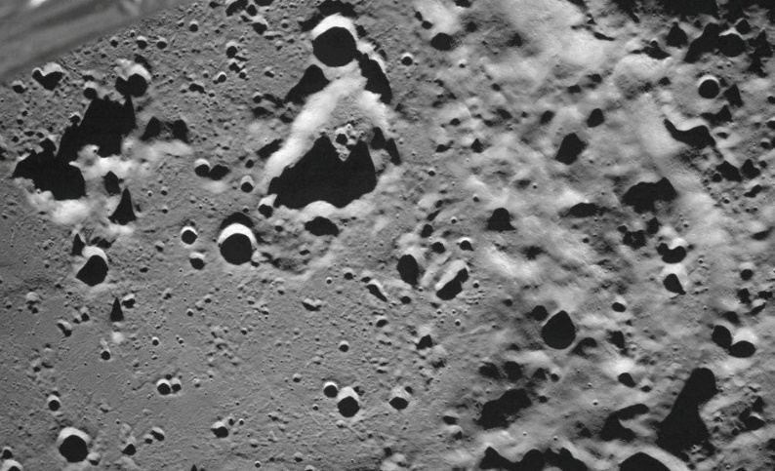
- FILE PHOTO: A picture taken from the camera of the lunar landing spacecraft Luna-25 shows the Zeeman crater located on the far side of the moon, August 17, 2023. Roscosmos/Handout via REUTERS ATTENTION EDITORS - THIS IMAGE HAS BEEN SUPPLIED BY A THIRD PARTY. MANDATORY CREDIT./File Photo Acquire Licensing Rights

- As news of the Luna-25 failure broke, the Indian Space Research Organisation (ISRO) posted on X, formerly Twitter, that Chandrayaan-3 was set to land on Aug. 23.
- Russian officials had hoped that the Luna-25 mission would show Russia can compete with the superpowers in space despite its post-Soviet decline and the vast cost of the Ukraine war.
- "The flight control system was a vulnerable area, which had to go through many fixes," said Anatoly Zak, the creator and publisher of www.RussianSpaceWeb.com which tracks Russian space programmes.
- Zak said Russia had also gone for the much more ambitious moon landing before undertaking a simpler orbital mission - the usual practice for the Soviet Union, the United States, China and India.
- While Luna-25 went beyond the earth's orbit - unlike the failed 2011 Fobos-Grunt mission to one of the moons of Mars - the crash could impact Russia's moon programme, which envisages several more missions over coming years including a possible joint effort with China.
- Russian scientists have repeatedly complained that the space programme has been weakened by poor managers who are keen for unrealistic vanity space projects, corruption and a decline in the rigour of Russia's post-Soviet scientific education system.
- "It is so sad that it was not possible to land the apparatus," said Mikhail Marov, a leading Soviet physicist and astronomer.
- Marov, 90, was hospitalised in Moscow after news of the failure of Luna-25 was announced, although details of what he was ill with were not available.
- Marov told the Moskovsky Komsomolets newspaper that he hoped the reasons behind the crash would be discussed and examined rigorously.
- "This was perhaps the last hope for me to see a revival of our lunar program," he said.
- Reporting by Guy Faulconbridge Additional reporting by YP Rajesh in New Delhi Editing by Christina Fincher and Frances Kerry
- =======================================================
India Eyes Moon Victory Amid Moscow Flop
Country could now become the first to land on unexplored south pole on Aug. 23
BY VIBHUTI AGARWAL, The Wall Street Journal | Page A008Monday, 21 August 2023
NEW DELHI—The crash of a Russian spacecraft left India better poised to become the first country to land on the moon’s unexplored south pole, an achievement that would solidify its position as a major space power amid renewed global interest in lunar exploration.
The Indian Space Research Organization, the country’s space agency, said on Sunday that its spacecraft had successfully slowed down and would await sunrise in the challenging terrain before attempting a landing on Aug. 23.
If India’s lander is able to set down safely on Wednesday, it would be a moment of intense national pride.
“Chandrayaan-3 scripts a new chapter in India’s space odyssey. It soars high, elevating the dreams and ambitions of every Indian,” Prime Minister Narendra Modi said on X, the platform previously known as Twitter, after India launched its unmanned spacecraft in July.
The mission is India’s second bid to land on an area of the moon that scientists believe could hold water, and perhaps support a future human settlement. Chandrayaan- 3 means “moon craft” in Hindi.
As India’s landing date approached, India found itself in a race with Russia, which launched its Luna-25 spacecraft earlier this month, and aimed to make a landing attempt on the lunar south pole on Aug. 21, days ahead of the India craft. But on Sunday Russian authorities said that the country’s first mission to the moon in nearly 50 years had ended in disaster after the unmanned vehicle crashed while preparing to land. An ISRO official expressed sadness over the mission’s failure. “We were hoping to meet on the moon,” said the official.
A successful moon landing for India would catapult it into an elite club of space-faring nations. China became the third country to land there, after the U.S. and Russia, when it safely set down its Chang’e- 4 probe on the far side of the moon in 2019.
India’s space activities are funded by a budget that is a fraction of what the U.S. or China can count on. In its latest budget, the country earmarked $1.5 billion for its Department of Space, which includes funding for ISRO. The budget for the U.S. National Aeronautics and Space Administration stands at around $25 billion.
Ram Jakhu, professor of space law at Canada’s McGill University, said the Chandrayaan- 3 will provide momentum to India’s space collaboration with other countries, including emerging economies that hope to develop their own space programs.
India’s travel time to the moon of about 40 days is longer than Russia’s because of the Chandrayaan-3’s heavier payload and more-limited fuel storage compared with the Luna-25. India sent its spacecraft on a route of loops around the Earth and moon to take advantage of gravity and economize on fuel.
============================================================

