Latest news on Julie Su

Su’s nomination as Secretary of Labor is in trouble

This is a note from our Historian Roger Dong. Julie Su is a relative of mine and does not have a link to Taiwan. She and her family, as well as my family, are all Cantonese from the village of Hsuen-du, Kwantung (Canton).

Julie is Chinese, female and a Californian.

Three strikes and you’re out.

Or maybe better put, Three strikes and you’re not in.

===============================================

Julie Su’s confirmation as Labor Secretary in serious jeopardy
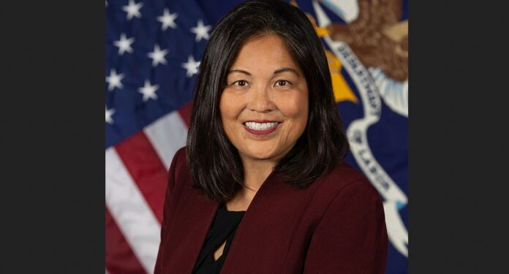
Julie Su -Department of Labor photo
BY NIGEL WHAN, AsAmNews, JULY 13, 2023
A Biden administration official criticized Senators Joe Manchin (D-WV) and Krysten Sinema (I-AZ) for apparently announcing that they plan to vote against approving Julie Su, Biden’s choice for Labor Secretary, reports Politico.
Julie Su is a Chinese and Taiwanese American attorney who has been serving as Biden’s acting Secretary of Labor since February, but Senatorial confirmation has eluded her. She would be the Biden administration’s first Asian American cabinet secretary if confirmed.
Manchin called the Stanford-and-Harvard-educated official’s credentials “impressive,” but said he decided to vote against her confirmation over a “genuine concern” over ideology.
Manchin objected to her “progressive background,” saying it would prevent her from forging compromises between labor and employers.
Sinema has avoided publicly declaring her position on Su’s confirmation, but the comments from the White House imply that she has privately signaled her no vote. Sinema reportedly does not usually forecast her votes.
Since no Republicans are expected to support her nomination, Su can only lose one Democratic-caucusing Senator and still win her confirmation. No Republican is considered likely to flip; but Manchin might accept her appointment in return for promises on labor policy, especially as he has expressed concern with her ideology, rather than competence.
The White House official said “President Biden and his team continue fighting for Acting Secretary of Labor Julie Su’s confirmation — because she is highly qualified, experienced, and has proven herself time and time again when it comes to delivering for America’s workers and our economy,” adding “We hope, Senator Manchin and Senator Sinema reconsider their position.”
NBC reports Su could potentially continue in the acting secretary as there is no time limit for someone to serve in a temporary capacity.
Su managed to win Manchin’s support two years ago for her current position of Acting Labor Secretary, but now it is elusive.
Su has the strong backing of many labor unions and Asian American and Pacific Islander organizations, including the ALF-CIO, the largest federation of unions in the United States. AFL-CIO spokesperson Ray Zaccaro described their support for her, telling Politico “Julie Su has been a champion for labor, and labor is mobilizing in the way only we can.”
Before joining the Biden administration, Su was California’s Secretary of Labor, where she created a series of 10-year “moonshot” proposals for reimagining work in more equitable ways.
AsAmNews is published by the non-profit, Asian American Media Inc.
==================================================
Say No to Julie Su at Labor
The Wall Street Journal | Page A013, 21 July 2023
The past few years have been tough on American workers: the sudden loss of jobs and income during the pandemic, inflation and the overall sense of economic uncertainty have all taken a toll. The White House might feel good about re-branding America’s lackluster economy under the laughable banner of “Bidenomics,” but for Americans struggling to make ends meet, President Biden’s economic policies only signal more pain to come.
Look no further than acting Labor Secretary Julie Su, whose permanent nomination to the post the Senate is considering. Before joining Mr. Biden’s Labor Department, Ms. Su served as secretary of the California Labor and Workforce Development Agency under Gov. Gavin Newsom.
Ms. Su oversaw the disastrous rollout of California’s AB5, which reclassified tens of thousands of independent contractors as employees as a favor to Big Labor. It was so unpopular and unworkable that the California Legislature enacted a second law creating a laundry list of exempted industries and professions. California voters approved a ballot initiative to protect drivers for Uber, Lyft and other apps from being labeled employees.
Ms. Su also championed the FAST Recovery Act, which created an unaccountable bureaucracy to control wages and working conditions at fast-food restaurants. This anticompetitive bargaining tactic undermines the autonomy of independent businesses while forcing partisan union priorities onto workers.
Though Mr. Newsom signed it into law last year, Californians succeeded in gathering enough signatures to put the measure on the ballot in the hopes of stopping its implementation.
If these case studies in Ms. Su’s command-and-control labor economics aren’t concerning enough, consider how Americans have been voting— with their feet.
The most recent census data show that liberal states like New York and California are no longer the economic powerhouses they once were. The fastest-growing region in the U.S. is the South—and it’s growing in direct opposition to the liberal consensus. A recent report found for the first time in U.S. history, the economic output of six states in the South—Florida, Texas, Georgia, North Carolina, South Carolina, and Tennessee— is outpacing the North-east corridor.
Besides better scenery and milder winters, these new economic centers have a few important things in common: They are right-to-work states with lower average costs of living and, consequently, higher quality of life.
The first advantage would be immediately gutted by the Biden-Su agenda. Both have advocated for the passage of the Protecting the Right to Organize Act. This coercive bill would strip workers of their right to decline to join a union, which more than half of states protect.
The PRO Act would forcibly unionize millions of American workers. It would also tip the scales for union organizers by doing away with secret-ballot votes and automatically turning over personal contact information to make it easier for organizers to harass workers into union membership. We don’t even have to imagine what Ms. Su’s implementation would look like. The PRO Act contains some of the same tests and standards included in AB5. She also established a Criminal Investigation Unit, consisting of a specialized labor police force that would be deputized against businesses.
The 50 states offer us real-time tests on policy outcomes. The South isn’t only booming, it’s also luring people away from states that have higher taxes, forced unionization and ever-increasing costs of living. In this new American migration, the Northeast and California are bleeding talent and capital, most of which find its way to places like our home state of North Carolina, where businesses can more easily build and where workers already want to be.
Unless we want to strangle this economic progress, we can’t afford for Ms. Su to take the top job at the Labor Department. We can either pursue the trajectory set by the booming South, or we can allow Mr. Biden’s bureaucrats to kneecap the nation’s economic future.
Mr. Budd, a Republican, is a U.S. senator from North Carolina. Mr. Voigt is Americans for Prosperity’s North Carolina state director.

