HOLY STROKES!

Why are we talking about strokes again?

Yes, we are being redundant here, but a dozen members of Cathay Post have already had a stroke. They were not major strokes, so all are alive and living almost normal lives. But we were all lucky that we had ministrokes (aka: TIA). Most strokes are TIA strokes which is good news, but a few strokes are major strokes and are deadly. When a stroke strikes, there is damage to our brains. (That get your attention?)

Strokes are a danger that we all face, every day, so let’s check up on the signs of a potential stroke so we can save our own lives, or the life of one of our Post members, or someone in your family or a good friend.

Let’s review the warnings of a stroke from the Center of Disease Control so that none of us will be sorry for being unprepared.

When anyone has a stroke, someone must call 911. This step is Critical.

============================================================

Stroke Signs and Symptoms
Learn what to do if you or someone else is having a stroke.
During a stroke, every minute counts! Fast treatment can lessen the brain damage that stroke can cause.
By knowing the signs and symptoms of stroke, you can take quick action and perhaps save a life—maybe even your own.
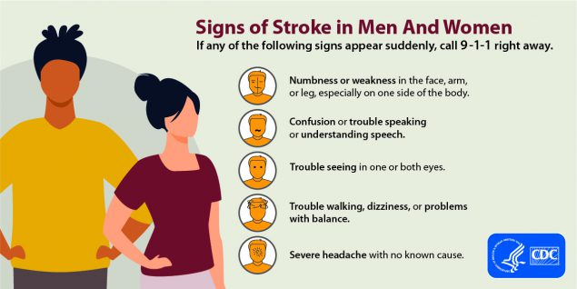

Call 9-1-1 immediately if any of these signs of stroke appear: Numbness or weakness in the face, arm, or leg; Confusion or trouble speaking or understanding speech; Trouble seeing in one or both eyes; Trouble walking, dizziness, or problems with balance; severe headache with no known cause.

What are the signs of stroke in men and women?
- Sudden numbness or weakness in the face, arm, or leg, especially on one side of the body.
- Sudden confusion, trouble speaking, or difficulty understanding speech.
- Sudden trouble seeing in one or both eyes.
- Sudden trouble walking, dizziness, loss of balance, or lack of coordination.
- Sudden severe headache with no known cause.
Call 9-1-1 right away if you or someone else has any of these symptoms. Even though 911 should be very aware of procedures for stroke victims. You should state that the victim appears to have had a stroke so they will send an EMT specialist who can dispense blood thinner to the victim.

