Who is Fei Fei Li?
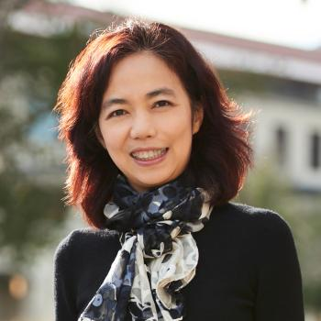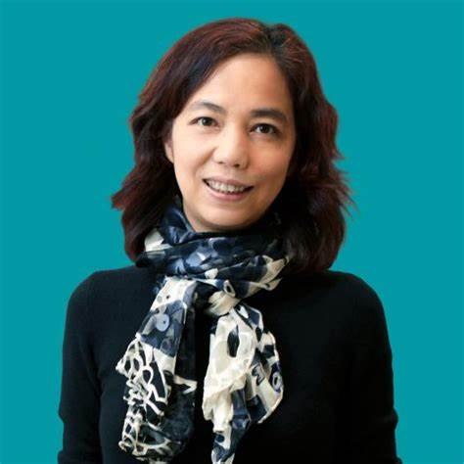
Most People don’t know who this Chinese American lady is. In fact, she is one of the smartest immigrants from China who today is one of the smartest Artificial Intelligence scientists in the world.
The following is quoted from Wikipedia:
QUOTE:
Dr Fei Fei Li is a Sequoia Capital Professor, Co-Director of the Stanford Institute for Human Centered Artificial Intelligence and Profess, by Courtesy, of Operations, Information and Technology at the Graduate School of Business.
Dr. Fei-Fei Li is the inaugural Sequoia Professor in the Computer Science Department at Stanford University, and Co-Director of Stanford’s Human-Centered AI Institute. She served as the Director of Stanford’s AI Lab from 2013 to 2018. And during her sabbatical from Stanford from January 2017 to September 2018, she was Vice President at Google and served as Chief Scientist of AI/ML at Google Cloud. Dr. Fei-Fei Li obtained her B.A. degree in physics from Princeton in 1999 with High Honors, and her PhD degree in electrical engineering from California Institute of Technology (Caltech) in 2005. She also holds a Doctorate Degree (Honorary) from Harvey Mudd College. Dr. Li joined Stanford in 2009 as an assistant professor. Prior to that, she was on faculty at Princeton University (2007-2009) and University of Illinois Urbana-Champaign (2005-2006).
Dr. Li has been working with policymakers nationally and locally to ensure the responsible use of technologies, including a congressional testimony on the responsibility of AI in 2018, her service as a member of the California Future of Work Commission for the Governor of California in 2019 - 2020, and a member of the National Artificial Intelligence Research Resource Task Force (NAIRR) for the White House Office of Science and Technology Policy (OSTP) and the National Science Foundation (NSF) in 2021-2022.
Currently at Stanford University she is:
Co-Director, Stanford Institute of Human-Centered AI (HAI) (2019 - Present)
Director, Stanford Artificial Intelligence Lab (SAIL) (2013 - 2018)
Her Honors and Awards:
Thomas S. Huang Memorial Prize, IEEE PAMI (2022)
Member, American Academy of Arts and Sciences (AAAS) (2021)
Member, National Academy of Medicine (NAM) (2020)
Member, National Academy of Engineering (NAE) (2020)
Distinguished Alumni Award Winner, California Institute of Technology (2020)
UNQUOTE
Dr. Lee was born in Beijing, China in 1976 and grew up in Chengdu. When she was 12, her father moved to the US; when she was 15, she and her mother joined him in Parsippany-Troy Hills, New Jersey.[13] She graduated from Parsippany High School in 1995 before entering into a very successful college career.
Artificial Intelligence is now dangerously linked with military science and weapons. Dr. Lee’s focus is to make AI serve humanity. Li told The New York Times, "I believe in human-centered AI to benefit people in positive and benevolent ways. It is deeply against my principles to work on any project that I think is to weaponize AI."
Dr Li is also known for her nonprofit work as the co-founder and chairperson of nonprofit organization AI4ALL, whose mission is to educate the next generation of AI technologists, thinkers and leaders by promoting diversity and inclusion through human-centered AI principles. The program was created in collaboration with Melinda Gates (Gates Foundation) and Jensen Huang (Founder of the very successful high tech firm, NVIDIA).
Dr Fei Fei Li is truly one of the greatest Chinese American female scientists who has dedicated her skills and knowhow to benefit America and Mankind.
Recent media reports that many Chinese American scientists are leaving the country, for a number of reasons, the most cogent is that Chinese Americans face violence for racial and political reasons.
===============================================================
SOURCE:
Chinese Scientists Are Leaving the United States
Here’s why that spells bad news for Washington.
By Christina Lu and Anusha Rathi, JULY 13, 2023
Facing an increasingly suspicious research climate, a growing number of Chinese scientists are leaving the United States for positions abroad, the latest indicator of how worsening U.S.-China relations are complicating academic collaboration and could hamstring Washington’s tech ambitions.
Chinese scientists living in the United States have for decades contributed to research efforts driving developments in advanced technology and science. But a growing number of them may now be looking elsewhere for work, as deteriorating geopolitical relations fuel extra scrutiny of Chinese researchers and Beijing ramps up efforts to recruit and retain talent. Between 2010 and 2021, the number of Chinese scientists leaving the United States has steadily increased, according to new research published last month. If the trend continues, experts warn that the brain drain could deal a major blow to U.S. research efforts in the long run.
“It’s absolutely devastating,” said David Bier, the associate director of immigration studies at the Cato Institute. “So many of the researchers that the United States depends on in [the] advanced technology field are from China, or are foreign students, and this phenomenon is certainly going to negatively impact U.S. firms and U.S. research going forward.”
From semiconductor chips to artificial intelligence, technology has been at the forefront of U.S.-China competition, with both Washington and Beijing maneuvering to strangle each other’s sectors. Cooperation, even in key sectors like combating climate change, has been rare.
From 2010 to 2021, the number of scientists of Chinese descent who left the United States for another country has surged from 900 to 2,621, with scientists leaving at an expedited rate between 2018 and 2021, according to research published in the Proceedings of the National Academy of Sciences (PNAS). Nearly half of this group moved to China and Hong Kong in 2010, the study said, and a growing percentage of Chinese scientists have relocated to China over the years.
While this number represents a small fraction of the Chinese scientists in the United States, the uptick reflects researchers’ growing concerns and broader apprehension amid a tense geopolitical climate. After surveying 1,304 Chinese American researchers, the report found that 89 percent of respondents wanted to contribute to U.S. science and technology leadership. Yet 72 percent also reported feeling unsafe as researchers in the United States, while 61 percent had previously considered seeking opportunities outside of the country.
“Scientists of Chinese descent in the United States now face higher incentives to leave the United States and lower incentives to apply for federal grants,” the report said. There are “general feelings of fear and anxiety that lead them to consider leaving the United States and/or stop applying for federal grants.”
The incentives to leave are twofold. Beijing has funneled resources into research and development programs and has long attempted to recruit scientists, even its own, from around the world. For one of its initiatives, the Thousand Talents Plan, Beijing harnessed at least 600 recruitment stations worldwide to acquire new talent. “China has been really trying to lure back scientists for a long time,” said Eric Fish, the author of China’s Millennials.
But this latest outflow of Chinese scientists accelerated in 2018, the same year that then-U.S. President Donald Trump unveiled the China Initiative, a controversial program that was aimed at countering IP theft—and cast a chill over researchers of Chinese descent and collaborations with Chinese institutions. In 2020, he also issued a proclamation denying visas for graduate students and researchers affiliated with Chinese universities associated with the military.
Although the Biden administration shut down the China Initiative, experts warn that its shadow still looms over Chinese scientists. More than one-third of respondents in the PNAS survey reported feeling unwelcome in the United States, while nearly two-thirds expressed concerns about research collaboration with China.
“There is this chilling effect that we’re still witnessing now, where there is a stigma attached to collaboration with China,” said Jenny Lee, a professor at the Center for the Study of Higher Education at the University of Arizona.

