Another H0-Hum day for Shohei Ohtani

On June 28, 2023 Shohei Ohtani, the Los Angeles Angels pitcher struck out 10 batters, and hit two (2) home runs. Shohei is constantly breaking records as a pitcher and home run hitter. He is well paid and earns it.

He will be a designated hitter in the next all star game.

=========================================

Source:

Shohei Ohtani hits two homers, strikes out 10
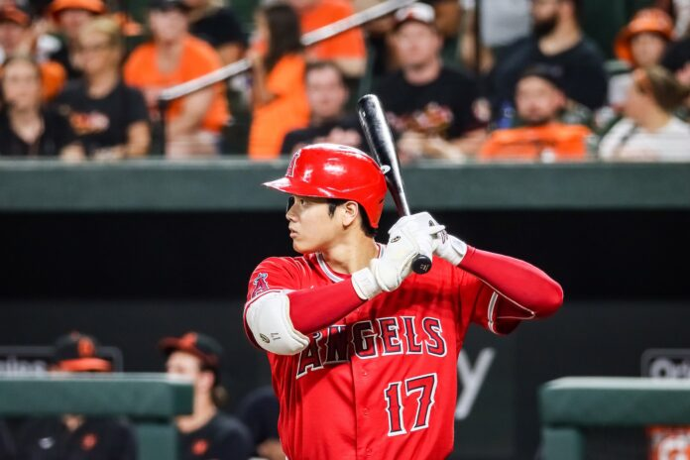 By Mogami Kariya via Wikimedia Creative Commons

BY AKEMI TAMANAHA, JUNE 28, 2023
Shohei Ohtani is continuing to wow baseball fans with his ability at the mound and at the plate.
On Tuesday night against the Chicago White Sox, Ohtani hit two home runs and struck out 10 hitters. According to MLB.com, he now leads the MLB with 28 home runs. He is the sixth player since 1900 to strike out at least 10 batters and hit two home runs in one game.
Ohtani wasn’t able to truly celebrate his first homerun, The Ringer reports. Normally, he would have donned the samurai helmet he purchased for celebrations and enjoyed the congratulations from his teammates.
One more note – On Friday June 30, 2023 Shohei Ohtani hit a 493 foot home run, the longest home run of this season.
When he joins another team next year, his salary will be out of sight!!!

