Both Koreas Have Space Ambitions to launch Reconnaissance satellites
The South succeeded in its first launch of multiple systems in June but the North Koreans failed their first launch in May.
Attaining satellite technology will allow the countries to identify military targets to precisely launch strikes during potential conflict without relying on their allies’ satellite technology for information. Neither side has a long range testing, although only the North needs a long range test facility to allow them to target the United States. The South’s missiles only need to fly a few miles to target Pyongyang and other N. Korean targets. The South also has cooperation from the U.S., and there is no evidence that China is aiding the N. Koreans in their space, or other ambitions.
The South Koreans successfully launched their Nuri rocket lifting five (5) satellites into space.
In May, a North Korea attempt to launch their first satellite failed on the launch pad. This is a very seriously setback for the North Koreans. The have conducted a hundred rocket tests since 2022 and are obviously very serious about their rocketry and satellite capabilities.
Everyone is closely monitoring the N. Korea’s rocket/missile activities.
======================================================

SOURCES:

South Korea launches homegrown Nuri rocket carrying satellites into orbit
By Jessie Yeung, Yoonjung Seo and Gawon Bae, CNN, Tue June 21, 2022

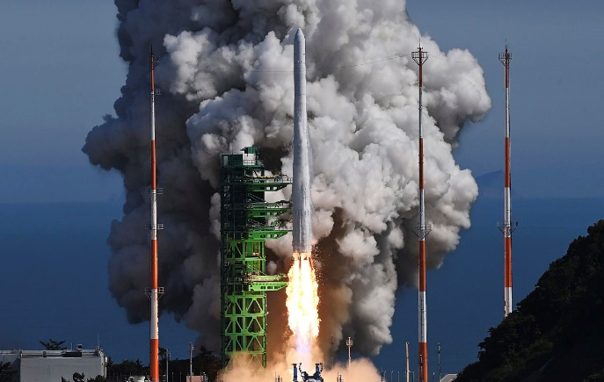
South Korea's homegrown Nuri rocket lifts off at the Naro Space Center in Goheung on June 21. AP
Seoul, South Korea CNN —
South Korea successfully launched satellites into orbit with its homegrown Nuri rocket on Tuesday, a significant step for the country’s burgeoning space program after a failed attempt last year.
The three-stage rocket, more than 47 meters (154 feet) long and weighing 200 tons, was launched from the Naro Space Center in the country’s southern coastal region at 4 p.m. local time.
It was topped with five satellites that will carry out Earth observation missions, such as monitoring the atmosphere, for up to two years, as well as a 1.3-ton dummy satellite, according to the country’s Science Ministry.
“The road from South Korea to space has opened now,” said President Yoon Suk Yeol after the launch. “It’s the fruit of the difficult challenges of the past 30 years. Now, our Korean people and our young people’s dream and hope will reach toward space.”
Prior to South Korea’s mission on Tuesday, only Russia, the United States, the European Union, China, Japan and India had developed a space launch vehicle capable of carrying a satellite weighing more than 1 ton, according to the Korea Aerospace Research Institute (KARI).
South Korea first tried to launch a dummy satellite with the Nuri rocket last October. The attempt failed when the rocket’s third-stage engine shut down and the dummy satellite failed to reach low Earth orbit.

Burgeoning space industry
South Korea has struggled to keep up with its Asian neighbors in the space race.
Its first two carrier rocket launches in 2009 and 2010 used Russian-developed engines, and both failed to reach orbit. In 2013, South Korea finally succeeded in sending a carrier rocket into low Earth orbit – but this, too, was developed using Russian technology.
Since 2010, South Korea has invested nearly 2 trillion Korean won (about $1.5 billion) in building the three-stage Nuri – which means “world” in Korean. Nuri is the country’s first rocket using its own technology, opening the door to a range of future satellites and missions.

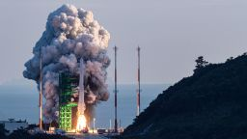
South Korea fails to put dummy satellite into orbit

A total of 300 South Korean companies took part in developing the rocket, according to KARI.
KARI head Ahn Sang-il has previously said the rocket’s success would allow South Korea more autonomy in its space program.

“In the past, cube satellites were launched using rockets in other countries but from this launch, we’ll have an opportunity to load Korean-made cube satellites to a rocket also made in Korea,” he told a news briefing in April. “We can have our satellites launched according to our own needs and at the right timing for us from this launch.”
After the failed attempt last year, then President Moon Jae-in said South Korea planned to launch the rocket five more times by 2027.
The country has other space projects in the works: its first lunar orbiter, developed in partnership with NASA, is expected to launch in August next year. It will orbit the moon for about a year, marking the first South Korean mission to travel beyond Earth’s orbit.

=====================================================
Both Koreas Hold Big Space Ambitions
The Wall Street Journal | Page A008, Friday, 26 May 2023
SEOUL—The two Koreas are elevating a space race aimed at modernizing how each country monitors the other’s improving military firepower.
As hopes for a diplomatic breakthrough have dimmed in recent years, North and South Korea have grown more antagonistic toward one another and upped their displays of military might. They have traded missile tests. Pyongyang has sent drones that flew over downtown Seoul. South Korea has sharpened security and defense ties with the U.S. and Japan.
The rise in tensions has elevated the importance—and need—for spy-satellite technology that neither country now has.
South Korea cleared a significant technological marker on Thursday, launching multiple commercial satellites aboard a homegrown rocket for the first time. North Korea’s Kim Jong Un regime stands poised to soon fly its first military reconnaissance satellite.
Nuri, South Korea’s three-stage liquid-fuel rocket, blasted off at 6:24 p.m. local time Thursday from the Naro Space Center in Goheung. The 200 ton rocket launched into space and deployed eight satellites into orbit about 342 miles above Earth.
Seoul has the clear technological advantage, weapons analysts say, though Pyong-yang has been quick to advance its sanctioned missile program to develop long-range rockets that can carry satellites. Both nations remain years away from having a full-fledged network of spy satellites. But attaining the technology would allow the countries to identify military targets to precisely launch strikes during potential conflict without relying on their allies’ satellite technology for information.
In North Korea’s case, space-based satellite technology is essential for its nuclear strategy. Having eyes in the sky would serve as an additional asset to launching nuclear strikes with better accuracy, said Yang Uk, a military expert at the Asan Institute for Policy Studies. Should the technology progress enough, North Korea could potentially identify nuclear strike targets in the U.S., he added.
“This triggers concerns for the U.S. and its neighbors in the region,” Yang said.
The U.S. possesses the most military satellites in the world, and allies like South Korea rely on Washington for information, such as monitoring the Kim regime’s strategic facilities. But Seoul has long held ambitions to harness an independent space reconnaissance program. Doing so, South Korean officials have said, would enable the country to keep an “unblinking eye” on their northern neighbors.
Furthermore, Seoul’s military has been in the process of regaining full operational control of its military from Washington, which South Korean President Yoon Suk Yeol said would require South Korea to secure and operate reconnaissance assets. South Korea’s homegrown rocket Nuri serves no military purposes, though the technology is overlapping and places the country among a rarefied group of nations that have developed rockets that can carry a satellite weighing more than 1 ton into space. The main satellite carried by Nuri is tasked with validating imaging radar technology and observing cosmic radiation, according to the science ministry.
As South Korea has vowed to strengthen its deterrence posture along with the U.S., it is important for the country to advance domestic technology that could aid the allies’ combined forces in countering North Korea, said Kim Gi-bum, an associate research fellow at the Korea Institute for Defense Analyses. “South Korea taking steps forward in space-based technology contributes to the joint posture of Washington and Seoul,” Kim said.
North Korea is preparing a satellite launch of its own. Last week, the country’s leader, Kim, examined the country’s first military reconnaissance satellite, calling it crucial in countering the U.S. and South Korea. The United Nations Security Council has banned North Korea from launching satellites into space, because such launches can be used to test long-range ballistic- missile technology.
=======================================================

North Korea calls botched spy satellite launch ‘most serious’ failure
By Hyung-Jin Kim and Kim Tong-Hyung, Associated Press, Monday, Jun 19

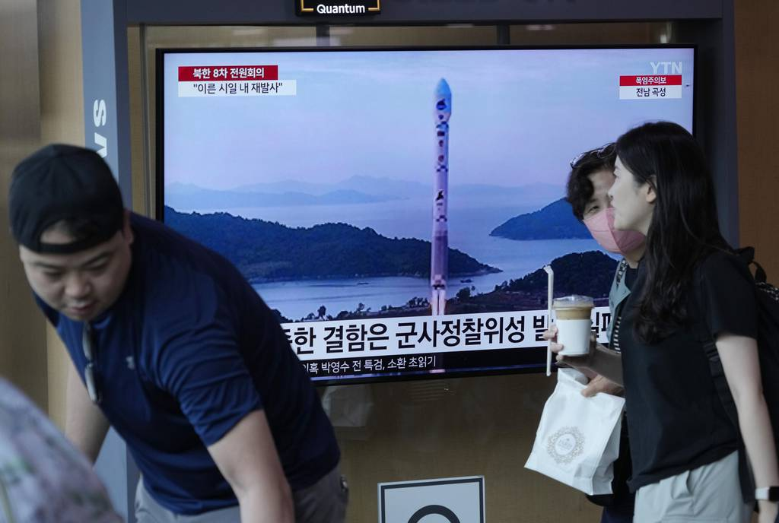
Top North Korean officials vowed to push for a second attempt to launch a spy satellite as they called their country's first, and failed, launch last month "the most serious" shortcoming this year and harshly criticized those responsible, state media reported Monday. (AP Photo/Ahn Young-joon)
SEOUL, South Korea (AP) — Top North Korean officials vowed to push for a second attempt to launch a spy satellite as they called their country’s first, and failed, launch last month “the most serious” shortcoming this year and harshly criticized those responsible, state media reported Monday.
In late May, a North Korean rocket carrying a military reconnaissance satellite crashed soon after liftoff, posing a setback to leader Kim Jong Un’s push to acquire a space-based surveillance system to better monitor the United States and South Korea.
The failed launch and North Korean efforts to modernize its weapons arsenal were discussed extensively at a three-day ruling party meeting that ended Sunday, with the presence of Kim and other top officials.
A lengthy Korean Central News Agency dispatch on the meeting didn’t clearly say who spoke, but said a report to the meeting “bitterly criticized the officials who irresponsibly conducted the preparations for (the) satellite launch.”
The report set forth tasks for officials and scientists to learn the lessons of the failed launch, find what caused the rocket’s crash and make a successful launch in a short span of time, KCNA said.
It didn’t say exactly when North Korea might attempt a second launch. But South Korea’s spy agency earlier told lawmakers that it would take likely take “more than several weeks” for North Korea to determine what went wrong in the failed launch.
North Korea monitoring groups haven’t reported any purges or dismissals of scientists or others involved in the failed launch.
A spy satellite is among several high-tech military assets Kim has publicly vowed to acquire to cope with what he calls U.S.-led hostility. Other weapons systems Kim wants to possess are a multi-warhead missile, a nuclear submarine, a solid-propellant intercontinental ballistic missile and a hypersonic missile.
Since the start of 2022, North Korea has carried out more than 100 missile tests, some of which were related to developing a spy satellite and other powerful weapons on Kim’s wish list.
During the meeting, Politburo members also analyzed the “extremely deteriorating security situation” in the region caused by the “reckless war moves” of North Korea’s rivals, the report said, apparently referring to the expanded U.S.-South Korea military drills.
The United States and South Korea have been expanding their military drills in response to North Korea’s advancing nuclear arsenal and warn that any attempt to use nuclear weapons would result in the end of Kim’s government.
The Politburo members set down unspecified “important tasks” for strengthening solidarity with countries that are “opposed to the U.S. brigandish strategy for world supremacy,” KCNA said.
North Korea has pushed to boost relations with Russia, including defending its military action in Ukraine. It says Russia is protecting itself against the West’s “hegemonic policy.”
The North has also sought to build on its ties with China, its main ally and economic lifeline that is locked in an intensified strategic rivalry with the United States over trade, technology and regional influence.
Russia and China, both veto-holding permanent members of the U.N. Security Council, have repeatedly blocked attempts by the U.S. and others to toughen U.N. sanctions on North Korea over its missile tests.
The party meeting also discussed efforts to improve North Korea’s struggling economy, which experts say has been further strained by pandemic-related border closures.
KCNA said there has been some progress in efforts to boost agricultural output and revive production in metal and chemical industries, though it acknowledged unspecified shortcomings. KCNA claimed progress in the construction field, citing a project to build tens of thousands of new homes in the capital, Pyongyang.
It’s virtually impossible to verify the claims by the North, one of the most secretive countries in the world. Experts say there are no signs of social unrest or famine in North Korea despite the pandemic-caused hardships.
KCNA didn’t say whether Kim spoke during the plenary meeting of the Workers’ Party Central Committee.
Koo Byoungsam, spokesperson for South Korea’s Unification Ministry, said it would be highly unusual for Kim to sit through such a high-profile party meeting without a public speech. Koo said the apparent lack of a Kim speech might stem from the satellite launch failure and North Korea’s lack of economic achievements.

