The following article was prepared by our Historian, retired Lt Colonel Roger S. Dong, who served over 37 years in our Air Force. Roger has been a China specialist since 1972, and has also served on Taiwan for 12 years, in the capacity of a Counter-Intelligence Office, Air Attaché and Defense Attaché. His knowledge of the political leaders in China adds to the valuable insights in his reports.
============================================================
Taiwan Beefs Up Her Air Force with 20 Female Pilots
China Threatens and Taiwan Responds.
For many years, the Taiwan Air Force was totally dominated with male pilots. With the huge threat from the Mainland, Taiwan which is one of the high-tech hubs of the world with 80% of her population holding college degrees, has been urging patriotic young people to serve in her military.
Not all young Taiwanese are rushing to join the military, but there are many more now willing to defend Taiwan. Mandatory military service has increased from 4 months to a full year. Her military reserves are still quite small, when compared with China, but those joining the military now are highly motivated and serious about defending Taiwan.
One of the outstanding developments in the Taiwan Air Force (TAF) is the addition of female Air Force personnel, and the inclusion of twenty (20) female pilots. A few are even combat pilots who have been flying fighter jets. They have even been rendezvousing over the Taiwan Strait with Chinese fighters who have crossed Taiwan's Air Defense Zone for several years.
Here are two of Taiwan’s best female pilots:
The Telegraph
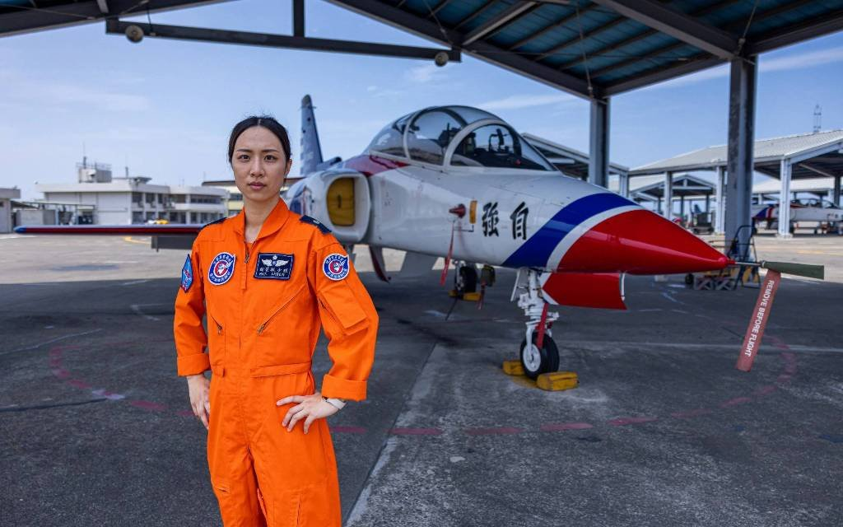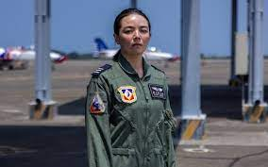
Major Hsieh Yunting, Taiwan Combat Pilot Captain Guo Wenching, Taiwan F-16 pilot

Major Hsieh Yunting and Capt Guo Wenching are two female fighter pilots who fly Taiwan's F-16 A/B and their own AT-3. Their mission is to counter the Chinese Air Force J-11 and J-20 fighters, both of which are newer and more capable than their Taiwan opposition. In fact, Taiwan's F-16's have technology developed in the 1970s.
(In late 2022, a few of the 66 F-16Vs have arrived in Taiwan, but their pilots are just learning to fly this much more capable fighter. It will be another 2 years before all 66 F-16Vs can be delivered. (Note that Taiwanese and Singaporeans pilots have been, and are, training in the U.S. for many years.)
The Chinese J-11s and J-20s are armed with long range missiles and stealth capabilities to avoid radar. Chinese fighter pilots have little or no combat experience, so their ability to utilize the more modern fighter jets is yet to be demonstrated. Also, Taiwan, at its' widest point is only 110 miles from China. The stealth advantages and long-range missiles are intended to operate at much greater ranges and may not give inexperience Chinese pilots a lot of advantage.
In interviews with Major Hsieh and Capt Guo, both display confidence in their flying skills and the capabilities of their aircraft. They know their counter parts have limited combat experience, so they feel confident that they can defend Taiwan. These are fearless women who will make Taiwan proud. Both pilots are married and have children. Their husbands are also Taiwan Air Force pilots. They must have great conversations at their nightly dinner table.
Statistically, China's Air Force is six (6) time larger than Taiwan's Air Force. But China is not going to engage Taiwan with any significant portion of her Air Force. She must retain a large portion of her Air Force, and military, for any potential conflict against America.
China also knows that from per past history, some of her neighbors covet their borders with China may take action to recover contested territory, if the PLA gets engaged in any major conflict. Russia, and all her past governments, have been also been contesting China over border land.
With all these important
======================================================

The female pilots defending Taiwan from Chinese warplanes

Aerial showdowns are becoming more commonplace as tensions rise over the island which Beijing claims as its territory and has vowed to annex

By Sophia Yan IN KAOHSIUNG, Taipei Times, 18 June 2023
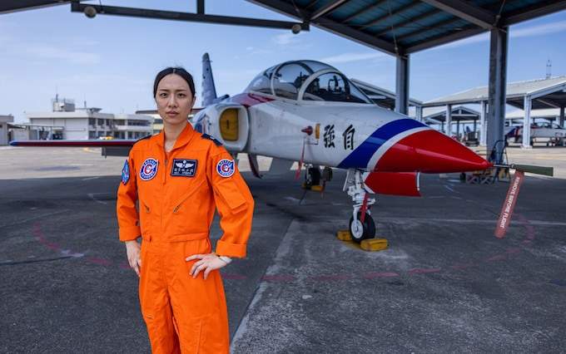
Combat pilot Major Hsieh Yunting trains future aviators at an airport and military air base in southern Taiwan CREDIT: ANNABELLE CHIH for The Telegraph

An interview with female air force pilots in Taiwan published by the UK’s Telegraph newspaper on Sunday highlights their strong willpower, responsibility and resilience as female fighter pilots, despite facing increasing Chinese military threats.
The report interviewed 34-year-old Captain Guo Wen-jing (郭文靜) and 33-year-old Major Hsieh Yun-ting (謝蕓梃), who are the air force’s fourth and third fighter pilots respectively.
Captain Guo Wen-jing, F-16 combat pilot
Guo studied business management at university and briefly considered working in a bank after graduation, but at the age of 22, she was drawn to the challenge of enlisting in the military, particularly in aviation, the report said.
The promise of a steady wage cemented her decision, as she had hoped to support her family in covering expensive late-stage cancer treatments for her late father at the time.
“I thought: If the boys can do it, then girls can, too… I didn’t even tell my family what I was up to until the morning I was assigned to report for duty,” the newspaper cited her as saying.
During her childhood, Hsieh often watched planes taking off and landing at a nearby airport and military air base in Kaohsiung, and she now trains future fighter pilots on AT-3 trainer aircraft.
“I wondered if perhaps someday I could fly one of those planes,” the report cited her as saying.
On her first solo flight, she said she looked behind in the plane, not convinced that she was flying alone without an instructor, but she told herself “you got this” and succeeded, because she believed in herself, the report cited her as saying.
Days usually begin at about 5am for Guo and Hsieh, but sometimes they can start as early as 3am.
Other than their military duties, they need to manage their responsibilities at home — Hsieh is a mother of two children, aged seven and five.
As women comprise only about 15 percent of active-duty personnel in the military, and most female pilots end up flying transportation planes, there are only 20 female fighter pilots, the report said.
There were so few women when they started their pilot training about a decade ago, that “our officers placed us under a magnifying glass — at least, that’s what it felt like,” Guo was cited as saying.
Recruiting has not been easy in Taiwan, as the military’s public image has long been associated with repression, due to the history of martial law until 1987, so Guo’s two older brother still tease her for becoming a soldier and are not interested in enlisting themselves, it said.
However, Guo and Hsieh’s sense of accomplishment from having joined the elite ranks of the air force cannot be replaced, it reported.
Beijing commands six times as many warplanes as Taiwan and has increasingly sophisticated aircraft, so as tensions rise over a potential invasion of Taiwan, Guo and Hsieh might one day be at the forefront of a war with China, the report said.
Facing Beijing’s military advantages, the female fighter pilots have shown how to stay calm during their missions to intercept Chinese aircraft, as well as demonstrating determination to defend Taiwan, it added.
===========================================================

