Future Chinese American Hero – Clovis Hung

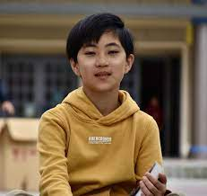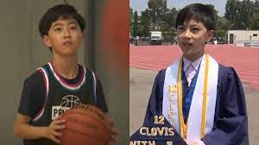

Let us meet y0ung Clovis Hung, who is just 12 years old and graduated from Fullerton College with five (5) associate degrees, and he plans to earn his sixth (6) degree in a few months. Some of us only have one (1).

The only issue facing this future Chinese American Hero is that there are now very high expectations.

One thing we must inform you. Clovis started college when he was only 9 years old. He must have gone from diapers then immediately to college. They call this special admissions. (This was never offered to me - for the right reasons.)

You might assume that Clovis is a nerd, but his life includes many normal activities you (and I) were involved with. He plays basketball five (5) days a week and also video games, and is a Boy Scout. He loves pets and travel.

Clovis thanks his professors and classmates who were a great encouragement and support.

He is already planning careers in aerospace, engineering, piloting or pediatrics. (Bet he might become a Space Force member!)

Remember the name now, Clovis Hung. It won't be too long before we hear much more about his exciting future and accomplishments.

===============================================

Source:

12-year-old, Clovis Hung, graduates college in California, setting school record
May 26, 2023, By Sakshi Venkatraman, NBC News

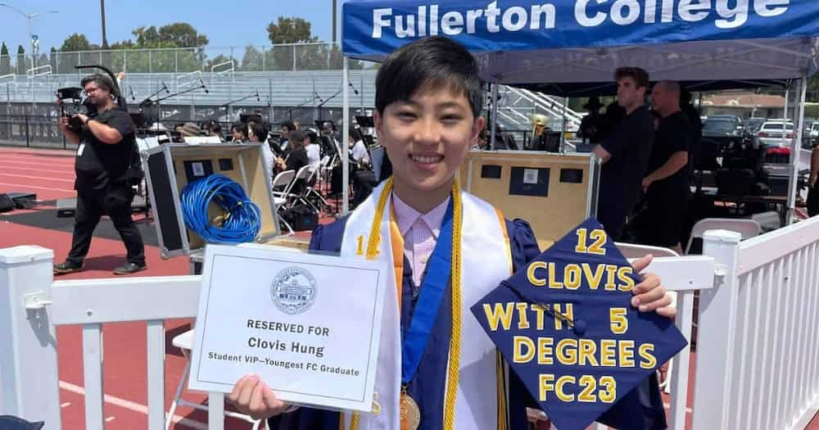
A 12-year-old last week became the youngest person ever to graduate from California’s Fullerton College.
Clovis Hung, who started college when he was just 9 years old, said his decision to enroll was motivated by a sense of friendly competition. He said he heard about Fullerton alum Jack Rico, who at 13 years old set the previous record as the college’s youngest graduate, and set out to match his accomplishment.
“I also wanted to be the youngest graduate,” Hung told Fullerton news station KABC. “I didn’t expect to beat him.”
On Saturday, Hung walked across the stage in a cap and gown alongside fellow Fullerton graduates, most of them at least a decade his senior. He was awarded five associate of arts degrees: history; social sciences; social behavior and self-development; arts and human expression; and science and mathematics. He said he plans to pursue another one next year.
Hung enrolled at Fullerton through the school’s Special Admit program, which allows students of any age to take courses for college credit. According to a press release by the school, Hung’s mom combined his college classes with a homeschooling curriculum to best meet his academic needs.
“Clovis is super inquisitive, mature, diligent, self-disciplined and highly motivated,” Hung’s mother, Song Choi, said in the release. “He is also very curious and traditional public schools could not satisfy his curiosity, therefore, the best option was college.”
Adjusting to an in-person college experience was daunting at first, Hung said, but he found a support system in his new professors and classmates. Everyone welcomed him with open arms and was glad to have discussions with him about course material, he said.
“When I had questions, I asked them, and if they had questions, they’d ask me,” Hung said. “They treated me like a little brother.”
Some of his professors worried about how he would relate to his older classmates, the release said, but soon found that he fit in seamlessly.
“Clovis has been a great mixture of ‘kid’ and college student,” Fullerton biology professor Kenneth Collins said. “He is mature enough that the other students take him seriously, but enough of a kid that they look after him like a younger brother and cheer him on.”
Like many recent grads, Hung plans to spend his summer traveling. He also plays basketball five days a week, enjoys Minecraft and Roblox, and is earning badges as a Boy Scout.
“I also just joined the Civic Air Patrol and hope to get my pilot license at age 16,” he said in the release.

