If you haven't noticed, there is an international race underway to attempt to develop and accumulate sufficient semiconductor technology so that whomever succeeds can rule the world.

What? How can that happen?

Most us know that semiconductor chips are important and that chips are used for many, many applications. But it may surprise many of us when we learn that semiconductor chips impact our lives virtually 24 hours a day.

Virtually all modern electronic products use semi-conductors. We don't even think about. But, from our cell phones, lap top and desktop computers, to our kitchens where our refrigerators, stoves and micro-waves reside, to outdoor lighting on billboards, and of course, the dynamic displays at our sports arenas. Less exciting, but also of great value are LED lights which are used indoors and outdoors.

The most advance chips can pack a billion transistors and are used in the military in all our modern weapons. Still wondering why we are in a race to dominate the semiconductor industr?

The most sophisticated chips are made in Taiwan at the now famous Taiwan Semiconductor Manufacturing Company (TSMC) where more than 90% of the most advanced chips are made and sold to the world.

TSMC does not make chips, it's called a FAB, because it assembles the most dense chips in the world from parts made by several hundred companies that make integral parts for TSMC's products. Most of these companies are now spread out over Asia, with major components made in Singapore, Japan, and South Korea.

We have been a slow to realize the importance of semiconductors, so now we are trying not just to catch up, it is now our national goal, to catch up and dominate the chip world. That is going to be a real challenge. It is unrealistic for us to quickly become a TSMC and also replicate the many subcomponent manufacturers in the world.

The PLAN is to be a world's biggest FAB and also make all the subcomponents at home.

The important subcomponent manufacturers include our allies, like Japan, South Korea and Singapore. We are talking about major business ventures, so I would not expect them to move their chip making factories to America. We are talking about business here, so I do not expect that they will just give up the business to us. A few companies might be acquired by our businesses, but it would be day-dreaming to expect that most, or all, of the foreign companies would be sold to us.

Consider the current situation with Australia, South Korea and Japan, all three have serious national security problems with China, but strong trading continues in all these countries. Perhaps they think it solid trade is better than combat.

What is the latest major news about semiconductor technology? The good news is that our American firm, Nvidia has made a very significant breakthrough in chip making technology.

Until this development, the Dutch firm ASML held the technology for machines that facilitated the critical step of facilitating the manufacturing of the most advanced chips produced at TSMC. The machines now cost $400 million dollars each, unless a FAB is making billions of dollars, they cannot afford the ASML machine.

This month (March 2023) Nvidia developed a competing machine that is faster and uses less energy. If this is a reality, it will go a long way to help America become the dominant semiconductor producer in the world.

Stay tuned, this story is just beginning.

=====================================================

SOURCES:

Nvidia Claims Breakthrough in Chip Production Speed

TSMC, along with semiconductor equipment supplier ASML, plan on incorporating Nvidia's 'cuLitho' software library to streamline a key part of chip production.
By Michael Kan, PC Magazine, Mar 21, 2023
Nvidia says it’s unlocked a way for the tech industry to produce next-generation chips at a faster rate with less energy costs.
The GPU maker has developed a way to streamline a key part of the chip-making process known as lithography, Nvidia CEO Jensen Huang announced at the company’s GTC event. Lithography essentially involves using light to create the intricate patterns on a silicon wafer to form the microscopic transistors.
Chip makers such as TSMC and Intel use expensive lithography machines to project the light through a “photomask” or “reticle,” which can stencil out the pattern on the silicon wafer. To print the patterns at nano-meter levels, semiconductor makers have to rely on what’s called computational lithography—or specialized computer models—to optimize the photomask and prevent defects during the manufacturing process.
============================================================

Nvidia Announces Breakthrough in Computational Lithography
The company says its new technology will allow the production time for a single photomask to be cut down from two weeks to being completed overnight.

By Josh Norem, Extreme Technology, March 22, 2023
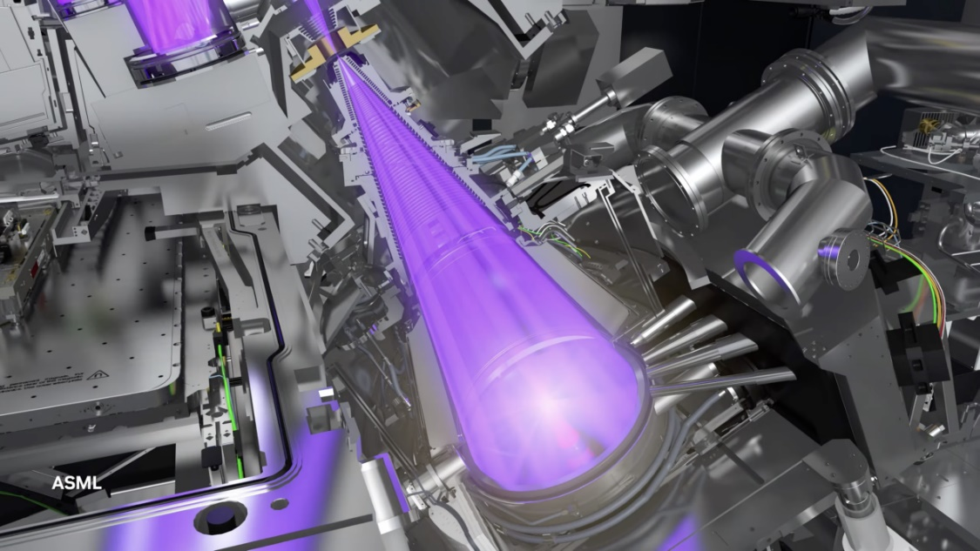
Credit: ASML
Nvidia CEO Jensen Huang unveiled an all-new technology designed to speed up chip production at his GTC keynote speech Tuesday. The system is called cuLitho, and it's designed to significantly cut down on both the time and resources required to create photomasks in silicon wafer production. The move by Nvidia sees it inserting itself directly into the CPU and GPU production supply chain.
In his keynote, Huang said current technologies used to make photomasks were "reaching the limit of physics." In response, Nvidia created the cuLitho software library to offload the computational workload of making photomasks onto Nvidia GPUs. The company stated in its announcement that 500 Nvidia DGX H100 machines could do the work of 40,000 CPU-based systems. Each DGX H100 has eight Nvidia Hopper GPUs, for 8,000 GPUs total. Overall, Nvidia says cuLitho can allow a company to increase the number of masks it can make by 3x to 5x while reducing the power needed by up to 9x.
Using more powerful computers to run algorithms in chip design is known as computational lithography. It's reportedly the most resource-intensive component of chip design, with companies like TSMC running massive data centers 24/7 to create photomasks. Though these processes get smaller, the complexity has increased to prevent optical distortion. Nvidia says its new software library will allow a faster path to advanced nodes, including 2nm and beyond. Though it'll allow for faster mask production in the short term, eventually, it'll lead to better yields, higher densities, and AI-powered lithography, according to Nvidia.
The company has worked on this project for four years, collaborating closely with chip makers, including TSMC, ASML, and Synopsis. All three companies have agreed to integrate cuLitho into their silicon production pipelines. Despite the company's claims that AI-powered lithography is on the horizon, it's not part of cuLitho at this time. As The Register reported, Vivek Singh, VP of Nvidia's advanced technology group, says right now, it's just about sheer horsepower, but it's looking at the AI angle for a future version.

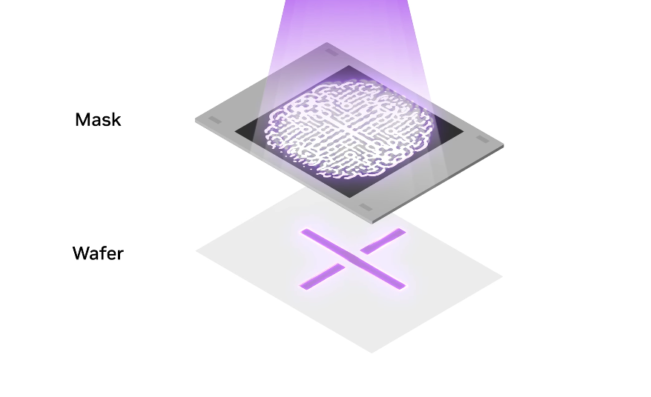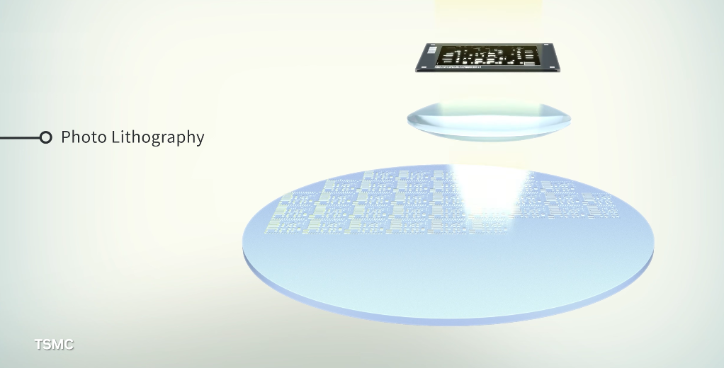How the lithography works.
The problem is that computational lithography requires extensive calculations and data processing; Jensen called it the “largest computational workload in chip design and manufacturing.” Hence, massive data centers are needed, forcing chip manufacturers to spend big on the computing resources and electricity.
In response, Nvidia is introducing “cuLitho,” a software library the company says can speed up computational lithography up to 40 times. As an example, Jensen noted a single reticle for an Nvidia H100 enterprise GPU could take two weeks to process using existing CPU-based approaches. With cuLitho, a chip maker would only need a single eight-hour shift.
In another example, Jensen added: “TSMC can reduce their 40,000 CPU servers used for computational lithography by accelerating with cuLitho on just 500 DGX H100 systems."
This would also reduce TSMC’s computational lithography power requirements from 35 megawatts to only 5 megawatts. In addition, cuLitho promises to help manufacturers cut down on the prototyping period to build chips while aiding them in reaching processor designs at 2 nanometers and below.
Nvidia spent four years developing cuLitho, which runs on the company’s enterprise GPU hardware. TSMC, which makes chips for both Nvidia and Apple, plans on “qualifying” cuLitho for production starting in June, Jensen added. ASML, a maker of lithography machines, is also working with the company on integrating cuLitho into its products in the future.
“In the near term, fabs using cuLitho could help produce each day 3 to 5x more photomasks—the templates for a chip’s design—using 9x less power than current configurations,” Nvidia added. “Longer term, cuLitho will enable better design rules, higher density, higher yields and AI-powered lithography.”

