Betty Lee Sung 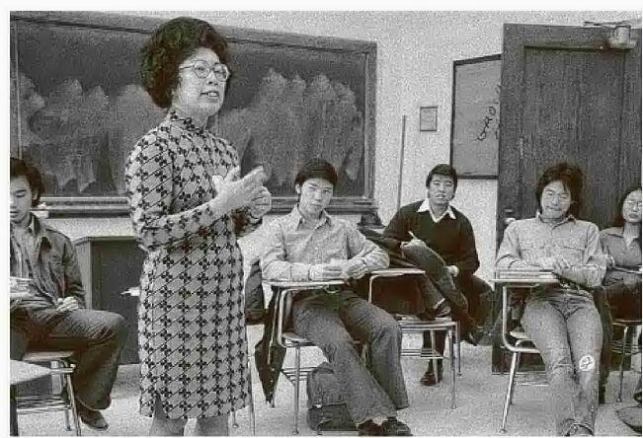
In January 2023 we lost another great Chinese American Heroine. Many of us don't know her, but our Historian worked with her a few years ago, and she was added to the Chinese American Heroes website. That heroine was Betty Lee Song born in 1924 in New York City.
Betty Lee Sung, her parents were immigrants who took her to China during the Depression, then escaped the invading Japanese as a teenager and struggled to make her way back to the United States.
She was very active during WWII with the Voice of America and also worked at the Library of Congress translating Chinese maps for the Army during World War II
And after the war, Dr Sung founded an Asian American studies program at City College of New York, billed as the first in the eastern United States. She was the chair of the department of Asian studies there when she retired in 1992.
Her post retirement life was most interesting and noteworthy as she devoted the three years to cataloging a database of 12,000 detailed immigrant records stored in 581 boxes that she had discovered in a National Archives warehouse in Bayonne, N.J.
=======================================================
From Wikipedia:
Betty Lee Sung (October 3, 1924 – January 19, 2023) was an American activist, author, and professor at City University of New York (CUNY). As a scholar of Asian American studies, her several publications on Asian American race issues have been recognized as an influential force in advancing the rights of Asian Americans and immigrants in the United States.^{[1]} Sung was awarded an honorary doctorate from the State University of New York Old Westbury in 1996.^{[2]}

Biography[edit]
Born in Baltimore, Maryland, on October 3, 1924,^{[3]} Sung's interest in the history of Chinese Americans was shaped by her own experience as a child of Chinese immigrant parents. When Sung was nine, her father briefly took the family back to their hometown, Taishan, but the family returned to Washington D.C. before Guangdong was captured by the Japanese during World War II. While growing up in Washington D.C., Sung and her family faced discrimination as Chinese immigrants. The treatment towards Chinese people in the United States was so severe that Sung recalled how her family largely avoided public areas like the movies or swimming pools.^{[4]}
Defying her father's wish that she marry instead of furthering her education, she attended the University of Illinois on a full scholarship and graduated Phi Beta Kappa with a major in economics in 1948. Much later, she received a Master of Library Science degree from Queens College (1968) and a Ph.D. from the City University of New York (1982).
On February 22, 1948, she married Hsi-Yuan Sung; they divorced in 1966. She had four children from her first marriage.^{[3]} Her second marriage to Charles Chia Mou Chung took place on July 23, 1972.^{[3]} In 1983, she and Charles moved to his apartment in Manhattan, and she became even more active in the Chinatown community, leading rallies, meeting political leaders and supporting Chinese American candidates for political office. In 2013, Charles filed a Petition for Dissolution of his marriage to Betty.
Sung moved to New York after graduating from University of Illinois and worked as a script writer for the Voice of America, where one of her programs "Chinese Activities" was focused on Chinese living in the United States. While doing research for her stories, Sung was struck by how most material, even in the Library of Congress, held inaccurate and often stereotypical assumptions about Chinese people and culture. This inspired Sung to write her first book, Mountain of Gold: The Story of the Chinese in America.
After publishing Mountain of Gold, Sung was invited to join the Asian American Studies program at The City College of New York in 1970, where she advanced to the Chair of the Department of Asian Studies. She held this position until her retirement in 1992.^{[4]} She published 7 other scholarly works on the socio-economic profile of the Chinese in America, Chinese immigrant children, and intermarriage. In 2015, she wrote her memoirs Defiant Second Daughter: My First 90 Years.
In 1994, Sung completed a database of the Chinese immigrant records in the New York Region National Archives with grants from the Chiang Ching Kuo Foundation and the National Endowment for the Humanities. The database was featured by the New York Times, and enables scholars to conduct genealogical research and recreate the early history of Chinese immigrants in New York.^{[5][6]} The records document the arrival of Chinese immigrants to New York City as early as 1860, filling in a missing piece of Chinese American history following the Chinese Exclusion Act of 1882.
In 2001, Sung and Thomas Tam co-founded CUNY's Asian American / Asian Research Institute (AAARI), a university-wide scholarly research and resource center on policies and issues that affect Asians and Asian Americans.^{[7]} In 2017, she received the Lifetime Achievement Award^{[8]} from the Association for Asian American Studies (AAAS).
Sung possessed a large collection of material related to Asian Americans. She donated a large portion to the Library of Congress Asia Division in 2007 and the remainder to the Museum of Chinese in America in 2019 and upon her death. Dr. Hwa-Wei Lee, former Chief of the Asian Division, wrote "Betty was very kind to donate her lifetime collection for the benefit of future generations."
Sung was also a member of the Committee of 100, an organization committed to addressing Chinese American issues.^{[9]} In her lifetime, Sung also has been honored by the Organization of Chinese Americans, the American Library Association, the Asian American Higher Education Council, and New York Historical Society. Additional information about Sung's life may be found at the Museum of Chinese in America, AARI, and the Committee of 100.
Sung died in Silver Spring, Maryland, on January 19, 2023, at the age of 98.^{[10]}

Education[edit]
Sung graduated Phi Beta Kappa with a B.A. in Economics from the University of Illinois in 1948.^{[3]} In 1968, she earned an MLS from Queens College of the City University of New York.^{[3]} In 1982, she earned a PhD from the Graduate School and University Center of the City University of New York.^{[3]}

Publications[edit]
- Mountain of Gold: The Story of the Chinese in America (1967)
- Chinese American Manpower and Employment (1976)
- The Chinese in America (1973)
- Album of Chinese Americans (1977)
- Statistical Profiles of the Chinese in the United States (1979)
- Adjustment Experience of Chinese Immigrant Children in New York City (1987)
- Chinese American Intermarriage (1990)
- Defiant Second Daughter: My First 90 Years (2015)^{[11]}

See also[edit]
- Chinese Americans in New York City
- Asian American Studies

References[edit]
  - ^ "The Institute on Man and Science; Chinese People in the United States". American Archive of Public Broadcasting. 17 January 1969. Retrieved 2020-05-27.
  - ^ "Betty Lee Sung". Asian American / Asian Research Institute. Retrieved January 22, 2023.
  - ^ Jump up to:ª ^{b} ^{c} ^{d} ^{e} ^{f} "Contemporary Authors Online". Gale Literature: Contemporary Authors. Gale. 2001. Retrieved January 22, 2023.
  - ^ Jump up to:ª ^{b} Brodsky, Sascha (November 12, 2004). "Asian studies pioneer & author going strong at 80". Downtown Express. Vol. 17, no. 24. New York, NY: Community Media LLC. Archived from the original on December 20, 2016. Retrieved January 22, 2023.
  - ^ "Betty Lee Sung". ChiamOnline.com. Archived from the original on 2015-09-23. Retrieved 2016-02-29.
  - ^ Hays, Constance L. (1994-07-17). "Archive Yields Rich Details of Era When Chinese Were Barred". The New York Times. ISSN 0362-4331. Retrieved 2016-02-29. (subscription required)
  - ^ "Thomas Tam". Legacy.com. Retrieved October 25, 2018.
  - ^ 2017 AAAS Annual Conference - Lifetime Achievement Award, Betty Lee Sung, Asian American / Asian Research Institute, 2017-04-17, retrieved 2018-10-26
  - ^ "Douglaston Hill and Little Neck Society". Archived from the original on 2016-03-05. Retrieved 2016-02-29.
  - ^ Roberts, Sam (2023-01-20). "Betty Lee Sung, Pioneering Scholar of Chinese in America, Dies at 98". The New York Times. ISSN 0362-4331. Retrieved 2023-01-22. (subscription required)
  - ^ "Defiant Second Daughter: My First 90 Years". Asian American / Asian Research Institute. Retrieved 2018-10-26. ==================================================

