Would anything change if the glaciers melt?

Few people can deny that the climate is changing, and the warming of our planet has a lot of impact on our lives, and even more impact on all of us who are going to around more than a few years. As the air around our entire planet warms, glaciers will melt even faster. Melting glaciers, not only in the Arctic and Antarctic will cause the seas to rise, globally. No one, no nation, can hide from rising tides. It doesn't matter how powerful your military is, or whether you are a democracy, or an autocracy.

The reports that Greenland is splitting in half, and glaciers in Alaska, and elsewhere, are shrinking means that the rise of the sea which have already started, will increase as the earth continues to warm. Seaports globally will go underwater, beach front property will also be underwater and worthless.

There are no simple solutions, but we must make efforts to slow the warming. The green house gas that is generated by all modern nations must be slowed down. The biggest generators of green house gases are China, the United States, and Russia.

Despite the cold war going on among the big Three, if the big Three do not cooperate, Man's existence on planet earth may be less than 100 years.

Of course, there are other threats that will shorten Man's history on this planet. We need to stop wars, we need to cooperate even with our enemies, to deal with changes to our planet that climate change has already significantly impacted regarding food production. We must locate the safest locations for man to survive which has access to clean water and clean land for farming.
For doubters of climate change, check out: https://youtu.be/lY3mXFXd3GU

=======================================================

SOURCES:

Up to half of the world’s glaciers could disappear even if ambitious climate targets are hit, new study finds
By Laura Paddison, CNN, Thu January 5, 2023

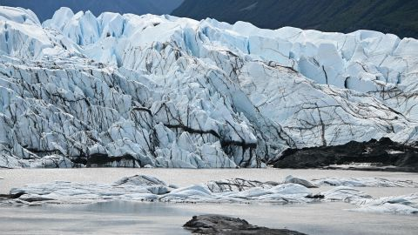
The Matanuska Glacier, 100 miles northeast of Anchorage near Palmer, Alaska. Like many Alaskan glaciers, it is shrinking.
Patrick T. Fallon/AFP/Getty Images
Glaciers are set to lose substantially more ice and contribute more to sea level rise than current scientific estimates project, according to a new report. Using new satellite data to model different climate change scenarios, researchers found that up to half of glaciers could be lost by the end of the century, even if the world’s ambitious global climate targets are met.
More than 215,000 glaciers creep and slide over the world’s mountains, growing when the snow falls and shrinking when the temperature rises. They provide fresh water for nearly 2 billion people and are a key contributor to sea level rise, a threat to the billions of people living along the world’s coastlines.
While it has long been known that these giant ice “rivers,” some of which are hundreds of thousands of years old, are hugely vulnerable to the climate crisis, understanding how glaciers will react to different climate scenarios has been a challenge. Data are often regional or otherwise limited in scope, said David Rounce, a glaciologist at Carnegie Mellon University and lead author of the report, which was published on Thursday in the journal Science.
The past few years, however, have seen “a revolution in using satellite images to monitor glacier changes,” Rounce said, allowing scientists to come up with estimations for each individual glacier.
“That’s really a huge advance compared to previous studies,” he said.

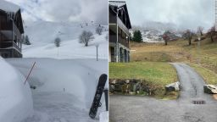
European ski resorts close because there's no snow

Using these new data sets, the researchers made predictions for the fate by the end of the century of the world’s more than 215,000-plus mountain glaciers (excluding the Greenland and Antarctic ice sheets) under a range of temperature increases: 1.5 degrees Celsius, 2 degrees Celsius, 3 degrees Celsius and 4 degrees Celsius.
Their modeling projects that glaciers will lose 41% of their mass by the end of the century, compared to 2015, if temperature rises hit 4 degrees Celsius.
Even if temperature rises are kept within 1.5 degrees Celsius – a target the world is not currently on track to meet – glaciers are still projected to lose 26% of their mass by the end of the century. Under a best case climate scenario, up to half the world’s glaciers could disappear by 2100, according to the report.
Current climate pledges are projected to result in global temperature rise between 2.1 and 2.9 degrees Celsius by 2100, according to the United Nations. If that happens, glaciers could almost completely disappear in several regions including central Europe, western Canada and United States, and New Zealand, the report says.

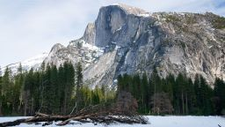
These glaciers are on track to disappear within the next 30 years, new report shows

“The loss of these glaciers, especially over time horizons that are within our lifetime or our children’s lifetime, is really disturbing,” Rounce said.
Shrinking glaciers will also have a clear impact on sea level rise. The researchers project that a 1.5-degree Celsius increase in warming would see 90 millimeters (3.5 inches) of sea level rise, compared to 154 millimeters (6 inches) under a 4-degree Celsius rise.
But while significant glacier loss is locked in, every effort to tackle climate change will help reduce further losses, Rounce said. “Even a small reduction in temperature change can have a really big impact.”
========================================================

600-square-mile iceberg, roughly the size of two New York Cities, breaks off Antarctica ice shelf
JANUARY 24, 2023 / 5:15 PM / CBS NEWS
One of the planet's most closely observed ice shelves just had a major change. On Sunday, a massive piece of Antarctica's Brunt Ice Shelf — a chunk about the size of two New York Cities — broke free.
The British Antarctic Survey said Monday that the iceberg is 1,550 square kilometers, or just under 600 square miles.
NEW satellite image of the huge iceberg that has calved off the Brunt Ice Shelf in #Antarctica shows a clear break. Image was acquired late Monday by Suomi/NPP VIIRS satellite courtesy of @NASA pic.twitter.com/16go7kezUo
— British Antarctic Survey (@BAS_News) January 24, 2023
This is the second major break-off from the ice shelf, known as calving, in two years, although scientists have long predicted it to happen. According to the British Antarctic Survey, cracks have been naturally developing across the entire ice shelf for a decade.
The Brunt Ice Shelf lies across the Weddell Sea from the site of another ice shelf that's made headlines, the Larsen C ice shelf on the Antarctic Peninsula. Last year, the Larsen C ice shelf — which was roughly the size of New York City and was long considered to be stable — collapsed into the sea.
It was the first time in human history that Antarctica had such a collapse. It happened after an atmospheric river brought unusually warm air to the region, and many pointed to climate change as a possible factor.
============================================================
The Doomsday Glacier is Collapsing. Who is Most at Risk?
https://youtu.be/lY3mXFXd3GU

