WARNING To all seniors, especially Chinese/Asian seniors.

Home invasion attacks have been happening, and we all need to be alert.

Here is the report from Dion Lim, KGO Television, June 9, 2022:

EXCLUSIVE: Older SJ couple bound, mouths taped shut in brazen home robbery detail terrifying ordeal
An older San Jose couple is detailing a terrifying home invasion robbery where they were gagged and bound by attackers.
By Dion Lim, KGO Television, June 9, 2022
SAN JOSE, Calif. (KGO) -- Two seniors, part of two brutal home-invasion robberies where their hands were bound, mouths covered with packing tape, and their home ransacked for hours are speaking about their ordeal. They're hoping by sharing their story it'll raise awareness and encourage other victims of crime to speak out.
The 82-year-old man who lives in the Berryessa neighborhood with his 72-year-old wife was resting at home, on the afternoon of May 31 when suddenly, several individuals jumped over a side fence and entered their home. A home, that for decades felt safe. So much so, that they'd often leave a front door unlocked.
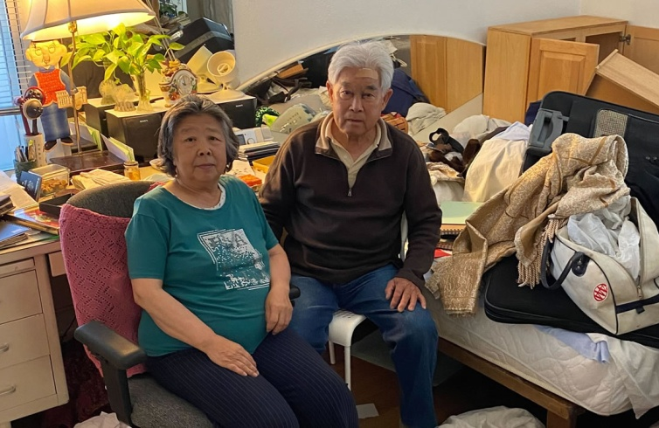
An older San Jose couple sit in their home that was ransacked by robbers during a home invasion where they were bound and gagged.

His daughter, who also requested not to be identified by name, translated and explained her stepmom "was watching her Chinese soap opera" at the time and "didn't even finish the episode," when the attackers came in. She says they used packing tape to cover their mouths and used their own belts to bound their wrists. The attackers then shoved the couple into a guest bathroom as they ransacked their home.
"In her wallet, she had maybe $30," said the 82-year-old man's daughter.

She says "the fear started to set in when they started getting impatient." This is after the attackers hit her father in the head with a gun and found the couple's ATM card. She says the attackers then used the couple's cellphone to call a translator and demand their PIN.
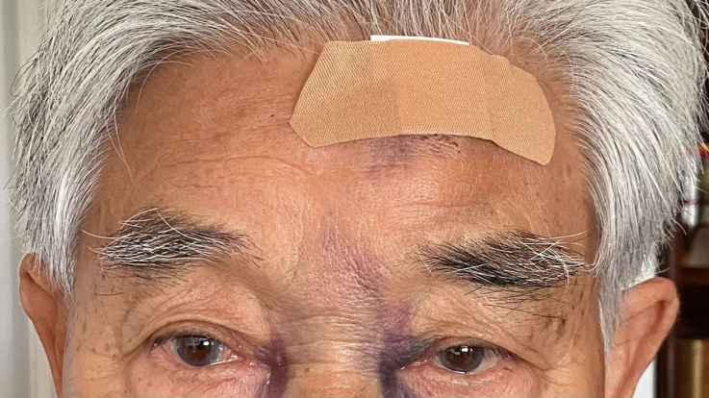

82-year-old San Jose man was hit in the head by a gun during a home invasion robbery that lasted two hours, police say.
"She's like we don't have a PIN number or password. And then the person on the other line said in Chinese 'Are you telling the truth?'" said the daughter.
The use of a translator during a crime is something even SJPD says is not usually heard of.
The couple's ordeal lasted two hours before the attackers stole their car and drove off. According to SJPD, the group used the car to commit another home invasion robbery just one mile away.
Dashcam from the victim's wife's vehicle, in that case, shows her returning home in the afternoon and panicking, describing what was going on.
"My husband is at gunpoint! I have an infant!" She cries out.
As seen in other Ring surveillance used in the police investigation robbers also jumped a fence to enter this home. In addition to the gun, other tools were used to threaten the father and his 15-month-old boy.
SJPD's Christian Camarillo says crime trends change and the department is vowing to apprehend the suspects.
"Just to do this consecutively a couple hours apart is very, very brazen," said Camarillo.
The attackers in this case even physically brought the victim to the bank in hopes of withdrawing cash. The suspects also allegedly wanted the victim to enter the bank to withdraw more cash, but the bank was closed.
"It's a traumatic experience for these community members, we'll have an update for them soon," said Camarillo. "We will find them, we will arrest them."
EXCLUSIVE: Senior couple's life savings stolen in brazen burglary caught on camera in SF

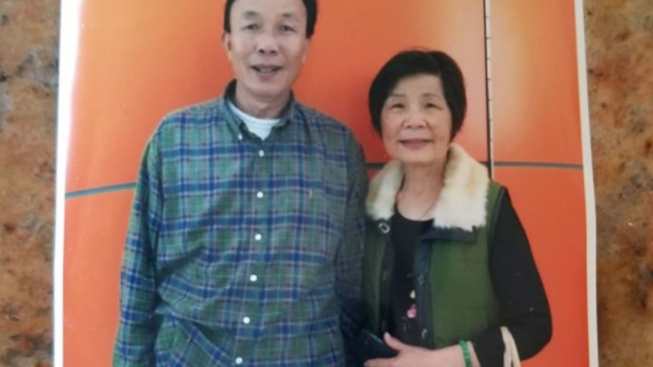
A senior couple in SF, who immigrated to America nearly 40 years ago, is heartbroken after their life savings was taken from them. A senior law enforcement official confirmed Asian American families are often targets because they keep cash in their homes.
Note: If you must keep cash at home, do not store too much. Most people store their cash in their bedrooms, that's the first place burglars search. (May be leave a few hundred dollars just so they might think that's all you have. If you have more, you must store the additional funds in a really secure location.)

He encourages the public to be vigilant and for those with information on these incidents, contact Detective Van Brande at 408-277-4166 or e-mail 4542@sanjoseca.gov.
The older Chinese couple's daughter in the meantime, is proud of her father and stepmother for speaking out.
"The story has to be told, especially from Asians. I hear a lot about it in San Francisco, but not in San Jose. That's where I'm trying to raise my voice for this area of the Bay Area to say be careful. Sharing the news is going to help. I just want the community to watch out for each other," she says.
Her parents are in good spirits and recovering well and hope someone will be able to help them install a higher security fence and install cameras in their home soon.

