Bad News for Egg Lovers
Perhaps you heard that there is Bird Flu circulating and may not have given it a second thought. Reminder: Chickens are birds and they provide all of us with eggs which provide all us egg eaters with nutrition and other essential high food value. Just learned on January 15, 2023 that Costco (where I buy eggs) is out of eggs. It has been hinted that we would be short of eggs soon. The average citizen who eats on the average at least one egg a day, consumes about 400 eggs a year. Multiply that by 340 million people and the total is 135,000,000,000 eggs that are needed to feed all Americans. Eggs are very nutritional, that’s why we eat eggs every day, or almost every day.
Some of us would consider this a national security matter.
Without chickens, not only do we not have eggs, but chicken meat is also deficit. The Costco baked chicken will cost more than $4.99 soon, if the price hasn’t already gone up!
Interesting side note… most people do not know that Bird Flu hit China about 2 years ago, and 70% of their chickens were infected and perished. What did they do? Eggs are also essential food for 1.4 billion Chinese. Chicken dishes is a staple for most Chinese. (Orange chicken is one of my favorite dishes.)
How did they fill in their gap. Chinese businessmen made many calls, and did connect with farmers in Iowa and ordered several million tons of frozen chicken meat and solved the chicken food problem for months.
Problem for us is, with the bird flu affecting us, there is no foreign country like the United States to order all the chicken meat we need. China's chicken population has not recovered yet, so they still have a shortage of chicken meat, and great source for chicken meat now. They still have an egg shortage problem.
This shortage of chicken problem is now global and there aren’t any quick fixes.
SOURCE:

Why are eggs so expensive? Empty supermarket shelves not just due to bird flu
ByPamela Parker via Monday, January 16, 2023
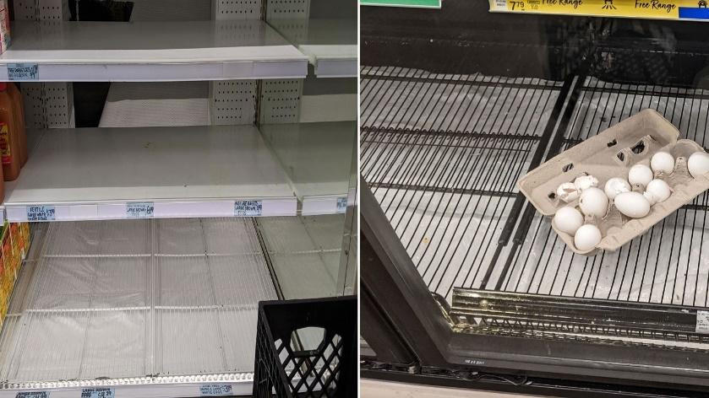

SAN FRANCISCO (KGO) -- The deadly avian flu outbreak in the U.S. isn't the only reason why supermarket shelves across California are often seen to be bare. Inflation, legacy supply chain problems, holiday demand and a longer lead time needed to restart egg laying flocks have all contributed to rising prices and lower availability.
"It takes longer for layer chicken to grow to be able to produce eggs again, whereas broilers are younger when they're processed and they move to market but in the egg industry, it takes a couple of months to get eggs back in production. So right now, there's still more farms trying to get up to speed with the numbers of eggs that they want to produce," said Bill Mattos, the president of California Poultry Federation.
According to USDA's weekly Egg Market Overview report on Jan. 13, the average wholesale price of a dozen eggs in the Golden State edged over $7 in January.
A dozen large eggs currently cost about $6.72, still double what it cost in July.
"The Northern California producers that actually send their eggs to Northern San Francisco in the area, they found that some supermarkets refused to sell eggs for the price that they need to," Mattos said. "So they don't even want any eggs in the supermarket, which I find a little odd. But I guess they'd rather not sell eggs than have to shock the consumer.".
According to Nate Rose, spokesperson for the California Grocers Association, the cost of putting eggs on the shelves have skyrocketed for grocery stores beyond what stores are willing to pass on to their customers.
"The prices that the grocery industry is paying to get the eggs onto the shelves, and then sell to consumers is actually going up faster than what consumers are paying in the store when you go to pick up your carton of eggs," he said. "So that's probably surprising to people because the prices have gone up as much as they have. Because they're such an important item, they're a top three item in people's grocery baskets, they are doing all they can to mitigate the impact on consumers. And in a lot of cases, they're taking a loss on eggs at this point."
Mattos adds, "The supply chain has been totally devasted since the COVID crisis, so the egg movement and the cost of doing business are over any thing they've ever been. But has really hit hard on the eggs is the bird flu. And that started last summer in the Midwest. They lost up to 70 million layered chickens and turkeys. But the other issue with the egg situation is it takes longer for a layered chicken to grow, to be able to produce eggs again, whereas broilers are younger when they processed and they move to market."
But there might be good news for shoppers soon. Prices could soften in the coming weeks as holiday demand for baked goods ease off.
"December does tend to be one of, if not the highest month in terms of volume for egg sales, due to holiday baking. And it's also due to people eating breakfast more at home, when they're cooking for their families. Typically in January and into February, we start to see that demand taper off," Rose said.
California's cage free laws implemented on Jan. 1, 2022 also contributed to especially high prices in the Golden State.
AB1437 required all eggs sold in the state come from hens living in cage-free barns. This in turn resulted in a smaller pool of sellers CA grocers can purchase eggs from, in turn driving prices up.
"You're buying from a smaller range of options in terms of where you can buy eggs from to be able to meet the regulatory conditions that are required," Rose said.
And if you look at the CDFA numbers on the avian flu situation, it's been found to be widespread across the state. There's been flocks that have had to be culled in 13 different counties. So it's been a huge impact on on egg producers and that's why you're seeing the high pricing and comparisons to other states where they have a wider pool to buy from," Rose said.

