Who knew that in 2004 a Chinese American engineer was responsible for design of Boeing Aircrafts first military plane ?

Yes, even though William Boeing is assumed to be responsible for building the first aircraft for Boeing Aircraft, in fact, Mr. Wong Tsu was the one aeronautic engineer who made that happen. And this is actually recognized in the Museum of Flight.

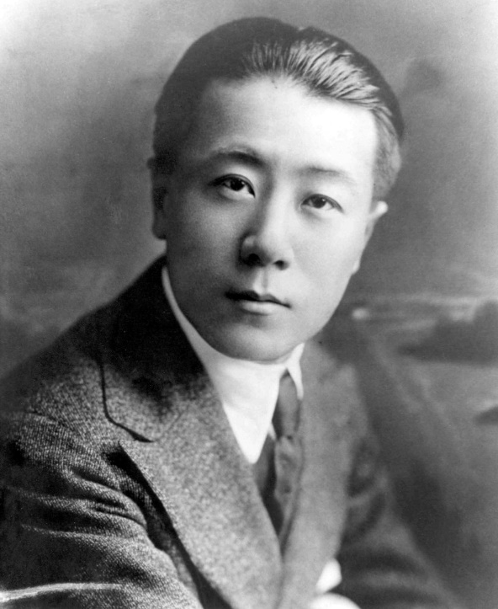

Wong Tsu was born in Beijing China in 1893, and as an obviously brilliant young man and the age of 12, was selected for the Manchu government’s Yang-Tai naval academy, and at 16, he became one of the first Chinese naval cadets sent to England to study naval engineering. After graduation, the government sent him to study the emerging science of aviation at the Massachusetts Institute of Technology (MIT).
In May 1916, the fledgling Boeing Airplane Company hired Wong as their first trained aeronautical engineer. He helped design the company's first successful military airplane, the Boeing Model C, which was purchased by the U.S. Navy. The Model C was first used to carry mail and the catalyst for the development of the Model 40A, the first Boeing aircraft to carry passengers.
During his career, Wong designed more than two dozen aircraft. And in 2004, Boeing unveiled a plaque and exhibit at the Museum of Flight in Seattle, Washington, recognizing and honoring Wong's work as its first engineer.
Wong Tsu's engineering achievements to aerospace industry were significant contributions to America's national defense in the early years of our nation's history.
We should all be very proud that Chinese Americans have been serving our Nation since the early 20th Century. Hooray. ===============================================

Sources:

Wong Tsu
From Wikipedia, the free encyclopedia

In this Chinese name, the family surname is Wong.
Wong Tsu
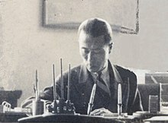
Wong Tsu in his office at CAMCO, Hangzhou
Born | 10 August 1893  Beijing, Qing China
Died | 4 March 1965 (aged 71)  Tainan, Taiwan
Nationality | Republic of China
Education | Massachusetts Institute of Technology
Engineering career
Employer(s) | Boeing
Awards | Acknowledged as first Boeing engineer at the Museum of Flight
Wong Tsu (also spelled Wong Tsoo, Chinese: 王助; pinyin: Wáng Zhù; 10 August 1893 – 4 March 1965) was a Chinese aeronautical engineer who was the first aeronautical engineer at Boeing.

Contents
- 1Life and education
- 2Work
- 3See also
- 4References
- 5External links

Life and education
Wong was born in Beijing, Qing China. At the age of 12, he was selected as a naval cadet; at 16, he was sent to England to study naval engineering, then to the United States to study aeronautical engineering at the Massachusetts Institute of Technology (MIT) during the period of great social and political upheaval in China.

Work[edit]
Wong graduated from MIT with a degree in aeronautical engineering in 1916. He then learned to fly at the Curtiss Flying Boat School in Buffalo, New York. In May 1916, the fledgling Boeing Airplane Company hired Wong as their first trained aeronautical engineer.^{[1][2]} He helped design the company's first successful product, the Boeing Model C,^{[3][4]} more than 50 of which the U.S. Navy purchased.^{[3]} In light of the financial windfall brought from the Navy purchases, "from Bill Boeing onward, the company's chief executives through the decades were careful to note that without Wong Tsu's efforts, especially with the Model C, the company might not have survived the early years to become the dominant world aircraft manufacturer."^{[4]}
Wong brought considerable expertise in wind tunnel testing to Boeing, and advised on the design of the Boeing Aerodynamical Chamber at the University of Washington. In 1917, after around a year at Boeing, he returned to China. In 1928, he became chief secretary of the airline China National Aviation Corporation. From 1934 to 1937, he served as the chief engineer of the Central Aircraft Manufacturing Company, (CAMCO) a joint venture between China and Curtiss-Wright Corporation, Douglas Aviation, and Intercontinent Aviation.^{[5]}
When the Kuomintang government was defeated in the Chinese Civil War, Wong went to Taiwan where he became professor of aviation at National Cheng Kung University. He died on March 4, 1965 in Tainan at the age of 71.
During his lifetime, Wong designed more than two dozen aircraft.^{[6]} In 2004, Boeing unveiled a plaque and exhibit at the Museum of Flight in Seattle, Washington, honoring Wong's work as its first engineer.^{[7]}

See also
- Air Warfare of WWII from the Sino-Japanese War perspective
- Aircraft of China both civil and military use from 1937 and before

References
  - ^ "The 1st...and the Best" (PDF). Boeing.
  - ^ Areddy, James (24 September 2015). "The Chinese Birdman Who Got U.S. Aircraft Giant Boeing Flying". WSJ Blogs - China Real Time Report. Retrieved 2016-01-22.
  - ^ Jump up to:ª ^{b} Bauer, Eugene (2000). Boeing: the first century. TABA Publishing. p. 18. ISBN 1879242095.
  - ^ Jump up to:ª ^{b} Fallows, James (2013). China Airborne: The Test of China's Future. Knopf Doubleday. p. 50. ISBN 9781400031276.
  - ^ Arnold, Doris ("Missy") (2008). Missy's China, Letters from Hangchow 1934 -1937. Hong Kong: Old China Hand Press. pp. passim. OCLC 488467698.
  - ^ 'Past Experience: Boeing’s Long History with China'. Seattle Business Magazine.
  - ^ Vu, Carol (26 November 2005). "An aviation pioneer, no longer forgotten". www.nwasianweekly.com. Retrieved 2016-01-22.
===================================================== ====

The Chinese-Born Engineer Who Helped Launch US Commercial Aviation
Wong Tsu’s 10 months at Boeing in 1916-17 led to the fledgling airplane manufacturer's first military plane, first airmail plane and eventually, its first passenger plane.

Wong Tsu, Boeing's first aeronautical engineer, graduated from MIT in 1916. He is pictured here the following year.
Anti-Asian sentiment in the U.S. rose to a fever pitch as Congress passed an indefinite extension of the Chinese Exclusion Act, almost entirely closing the gates on Chinese immigration. Yet just over a decade later, Beijing-born Wong Tsu came to study at the Massachusetts Institute of Technology through a loophole in the law that made an exception for students. Shortly after graduating from MIT’s new aeronautical program in June 1916, Wong was hired as Boeing’s first aeronautical engineer, cementing his place in aviation history.
The turn of the 20th century was an era of remarkable growth for flight, and Wong played a crucial role: He was integral in designing Boeing’s first successful plane, the Boeing Model C. That became the company’s first military plane, its first used to carry mail and the catalyst to the development of the Model 40A, the first Boeing aircraft to carry passengers.
“The Model C was not only Boeing’s first production order, it was the first Boeing aircraft to be produced in large numbers and sold,” says Tom Crouch, curator emeritus at the Smithsonian’s National Air and Space Museum, and author of several books, including Wings: A History of Aviation from Kites to the Space Age. “Wong Tsu put the company on the map,” he says.
While Wong was still a child in China, Wilbur and Orville Wright, two bicycle mechanics from Dayton, Ohio, made history in 1903 with the first powered, sustained and controlled airplane flight over the dunes of Kitty Hawk. The Wright brothers envisioned a future where planes carried mail and passengers, but aviation in the pre-World War I period was initially met with skepticism.
The first aircraft were extremely frail with few instruments, relegating flight to the realm of sensational spectacle as stunt pilots flew to curious onlookers at carnivals and county fairs. Heavy winds were particularly troublesome, and anxious pilots preferred to fly only in the early morning or late afternoon, when the air was at its calmest.

Wong Comes to MIT
At the age of 12, Wong was selected for the Manchu government’s Yang-Tai naval academy, and at 16, he became one of the first Chinese naval cadets sent to England to study naval engineering. The Chinese government then sent him to study the fledgling science of aviation at MIT.
At MIT, Wong used the university’s new four-foot-square wind tunnel—one of the first in the country of its kind—to conduct controlled experiments and gain rare insight into aerodynamic stability. With a thesis on Air Resistance of Cylinder Combinations, Wong in 1916 became one of the few degreed aeronautical engineers in the country.
On July 4, 1914, William Edward Boeing, a successful lumber company owner in Seattle, convinced early aviator Terah Maroney to take him on his Curtiss seaplane. Boeing’s maiden flight reinforced what he already believed: The future was in aviation.
Boeing also felt he could build a better plane—he just needed the right aeronautical engineer. He turned to a friend, Naval Lieutenant George Conrad Westervelt, who had spent time at MIT and was stationed at the naval shipyards in nearby Bremerton. Together, they created Pacific Aero Products Co., and named their first aircraft the B & W, after their respective initials. Unfortunately, the B & W showed a tendency to tilt while airborne during tests for the Navy in 1916. While the issue was rectified, the damage had been done, and not a single B & W plane was ever sold in the U.S.
After Westervelt was assigned by the Navy back East, he consulted with Jerome C. Hunsaker, the aeronautics program founder at MIT, on a replacement engineer. Hunsaker recommended Wong. Boeing, upon learning of Wong’s vast wind tunnel expertise, responded by telegram: “Engage Chinaman.”

Anti-Chinese Sentiment in the Pacific Northwest
During Wong’s time at MIT, students from China made up the largest percentage of foreigners. They participated not only in research, but in the essential fabric of student life, taking part in everything from athletics to theater. But on the West Coast, particularly in the Pacific Northwest, people of Asian descent had a very different experience. In 1885, a giant mob in Tacoma, Washington forcefully expelled hundreds of Chinese residents, herding them to a nearby railway station. In 1886, nearly 400 more in Seattle were dragged from their homes, and led to a steamer bound for San Francisco.
It was a perilous time to be Chinese in Seattle. To lure Wong, Boeing personally gave assurances for his safety, according to Key Donn, a former president of the Boeing Asian American Professional Association. That promise paid off in spades.

Boeing's Model C
Wong played an integral role in developing the Model C training seaplane, which incorporated several mold-breaking innovations: tThe wings tilted slightly upwards, with the upper wing sitting forward of the lower wing rather than being stacked for greater stability. Crucially, Wong was also able to test a model in a newly built wind tunnel at the University of Washington, and apply his data analytical skills honed at MIT.
Boeing was so proud of the seaplane, that he referred to it as the first “all-Boeing” design. The Model C first flew on Nov. 5, 1916, and an improved Model C, with a bigger rudder, made its first flight on April 9, 1917. Two weeks later, Boeing changed the name of Pacific Aero Products Co. to Boeing Airplane Co.
After test flights at the Naval Air Station in Pensacola, Florida in the summer of 1917, Navy officials were also impressed. Despite 35-m.p.h. winds, the Model C proved better than anything they had seen. They ordered 50 Model Cs for a price of $575,000. Considering the total value of all aircraft orders in the U.S. in 1914 totaled just under $800,000, it was a substantial order by any measure and launched Boeing as a successful airplane manufacturer.

