You, or someone you know, may need an MRI in the future.
Until recently, we did not know that having an MRI can be very dangerous.
Many of us have had MRIs, needed to assist in dealing with any number of different types of health issues. Those who had strokes most likely had at least one MRI, so that the treating doctor could view our brains and detect where and to what extent, the stroke damaged our brains. In some of these instances, victims were injected with Gadolinium, used to darken our tumors and inflammation to help with diagnosis.
We now know that Gadlinium can have serious consequences, and therefore, if you, or I, need an MRI, we might be told that the doctor thinks the injection of Gadolinium might be useful in diagnosing the situation. But, we now know that for some patients, Gadolinium, has had some very dangerous side effects.
In the one instance of the Gena Norris, spouse of the famous action actor, Chuck Norris, she suffered burning pains all over her body, violent shaking, numbness, tingling and numbness. She also suffered breathing difficulties, cognitive deficits and kidney damage.
Had the Norris's known in advance of the risks, they probably would have rejected the injection of Gadolinium.
We now know that Gadolinium can also be toxic. We have also learned that traces of Gadolinium can linger in the brain, bones, or tissues for a long time. Gadolinium can also trigger a rare, but serious skin and joint ailments.
Now that we have you scared, make sure the use of Gadolinium is absolutely necessary, before you take the risk.
In fact the Food and Drug Administration once approved it's use, but in 2017 issued a warning of its side effects.
=======================================================
SOURCE:

FDA Drug Safety Communication: FDA warns that gadolinium-based contrast agents (GBCAs) are retained in the body; requires new class warnings

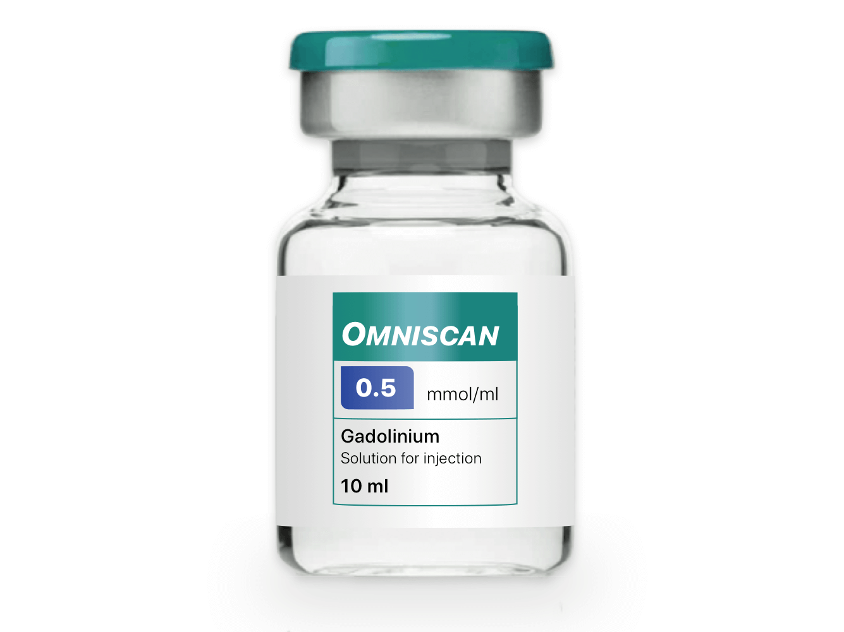
05-16-2018 Update
In addition to approving the updated prescribing information concerning the gadolinium retention safety issues described in the Drug Safety Communication below, FDA has also approved new patient Medication Guides for all GBCAs.
Health care professionals and patients can access the patient Medication Guides according to the GBCA drug name* on the Medication Guides webpage, or the latest prescribing information by searching in Drugs@FDA.
All MRI centers should provide a Medication Guide the first time an outpatient receives a GBCA injection or when the information is substantially changed. In general, hospital inpatients are not required to receive a Medication Guide unless the patient or caregiver requests it. A health care professional who determines that it is not in a patient’s best interest to receive a Medication Guide because of significant concerns about its effects may direct that it not be provided to that patient; however, the Medication Guide should be provided to any patient who requests the information.†
*The brand names of the GBCAs can be found in Table 1 below.
†For more information on distribution of Medication Guides, see the Guidance Document, the Drug Info Rounds Video, or the Code of Federal Regulations at 21 CFR 208.26.
This is an update to the FDA Drug Safety Communication: FDA identifies no harmful effects to date with brain retention of gadolinium-based contrast agents for MRIs; review to continue issued on May 22, 2017.
Safety Announcement
[12-19-2017 ] The U.S. Food and Drug Administration (FDA) is requiring a new class warning and other safety measures for all gadolinium-based contrast agents (GBCAs) for magnetic resonance imaging (MRI) concerning gadolinium remaining in patients’ bodies, including the brain, for months to years after receiving these drugs. Gadolinium retention has not been directly linked to adverse health effects in patients with normal kidney function, and we have concluded that the benefit of all approved GBCAs continues to outweigh any potential risks.
However, after additional review and consultation with the Medical Imaging Drugs Advisory Committee, we are requiring several actions to alert health care professionals and patients about gadolinium retention after an MRI using a GBCA, and actions that can help minimize problems. These include requiring a new patient Medication Guide*, providing educational information that every patient will be asked to read before receiving a GBCA. We are also requiring manufacturers of GBCAs to conduct human and animal studies to further assess the safety of these contrast agents.
GBCAs are used with medical imaging devices called MRI scanners to examine the body for problems such as cancer, infections, or bleeding. GBCAs contain gadolinium, a heavy metal. These contrast agents are injected into a vein to improve visualization of internal organs, blood vessels, and tissues during an MRI, which helps health care professionals diagnose medical conditions. After being administered, GBCAs are mostly eliminated from the body through the kidneys. However, trace amounts of gadolinium may stay in the body long-term. Many GBCAs have been on the market for more than a decade.
Health care professionals should consider the retention characteristics of each agent when choosing a GBCA for patients who may be at higher risk for gadolinium retention (see Table 1 listing GBCAs). These patients include those requiring multiple lifetime doses, pregnant women, children, and patients with inflammatory conditions. Minimize repeated GBCA imaging studies when possible, particularly closely spaced MRI studies. However, do not avoid or defer necessary GBCA MRI scans.
Patients, parents, and caregivers should carefully read the new patient Medication Guide* that will be given to you before receiving a GBCA. The Medication Guide explains the risks associated with GBCAs. Also tell your health care professional about all your medical conditions, including:
If you are pregnant or think you might be pregnant
The date of your last MRI with gadolinium and if you have had repeat scans with gadolinium
If you have kidney problems
There are two types of GBCAs based on their chemical structures: linear and macrocyclic (see Table 1 below). Linear GBCAs result in more retention and retention for a longer time than macrocyclic GBCAs. Gadolinium levels remaining in the body are higher after administration of Omniscan (gadodiamide) or OptiMARK (gadoversetamide) than after Eovist (gadoxetate disodium), Magnevist (gadopentetate dimeglumine), or MultiHance (gadobenate dimeglumine). Gadolinium levels in the body are lowest after administration of Dotarem (gadoterate meglumine), Gadavist (gadobutrol), and ProHance (gadoteridol); the gadolinium levels are also similar across these agents.
*The Medication Guide will be posted once it is approved.
To date, the only known adverse health effect related to gadolinium retention is a rare condition called nephrogenic systemic fibrosis (NSF) that occurs in a small subgroup of patients with pre-existing kidney failure. We have also received reports of adverse events involving multiple organ systems in patients with normal kidney function. A causal association between these adverse events and gadolinium retention could not be established.
We are continuing to assess the health effects of gadolinium retention in the body and will update the public when new information becomes available. We are requiring the following specific changes to the labeling of all GBCAs:
A Warning and Precaution
Changes related to gadolinium retention in the Adverse Reactions, Pregnancy, Clinical Pharmacology, and Patient Instructions sections
We urge patients and health care professionals to report side effects involving GBCAs or other medicines to the FDA MedWatch program, using the information in the “Contact FDA” box at 1-888-INFO-FDA (1-888-463-6332)

