Do You Still Doubt Climate Change?
Today, there are a few people who still do not believe that climate is really changing. These souls believe the past generation of scientists who had used past climate change cycles to explain what is happening today.
Anyone who follows the news, even if one just follows our national news can see that our climate is changing. (It's also changing globally.)
The size and frequency of storms, wild fires and the damage to our nation are catastrophic.
Just the example of our state of Florida and the tornado damage to the entire state is unprecedented. This state may never recover, because there is not enough money (insurance companies are abandoning their clients), or enough wood (shortage due to wild fires), or laborers (mainly carpenters, electricians ) to rebuild all the 4 million homes destroyed.
And it is not just Floridians who are suffering, as agriculture has been severely damaged (the shortage of Florida oranges will be felt by all) and loss of Florida sea food distributed nationally will also be missed. Droughts are impacting a half dozen western states which will have a dramatic impact on food production resulting much higher prices for limited supplies and unprecedented food shortages affecting everyone.
Recently, even the Rockefeller Foundation announced in July that it was "reimagining its philanthropy so the existential threat of climate change would be at the heart of all its giving.
It was an extraordinary decision for a more than $5 billion traditional philanthropic institution, particularly one founded by John D. Rockefeller, whose fortune was made from the world's first and most notable fossil-fuel industry - Standard Oil," as Rajiv Shah, the foundation's president says.

=====================================================

how do we know climate change is real

there is unequivacle facts that the earth is warming up at an unprecented rate. and human activity is the principal cause
TAKEAWAYS
- While Earth’s climate has changed throughout its history, the current warming is happening at a rate not seen in the past 10,000 years.
- According to the Intergovernmental Panel on Climate Change (IPCC), "Since systematic scientific assessments began in the 1970s, the influence of human activity on the warming of the climate system has evolved from theory to established fact."¹
- Scientific information taken from natural sources (such as ice cores, rocks, and tree rings) and from modern equipment (like satellites and instruments) all show the signs of a changing climate.
- From global temperature rise to melting ice sheets, the evidence of a warming planet abounds.

The rate of change since the mid-20th century is unprecedented over millennia.
Earth's climate has changed throughout history. Just in the last 800,000 years, there have been eight cycles of ice ages and warmer periods, with the end of the last ice age about 11,700 years ago marking the beginning of the modern climate era — and of human civilization. Most of these climate changes are attributed to very small variations in Earth’s orbit that change the amount of solar energy our planet receives.

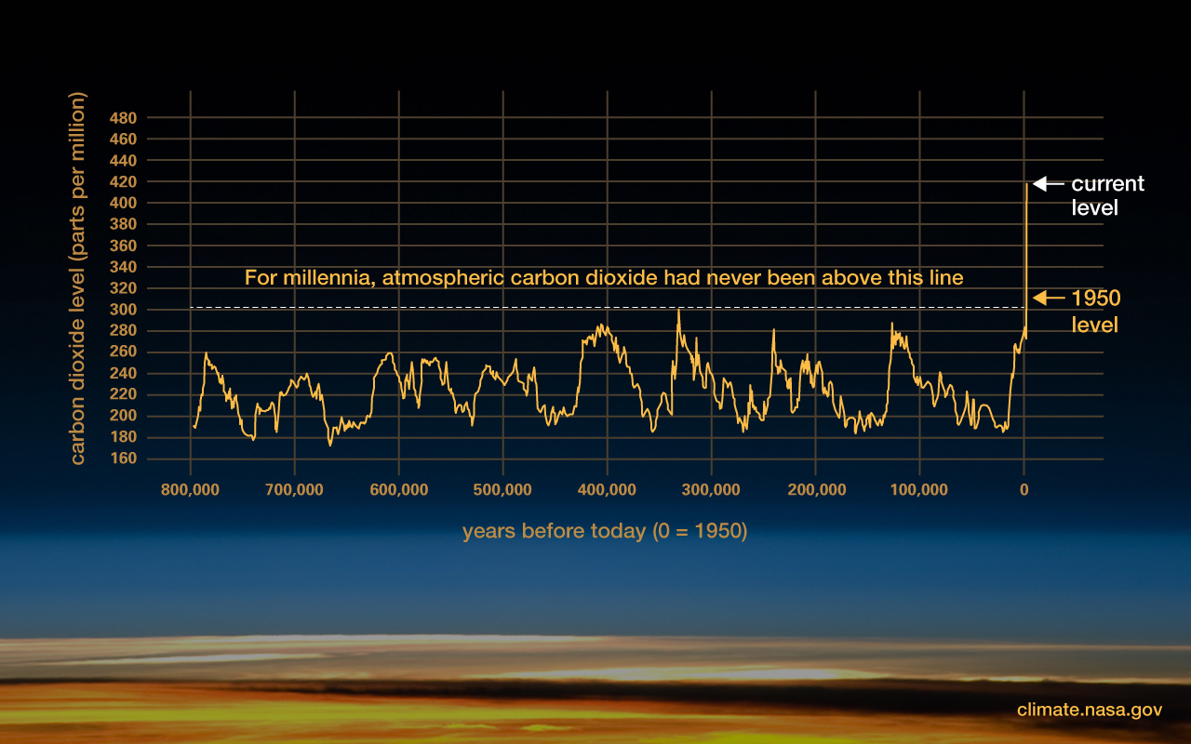
This graph, based on the comparison of atmospheric samples contained in ice cores and more recent direct measurements, provides evidence that atmospheric CO₂ has increased since the Industrial Revolution. (Credit: Luthi, D., et al.. 2008; Etheridge, D.M., et al. 2010; Vostok ice core data/J.R. Petit et al.; NOAA Mauna Loa CO₂ record.) Find out more about ice cores (external site).
The current warming trend is different because it is clearly the result of human activities since the mid-1800s, and is proceeding at a rate not seen over many recent millennia.¹ It is undeniable that human activities have produced the atmospheric gases that have trapped more of the Sun’s energy in the Earth system. This extra energy has warmed the atmosphere, ocean, and land, and widespread and rapid changes in the atmosphere, ocean, cryosphere, and biosphere have occurred.
Do scientists agree on climate change?
Earth-orbiting satellites and new technologies have helped scientists see the big picture, collecting many different types of information about our planet and its climate all over the world. These data, collected over many years, reveal the signs and patterns of a changing climate.
Scientists demonstrated the heat-trapping nature of carbon dioxide and other gases in the mid-19th century.² Many of the science instruments NASA uses to study our climate focus on how these gases affect the movement of infrared radiation through the atmosphere. From the measured impacts of increases in these gases, there is no question that increased greenhouse gas levels warm Earth in response.
Scientific evidence for warming of the climate system is unequivocal.
- Intergovernmental Panel on Climate Change
Ice cores drawn from Greenland, Antarctica, and tropical mountain glaciers show that Earth’s climate responds to changes in greenhouse gas levels. Ancient evidence can also be found in tree rings, ocean sediments, coral reefs, and layers of sedimentary rocks. This ancient, or paleoclimate, evidence reveals that current warming is occurring roughly 10 times faster than the average rate of warming after an ice age. Carbon dioxide from human activities is increasing about 250 times faster than it did from natural sources after the last Ice Age.:

w Do We Know Climate Change Is Real?
There is unequivocal evidence that Earth is warming at an unprecedented rate. Human activity is the principal cause.
=========================================================

Earth is 'unequivocally' in midst of climate emergency, scientists say

Date: October 26, 2022
Source: Oregon State University
Summary:

An international coalition of researchers says in a new report that the Earth's vital signs have worsened to the point that 'humanity is unequivocally facing a climate emergency.'
An international coalition of researchers says in a report published today that the Earth's vital signs have worsened to the point that "humanity is unequivocally facing a climate emergency."
The report, "World Scientists' Warning of a Climate Emergency 2022," published in the journal BioScience, notes that 16 of 35 planetary vital signs the authors use to track climate change are at record extremes.
The report's authors share new data illustrating increasing frequency of extreme heat events, rising global tree cover loss because of fires, and a greater prevalence of the mosquito-borne dengue virus.
They also note large increases in fossil fuel energy consumption following COVID-19 pandemic shutdowns -- despite an upswing in commitments for fossil fuel divestment -- and a rise in atmospheric carbon dioxide levels to 418 parts per million, the highest on record.
William Ripple, a distinguished professor in the OSU College of Forestry, and postdoctoral researcher Christopher Wolf are the lead authors of the report, and 10 other U.S. and global scientists are co-authors. The report follows by five years the "World Scientists' Warning to Humanity: A Second Notice" published by Ripple in in BioScience and co-signed by more than 15,000 scientists in 184 countries.
"As we can see by the annual surges in climate disasters, we are now in the midst of a major climate crisis, with far worse to come if we keep doing things the way we've been doing them," Wolf said. "We implore our fellow scientists to join us in advocating for research-based approaches to climate and environmental decision-making."
Other co-authors of the report are from UCLA, the University of Sydney, Independent University Bangladesh, the University of Cambridge, the University of Exeter, Bezos Earth Fund and the Potsdam Institute for Climate Impact Research.
"Climate change is not a standalone issue," said Saleemul Huq of Independent University Bangladesh. "It is part of a larger systemic problem of ecological overshoot where human demand is exceeding the regenerative capacity of the biosphere. To avoid more untold human suffering, we need to protect nature, eliminate most fossil fuel emissions and support socially just climate adaptations with a focus on low-income areas that are most vulnerable."
The report points out that in the three decades since more than 1,700 scientists signed the original "World Scientists' Warning to Humanity" in 1992, global greenhouse gas emissions have increased by 40%.
"As Earth's temperatures are creeping up, the frequency or magnitude of some types of climate disasters may actually be leaping up," said the University of Sydney's Thomas Newsome. "We urge our fellow scientists around the world to speak out on climate change."
In addition to Wolf and Ripple, three other OSU scientists are co-authors of the paper: Jillian Gregg, Matthew Betts and Beverly Law.
"World Scientists' Warning of a Climate Emergency 2022" is an update of a paper published in BioScience three years ago. The Alliance of World Scientists, an independent organization formed to be a collective voice on environmental sustainability and human well-being, continues to collect co-signers on the 2019 paper. To date more than 14,000 scientists from 158 countries have signed.
Ongoing work to spur climate change action by scientists around the world is chronicled in a new 35-minute documentary film "The Scientist's Warning." The film, by Oregon State Productions, is now available for free online viewing (see: https://scientistswarning.forestry.oregonstate.edu/) following its Oct. 14 premiere at the Newport Beach Film Festival in Newport Beach, California.
"The Scientist's Warning" also chronicles Ripple's personal journey: from a rural, low-income childhood in South Dakota in the 1950s to becoming an ecologist in Yellowstone to assuming a role as a global advocate for using science to make informed policy decisions.
"Look at all of these fires, floods and massive storms," Ripple said. "The specter of climate change is at the door and pounding hard."
Oregon State Productions makes films as part of the university's mission to educate the public about critical issues facing our planet and highlight those working to make a difference. Its portfolio includes the feature-length documentary "Saving Atlantis," which tells the story of the world's declining coral reefs and some of the people working to save them.

Story Source:
Materials provided by Oregon State University. Original written by Steve Lundeberg. Note: Content may be edited for style and length.

Journal References:
- William J Ripple, Christopher Wolf, Jillian W Gregg, Kelly Levin, Johan Rockström, Thomas M Newsome, Matthew G Betts, Saleemul Huq, Beverly E Law, Luke Kemp, Peter Kalmus, Timothy M Lenton. World Scientists’ Warning of a Climate Emergency 2022. BioScience, 2022; DOI: 10.1093/biosci/biac083
- William J Ripple, Christopher Wolf, Thomas M Newsome, Phoebe Barnard, William R Moomaw. World Scientists’ Warning of a Climate Emergency. BioScience, 2019; DOI: 10.1093/biosci/biz088
- William J. Ripple, Christopher Wolf, Thomas M. Newsome, Mauro Galetti, Mohammed Alamgir, Eileen Crist, Mahmoud I. Mahmoud, William F. Laurance. World Scientists’ Warning to Humanity: A Second Notice. BioScience, 2017; 67 (12): 1026 DOI: 10.1093/biosci/bix125

=================================================================================

Going Big on Climate, The Rockefeller Foundation is Backing Environmental Programs to Champion the Vulnerable Populations it has long served.

Abby Schultz, Penta, December 2022.

