Most of our Post members may not know that in 2005 our Post Historian and another distinguished Cathay Post member, retired Air Force Colonel Joseph Chan developed a website called “Chinese American Heroes,” dedicated to identifying and honoring Chinese Americans who have made major and important contributions to America, and often for the whole world. About 10% of the heroes this website honors many Chinese American veterans. The website is currently being re-designed and will be accessible again in December 2022.
One of the greatest business and technology heroes on this website is Mr. Jensen Huang, known to technologists, but not well known to the general public. Mr Huang, originally from Taiwan, is the founder of one of the most important technology companies in the world, NVIDIA. Founded in 1993, Huang’s brilliance and leadership has, and is, having a very significant impact on civilian and military technology. Early investors in this stock in 1993, are very wealthy.
A few years ago, Jensen and his wife contributed ($3o million) to Stanford University which constructed the Huang Engineering Center, and most recently ($50 million) for further development of Artificial Intelligence computing at Oregon University.
We should all be watching and thanking the technical (and financial) contributions this hero and his wife will be rendering in the future.
==================================================================
Nvidia CEO Jensen Huang: ‘The semiconductor industry is near the limit’
Jensen Huang and his wife, Lori Huang, are donating $50 million to Oregon State University to help fund the development of a new innovation complex that will include a Nvidia supercomputer.
Max A. Cherney, October 15, 2022.
Max A. Cherney is a senior reporter at Protocol covering the semiconductor industry. He has worked for Barron's magazine as a Technology Reporter, and its sister site MarketWatch. He is based in San Francisco.
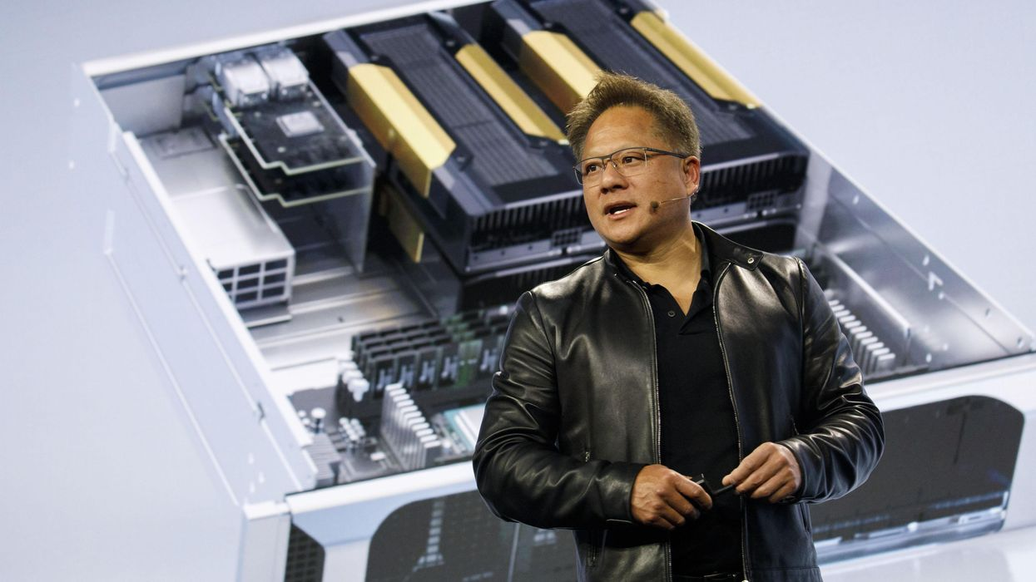
Jensen Huang, president and chief executive officer of Nvidia
“[W]e need to put (AI) in the hands of scientists, so they can apply it to the most important and pressing challenges,” Huang told Protocol. | Photo: Patrick T. Fallon/Bloomberg via Getty Images
Developing software and chips to tackle AI applications has for years been at the core of Nvidia’s mission, and it’s something founder and CEO Jensen Huang talks about at just about every turn.
The way Huang frames it, AI is a kind of time machine that allows scientists and researchers to effectively simulate aspects of the future, such as climate change. With a supercomputer, “something that used to take a month, now takes a day,” Huang told Protocol. “That’s a time machine. And you can see the future like you can’t possibly imagine.”
Jensen and his wife, Lori Huang, announced a $50 million donation to Oregon State University on Friday evening that will help fund a new $200 million Innovation Complex. The new complex, which will be named after Huang and his wife, will include a supercomputer built around Nvidia’s AI clusters that will be capable of training the largest AI models and performing digital twin simulations that will help researchers in climate science, materials science, and robotics, among other fields.
Protocol had a chance to catch up with Jensen and Lori Huang this week over a video conference to discuss the reasons for the donation, whether Moore’s law is truly dead, and why AI is such a crucial tech for universities to invest in.
Jensen Huang’s comments have been edited for clarity and length.
Artificial intelligence is one of the most transformative technologies that the world’s ever known. We can apply intelligence to problems at an extraordinary scale. Humans have great intelligence, but we can only read so much information and wrap that intelligence around so much data. And artificial intelligence, especially with today’s computing scale, could solve problems that no humans could possibly imagine wrapping their arms around. This instrument [AI] is available for the world’s largest technology companies that apply it for all kinds of interesting, very important problems like shopping and music recommendation and things like that.
But we need to put this technology in the hands of scientists, so they can apply it to the most important and pressing challenges. Most universities don’t have the budget. And it’s really quite a shame that most universities today still have [haven’t] come to grips with the idea that in order to advance the most important fields of science, you need a new type of instrument — just like we needed radio telescopes, just like we needed particle accelerators. We need instruments to advance science.
“[W]e need to put this technology in the hands of scientists, so they can apply it to the most important and pressing challenges.”
And in this new form, in this new world of scientific discovery, where principal methods, theoretical methods are still very important, but data-driven methods are vitally important. And this data-driven method is really about inferring from sensor information: How to predict physics, and in order to do this you need a large instrument, and that large instrument [today] is a computer, and most universities just don’t have the budgets for the scientists. They have the budget for the buildings, but they don’t have budgets for computers.
The semiconductor industry is near the limit. It’s near the limit in the sense that we can keep shrinking transistors but we can’t shrink atoms — until we discover the same particle that Ant Man discovered. Our transistors are going to find limits and we’re at atomic scales. And so [this problem] is a place where material science is really going to come in handy.
A great deal of the semiconductor industry is going to be governed by the advances of material sciences, and the material sciences today is such an enormously complicated problem because things are so small, and without a technology like artificial intelligence we’re simply not going to be able to simulate the complicated combination of physics and chemistry that is happening inside these devices. And so artificial intelligence has been proven to be very effective in advancing battery design. It’s going to be very effective in discovery and has already contributed to advancing more durable and lightweight materials. And there’s no question in my mind it is going to make a contribution in advancing semiconductor physics.
When something dies? It might be reincarnated, but it dies. The question is, what’s the definition of Moore’s law? And just to be serious, I think that the definition of Moore’s law is about the fact that computers and advanced computers could allow us to do 10 times more computing every five years — it’s two times every one and a half years — but it’s easier to go 10 times every five years, with a lower cost so that you could do 10 times more processing at the same cost.
A rendering of a supercomputerThe Huangs’ $50 million donation will help fund an AI supercomputer, seen rendered here, at Oregon State University.Photo: Oregon State University
Nobody actually denies it at the physics level. Dennard scaling ended close to 10 years ago. And you could see the curves flattened. Everybody’s seen the curves flatten, I’m not the only person. So the ability for us to continue to scale 10 times every five years is behind us. Now, of course, for the first five years after, it’s the difference between two times and 10 times — you could argue about it a little bit and we’re running about two times every five years. You could argue a little bit about it, you can nip and tuck it, you could give people a discount, you could work a little harder, so on and so forth. But over 10 years now, the disparity between Moore’s law is 100 times versus four times, and in 15 years, it’s 1,000 times versus eight.
We could keep our head in the sand, but we have to acknowledge the fact that we have to do something different. That’s what it’s really about. If we don’t do something different and we don’t apply a different way of computing, then what’s going to happen is the world’s data centers are going to continue to consume more and more of the world’s total power. It’s already noticeable, isn’t that right? It means the moment it gets into a few percent, then every year after that, it will [continue]. Every five years it will increase by a factor of 10.
So this is an imperative. It’s an imperative that we change the way we compute, there’s no question about it. And it’s not denied by any computer scientists. We just have to not ignore it. We can’t deny it. And we just have to deal with it. The world’s method of computation cannot be the way it used to be. And it is widely recognized that the right approach is to go domain by domain of application and get accelerated with new computer science.
The basic science thing and the reason for [our donation] is because people see a different future. And number one: Some people think that climate science and climate change is a real problem. Some people don’t. People also see the solutions differently. We need a time machine [a supercomputer] — we need a simulation. We need a method to predict the impact of climate science and the magnitude of impact in different regions around the world.
“We could keep our head in the sand, but we have to acknowledge the fact that we have to do something different.”
We can do this. It’s within the capabilities of our technology, within the capabilities of our time to simulate to predict the impact of climate change in different regions around the world. So that we can answer the question, what does climate change mean to me? What does climate change mean to an Oregonian? What does climate change mean to an Australian? What does climate change mean to a Venetian? What does climate change mean to somebody living in Southeast Asia next to the Mekong River? What does climate change mean to somebody who lives in Northern California where we have so many, so many wildfires? We need to be able to answer the question, what does it mean?
Number two: We also need a simulator that allows us to simulate scenarios so that we can predict the impact or the mitigation strategies that we have and which ones we use first. Some mitigation strategies have great potential but have side effects. Every single mitigation strategy has side effects. We need to be able to simulate its impact as well as its side effects to understand the net benefit to mitigating climate change. And so there are all these types of questions that we would love to be able to answer. But we need amazing climate scientists and to give them the right instruments, the right tools — a time machine so that they can go into the future and explain and bring back the answer to us.

