Chinese declaration at meeting between Chinese and American senior military officials.
U.S. Defense Minister Lloyd Austin met with China's Defence Minister Wei Fenghe his Chinese counterpart in Singapore, and Defense Minister Wei made the declaration that “If Taiwan declares independence, that would result in war. And Taiwan would be smashed to smithereens.”
This was not a new revelation as China has consistently stated that it would take military action if Taiwan ever declared independence. China talks very firmly and boldly when the issue of independence is suggested inTaiwan. In the past, the talk has been louder than any bites. Leaders in Taiwan have not been threatening independence in recent years.
Despite the Chinese’ tough talk, the overall meeting between the two very senior officials, was described as smooth and useful.
Austin voiced his concerns about the aggressive Chinese military actions in the Taiwan Strait, but reiterated our One China policy urging the Chinese to not behave in a manner that would destabilize the situation.
====================================================
SOURCES:
https://www.aljazeera.com/news/2022/6/10/china-tells-us-it-will-not-hesitate-to-start-war-over-taiwan

‘Smash to smithereens’: China threatens all-out war over Taiwan
Defence minister warns his US counterpart China will ‘not hesitate to start war’ if self-ruled island engages in ‘independence plot’.
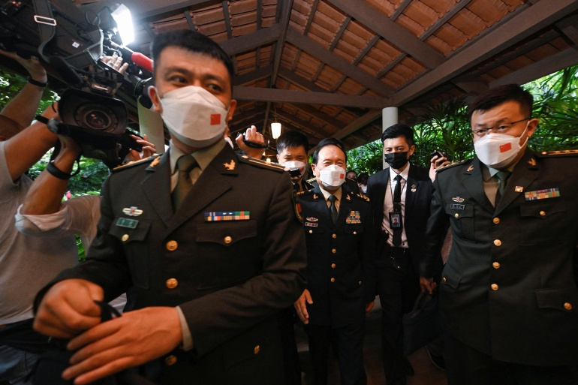
China's Defence Minister Wei Fenghe leaves a bilateral meeting with US Pentagon chief Lloyd Austin on the sidelines of the Shangri-La Dialogue in Singapore on Friday [Caroline Chia/Reuters]
Published On 10 Jun 2022
China will “not hesitate to start a war” and “smash to smithereens” any Taiwan independence efforts, its defence minister warned his US counterpart in the pair’s first face-to-face talks.
“If anyone dares to split Taiwan from China, the Chinese army will definitely not hesitate to start a war no matter the cost,” Defence Minister Wei Fenghe said during a meeting with Lloyd Austin on Friday.
“The PLA [People’s Liberation Army] would have no choice but to fight … and crush any attempt of Taiwan independence, safeguarding national sovereignty and territorial integrity.”
Despite the combative words, Wei said the talks with Austin “went smoothly”.
The meeting took place on the sidelines of the Shangri-La Dialogue security summit in Singapore for nearly an hour, double the time initially allotted.
The Chinese minister also pledged that Beijing would “smash to smithereens any Taiwan independence plot and resolutely uphold the unification of the motherland”, according to the Chinese defence ministry.
“Taiwan is China’s Taiwan… Using Taiwan to contain China will never prevail,” it said in a statement.

‘Operational behaviour’
Taiwan – a self-ruled, democratic island – lives under the constant threat of invasion by China. Beijing views the island as its territory and has pledged to one day seize it – by force if necessary.
Austin told Wei that Beijing must “refrain from further destabilising actions toward Taiwan”, the Pentagon said.
An American official, speaking on the condition of anonymity, said most of the meeting focused on Taiwan and Austin reiterated Washington’s position on Taiwan was unchanged, while criticising China’s “military aggression”.
=======================================================
Open SmartNews and read "U.S., Chinese defence ministers meet face-to-face, seeking to avoid misunderstandings" here: https://share.smartnews.com/bWiK3
U.S., Chinese defence chiefs stand firm over Taiwan in first meeting
By Idrees Ali and Chen Lin, Reuters, June 10, 2022
- SINGAPORE, June 10 (Reuters) - The defence chiefs of China and the United States held face-to-face talks for the first time on Friday, with both sides standing firm on their opposing views over Taiwan's right to rule itself.
U.S. Defense Secretary Lloyd Austin and Chinese Defence Minister General Wei Fenghe met on the sidelines of the Shangri-La Dialogue security summit in Singapore for nearly an hour, double the time initially allotted.
Austin and Wei's first face-to-face meeting comes as U.S. President Joe Biden is seeking to spend more time on Asian security issues after months of focus on Russia's invasion of Ukraine. The two defence chiefs spoke by phone in April.
Although both sides say they want to better manage their relationship, Beijing and Washington remain polarised over several volatile security situations, from Taiwan's sovereignty to China's military activity in the South China Sea and Russia's invasion of Ukraine.
After the meeting, Chinese and U.S. officials highlighted the cordiality of proceedings in a sign it could help open the door to more communication between the two militaries.
However, there was no evidence of any breakthrough on settling long-running security disputes.
Wei said the talks "went smoothly". A Chinese defence ministry spokesman later said Wei reiterated Beijing's firm stance on Taiwan, which is that it is part of China.
"The PLA (People's Liberation Army) would have no choice but to fight at any cost and crush any attempt of Taiwan independence, safeguarding national sovereignty and territorial integrity," the spokesman said.
Austin called on China to "refrain from further destabilising actions" on Taiwan, a U.S. statement issued after the talks said.
Taiwan's Foreign Ministry thanked the United States for the show of support and denounced China's "absurd" claims of sovereignty.
"Taiwan has never been under the jurisdiction of the Chinese government, and the people of Taiwan will not succumb to threats of force from the Chinese government," said ministry spokeswoman Joanne Ou.
UKRAINE DISCUSSED
A U.S. official, speaking on the condition of anonymity, said the bulk of the meeting focused on Taiwan and Austin reiterated that Washington's position on Taiwan was unchanged, while criticising China's military aggression.
"The United States has major concerns about increasing PLA behaviour, particularly unsafe, aggressive, unprofessional behaviour and is concerned that the PLA may be attempting to change the status quo through its operational behaviour," the official said after the meeting.
The United States is Taiwan's most important international supporter and arms supplier, a source of constant friction between Washington and Beijing.
China, which claims self-ruled Taiwan as its own territory, has increased military activity near the island over the past two years, responding to what it calls "collusion" between Taipei and Washington.
A Chinese fighter aircraft dangerously intercepted an Australian military surveillance plane in the South China Sea region in May and Canada's military has accused Chinese warplanes of harassing its patrol aircraft as they monitor North Korea sanction evasions.
The meeting between Austin and Wei also touched on other issues, including crisis communication and Russia's invasion of Ukraine.
During the meeting, Austin "strongly discouraged" China from providing material support to Russia for the war. In response, China's defence spokesperson said it did not provide Russia with military assistance.
This year, Washington warned that Beijing appeared poised to help Russia in its war against Ukraine.
China has not condemned Russia's attack and does not call it an invasion, but has urged a negotiated solution.
Beijing and Moscow have grown closer in recent years, and in February, the two sides signed a wide-ranging strategic partnership aimed at countering U.S. influence and said they would have "no 'forbidden' areas of cooperation".
Reporting by Idrees Ali and Chen Lin; Additional reporting by Ben Blanchard in Taipei; Editing by Raju Gopalakrishnan and Joe Brock

