Meet this Chinese American Hero
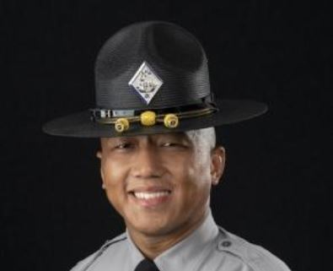 North Carolina State Trooper Cody Thao
Who is Cody Thao? A year ago, he was a tractor supply store worker and decided to join the North Carolina State Highway Patrol. As a NC State trooper, was recently called to deal with a vehicle on a state highway driving the wrong way and creating havoc.
Arriving at the scene Patrolman Thao quickly inserted his vehicle in the path of the on-coming suspect knowing that he would take a hit and risk possible injury and his life. The move also protected proximity innocent vehicles.
Luck was on this State Troope's side and he escaped without injury.
Our Highest Congratulations to State Trooper Cody Thao for his great courage and judgment.
============================================================

https://asamnews.com/2022/05/07/rookie-officer-high-speed-chase-suspected-drunk-driver-lives-saved/

Trooper hailed as a hero for stopping wrong-way driver
Cody Thao North Carolina Highway Patrol

Posted By Randall, May 7, 2022
When North Carolina Trooper Cody Thao heard the call about a wrong-way driver being chased on the freeway in Raleigh by state highway patrol officers, he acted instinctively to save the life of others.
WRAL reports he put himself in harm’s way by maneuvering his vehicle to prevent the suspect from hurting innocent motorists.
Thao positioned his vehicle in the path of the on-coming suspect knowing that he would take a hit and risk possible injury and his life.
“He was either going to hit me or hit someone else coming eastbound on I-40,” said Thao.
Thao said he used his instincts to assure that the suspect would hit the rear of his car and not take a direct hit.
Authorities say the suspect crashed into Thao’s patrol car speeding at 50 miles per hour.
Miraculously, Thao escaped injury.
“I could not be prouder of Trp. Thao and his quick decision to stop the wrong-way driver, his actions most undoubtedly saved lives,” Colonel Freddy L. Johnson, Jr., commander of the North Carolina State Highway Patrol, said in a statement, according to Law Officer.com. “His willingness to put himself in harm’s way is representative of the lifesaving work our members do each day. Placing others before ourselves is not just a saying amongst the law enforcement profession, it’s a reality of what we do for the betterment of the communities we serve.”
The Daily Mail reports that Thao quit his job at a tractor supply store to become a trooper just a year ago.
‘I’ve always had a servant’s heart, and I’ve always wanted to help people,’ he said.

