Robots are relieving the workload on our Nurses, and are developing more skills to serve patients better.

The Pandemic has had a terrible impact on our doctors, nurses and other medical staffs, and this first generation of robots is being well received. These mechanical aides are not a threat to the jobs of our medical staffs.

Early retirements of medical staffs at all levels, is shrinking our medical staffs, especially hospital staffs in major cities that have been exhausted by the workloads required to support ICUs. Watching Covid patients die, attended only by a nurse, has serious mental strains wherever there are significant numbers of Covid deaths. Also a severe strain is extremely stressful, when colleagues succumb to the virus, and serious concerns about bring home infection to children or elders at home. Recruiting for nurses is a real challenge today, and the more robots can do to serve a patient, is truly appreciated by many nurses.

However, robots are no substitute of human nurses who accompany the a dying patients when families may not be allowed to be close to a dying patient. These are different times we are living in.

Most recently, the mechanical "Moxi" robot has been used in dozens of hospitals, providing relief as the computerized systems does not forget and handles many routines that are beneficial to patients with a variety of illnesses. Moxi, a nearly 6-foot-tall robot can pick up and deliver medication, supplies, lab samples, and personal items through the halls, from floor to floor. These routine services are a welcome relief to many nurses. Computer controls track and deliver medicines on time and always with water for the patient to wash down the pills.

Today, the Moxies can only perform simple, repetitive tasks, but we should be expecting that in the future, Moxie's sons and daughters will be doing a lot more to provide timely and needed services to patients wherever they are being utilized.

Source:

Hospital Robots Are Helping Combat a Wave of Nurse Burnout
Moxi and other delivery-focused assistants have become even more critical as the Covid-19 pandemic has pushed health care workers to their limits.

Khari Johnson, WIRED, April 19, 2022

===============================================

Hospital Robots Are Helping Combat a Wave of Nurse Burnout
Moxi and other delivery-focused assistants have become even more critical as the Covid-19 pandemic has pushed health care workers to their limits.

Khari Johnson, WIRED, April 19, 2022

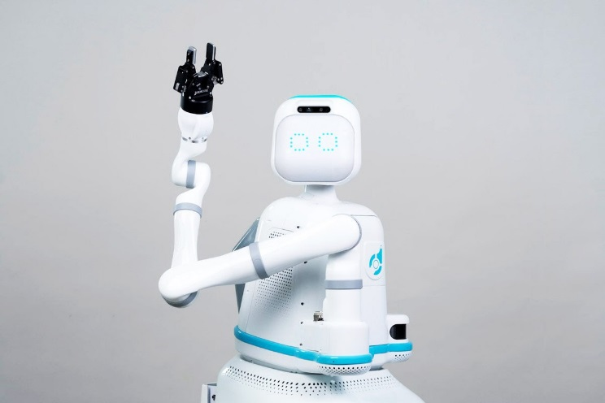
Courtesy of Diligent Robotics
Since February, the nurses at Mary Washington Hospital in Fredericksburg, Virginia, have had an extra assistant on their shifts: Moxi, a nearly 6-foot-tall robot that ferries medication, supplies, lab samples, and personal items through the halls, from floor to floor. After two years of battling Covid-19 and related burnout, nurses say it’s been a welcome relief.
“There's two levels of burnout: There's ‘we’re short this weekend’ burnout, and then there's pandemic burnout, which our care teams are experiencing right now,” says Abigail Hamilton, a former ICU and emergency room nurse that manages nursing staff support programs at the hospital.
Moxi is one of several specialized delivery robots that has been developed in recent years to ease the strain on health care workers. Even before the pandemic, nearly half of US nurses felt that their workplace lacked adequate work–life balance. The emotional toll of seeing patients die and colleagues infected at such a large scale—and fear of bringing Covid-19 home to family—has made feelings of burnout worse.
Studies also found that burnout can have long-term consequences for nurses, including cognitive impacts and insomnia years after the exhaustion of their early careers. The world already had a nurse shortage going into the pandemic; now, roughly two out of three nurses in the US say they have considered leaving the profession, according to a survey from the National Nurses United union.
In some places the shortage is leading to higher wages for permanent staff and for temporary travel nurses. In countries such as Finland, nurses are demanding better pay and going on strike. But it’s also paved the way for more robots in health care settings.
At the forefront of this trend is Moxi, which has spent the pandemic rolling down the halls of some of the largest hospitals in the country, carrying objects like a smartphone or beloved teddy bear to patients in emergency rooms when Covid-19 protocol kept family members from bedsides.
Moxi was created by Diligent Robotics, a company cofounded in 2017 by Vivian Chu, a former Google X researcher, and Andrea Thomaz, who developed Moxi while working as an associate professor at the University of Texas at Austin. The roboticists met when Chu advised Thomaz at Georgia Tech’s Socially Intelligent Machines Lab. The first Moxi commercial deployment came months after the start of the pandemic. About 15 Moxi robots are now operational in US hospitals, with an additional 60 scheduled to deploy later this year.
“In 2018, any hospital that was thinking about working with us, it was a special project for the CFO or innovation project about the hospital of the future,” says Diligent Robotics CEO Andrea Thomaz. “What we saw over the last two years is that almost every single health care system is thinking about robotics and automation or has robotics and automation on their strategic agenda.”
A range of robots have been developed in recent years to carry out health care tasks like disinfecting hospital wards or assisting physical therapists. Robots that touch people—like Robear, which helped lift elderly people out of bed in Japan—remain largely experimental, due in part to liability and regulatory requirements. Far more common are specialized delivery robots.
Moxi is equipped with a robotic arm and can greet passersby with cooing sounds and heart eyes on a digital face. But in practice Moxi is less of a caregiver and more like Tug, another hospital delivery robot, or Burro, a robot helping farm workers in California grape vineyards. A camera on the front and lidar sensor on the back help Moxi map the floors of hospitals and spot people and items it should avoid.
Nurses can hail Moxi robots from kiosks at nursing stations or send the robot a task via text message. Moxi might be used to transport items that are too big to fit into a tube system, like IV pumps; lab samples and other fragile cargo; or specialty items, like a slice of birthday cake.
A survey of nurses who worked with delivery robots similar to Moxi in a hospital in Cyprus found that roughly half expressed concern that robots represent a threat to their jobs, but they have a long way to go before they could conceivably replace humans. Moxi still needs help with basic tasks. For example, Moxi might have to ask a human to press an elevator button for a specific floor.
More concerning, the cyber-security risks hospital delivery robots present aren’t very well understood. Last week, security firm Cynerio showed that exploiting a vulnerability can allow hackers to take remote control of Tug robots or open patients up to privacy violations. (No comparable bugs have been found in Moxi robots, and the company says it’s taking steps to ensure its “security position.”)
Around the time of Moxi’s first commercial deployment in 2020, an American Nurses Association–supported case study assessed Moxi trials at hospitals in Dallas, Houston, and Galveston, Texas. Researchers cautioned that use of such robots requires more thorough supply management by hospital staff, because robots don’t read expiration dates; using expired bandages can increase risk of infections.
A majority of the 21 nurses interviewed as part of the review said Moxi gave them more time to talk with patients being discharged from the hospital. Numerous nurses said Moxi saved them energy, brought joy to patients and their families, and ensured that patients always had water when it was time for them to take their medication. “I could do it faster, but it’s better for Moxi to do it so I can do something else more useful,” said one of the surveyed nurses. In less positive feedback, nurses complained that Moxi had trouble maneuvering through cramped halls during the morning rush or anticipating needs by accessing electronic health records. Another said some patients were suspicious of “the robot’s eyes recording them.” Authors of that case study concluded that Moxi is incapable of delivering skilled nursing care and is best suited to focusing on low-risk, repetitive tasks that can save nurses time.
Those types of tasks can represent big business. In addition to its recent expansion into new hospitals, Diligent Robotics announced the closure of a $30 million funding round last week. The company will use the funding in part to more closely integrate Moxi’s software with electronic health records in order to carry out tasks without the need for a nurse or doctor to make a request.
In her experience, Abigail Hamilton of Mary Washington Hospital says burnout has the power to force people into early retirement, push them toward temporary travel nurse work, impact their relationships with loved ones, or make them leave the industry altogether.
Still, she says, the simple things Moxi does can make a difference. It can save nurses the 30 minutes it might take to go from the fifth floor to the basement to pick up medication that can’t go through the tube system from the pharmacy. And picking up after-hour meals for patients is one of Moxi’s most popular tasks. Since two Moxi robots began operating in the halls of Mary Washington Hospital in February, they’ve given workers back approximately 600 hours of time.
“As a society, we’re not who we were in February 2020,” Hamilton said when explaining why her hospital uses robots. “We have to think of different ways to support caregivers at the bedside.”

