You will like this story.

Duke Wong, a Chinese restaurant owner/cook had a stroke and his customers raised over $60,000 to help pay for medical bills.

Duke Wong, a Chinese restaurant owner and cook, owned and operated his establishment, the Mandarin Garden restaurant for more than 35 years’ Duke Wong, recently had a stroke and his many loyal and appreciative patrons missed their old, reliable friend. And there is a Miss Brenda Ross, a long time friend and patron, initiated a Go Fund Me campaign and raised over $60,000 to help pay for medical bills. One of Duke’s sons, Dr. Jeffrey Wong profusely thanked all the donors for their heart warming support and contributions.

God bless Brenda Ross, a good Samaritan, who sets an example for all of us.

THANK YOU BRENDA.

============================================================

SOURCE:

Customers rally around longtime Chinese restaurant owner
By Randall, AsAm News, March 4, 2022

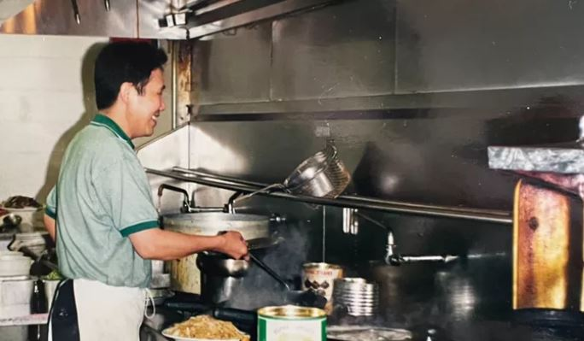 The Duke on duty
Loyal customers who arrived at Mandarin Garden Restaurant near St. Louis found a closed sign on the door and became concerned.
“I was so sad to learn of the reason the restaurant has not been open,” Sherry Cooper wrote on a Go Fund Me page.
Friends and regular patrons would sadly discover that owner and chef Mr Duke Wang suffered a massive stroke five weeks ago.
Mandarin Garden has been closed since while Wang recovers.
“For the past 35 years, Duke has been the managing owner and primary chef, working tirelessly from the kitchen to run this modest family business,” said family friend Brendan Ross. “He has worn many hats in this endeavor, from managing all business operations to creating recipes, and he prepares most meals with his own hands each day and night.”
Ross launched a Go Fund Me campaign that has so far raised more than $60,000 to help the family pay for medical expenses.
“We love this place. We’ve been coming here for a long time,” said Mike and Kathy Fritshce, who came to eat, only to find the doors locked shut, according to KMOV.
Wang grew up in Vietnam and his wife comes from Taiwan. The couple moved to St. Louis from Seattle with the dream of opening their own restaurant. Their son Henry is a Grammy-winning violinist and their other son Jeff is a doctor.
“No words can describe the amount of gratitude my family and I have for all of you who have donated to support my dad in his recovery,” said Jeff about the outpouring of support. “Thank you, thank you, thank you from the bottom of our hearts.”
Duke is out of intensive care and is continuing his recovery.

